Accessible venues in London as researched and explored by Sisters of Frida

This report was written as a guidance for accessible venues in London as researched and explored by Sisters of Frida and funded by the Mayor of London.

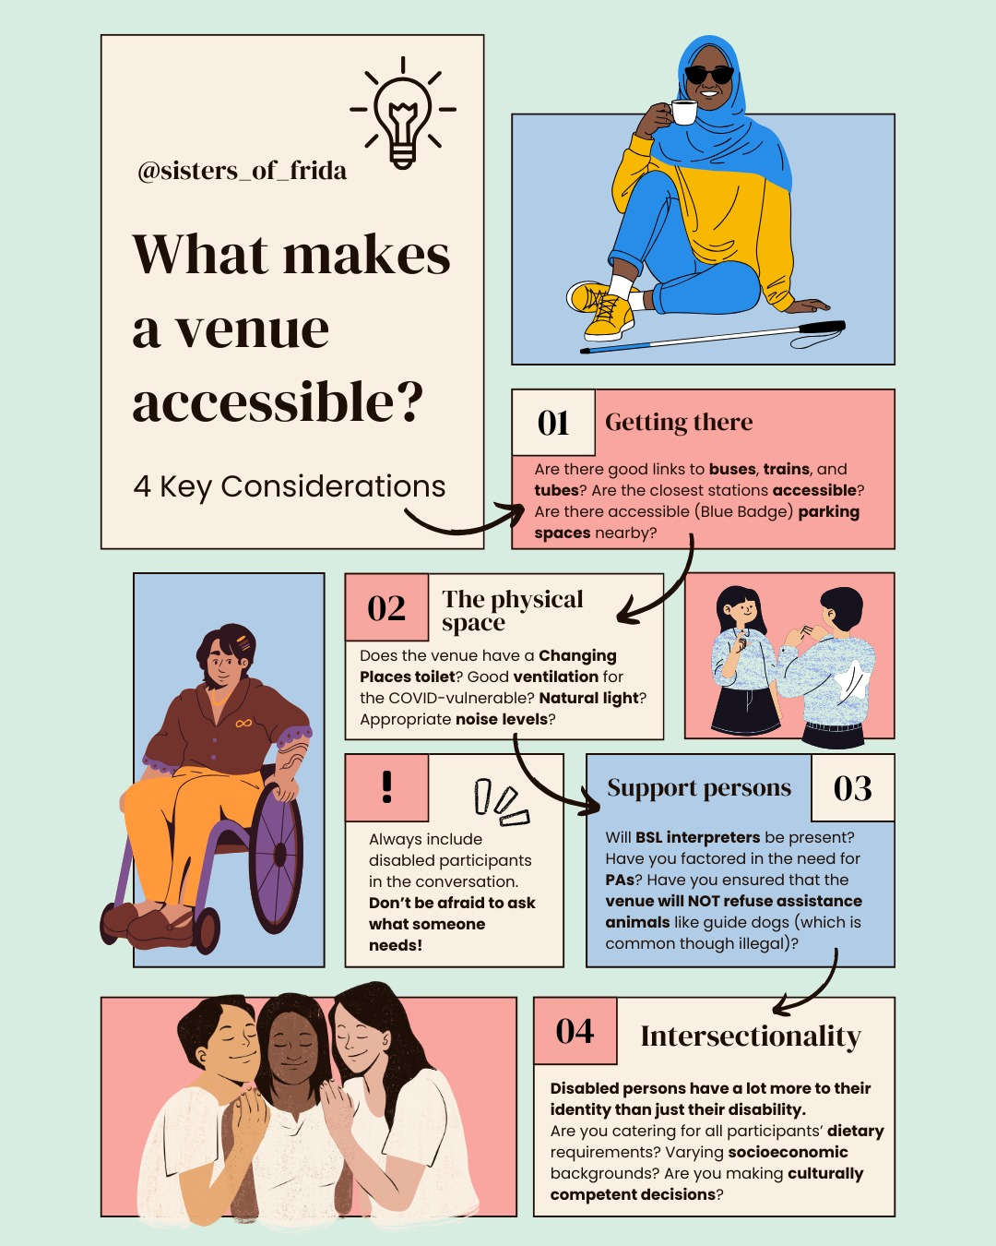

What makes a venue accessible?

4 key considerations

01) Getting there
(Infographic description: Image of a black woman wearing a headscarf. She is sitting on the floor, there is a white cane next to her and she is holding a cup.)
Are there good links to buses, trains, and tubes? Are the closest stations accessible? Are there accessible (Blue Badge) parking spaces nearby?

02) The physical space
(Infographic description: Image of woman of colour wearing trousers on a manual wheelchair)
Does the venue have a Changing Places toilet? Is there good ventilation for the COVID-vulnerable? Natural light? Appropriate noise levels?

03) Support persons
(Infographic description: Image of two women facing each other. They are signing.)
Will BSL interpreters be present? Have you factored in the need for PAs? Have you ensured that the venue will NOT refuse assistance animals like guide dogs (which is common though illegal)?

04) Intersectionality
(Infographic description: Image of three people. There is a black woman in the center. She is being embraced by the other two women of colour.)
Disabled persons have a lot more to their identity than just their disability.
Are you catering for all participants’ dietary requirements? Varying socioeconomic backgrounds? Are you making culturally competent decisions?

N.B Always include disabled participants in the conversation. Don’t be afraid to ask what someone needs!

Search for accessible venues in London
As part of the Socials for Disabled Women project, our goal was to identify accessible venues in London that meet certain accessibility criteria and budget requirements (see infographic above).
The search was conducted in 2024–25 with support from Mayor of London funding. The information is correct as of the publication date of March 2026. This list is by no means exhaustive, but we aim to continue adding more accessible venues to the Sisters of Frida website. The process took longer than anticipated, and we have tried to be as accurate as possible, but not all venues have been personally accessed. Venues that presented potential accessibility challenges were not included. We have also added some community spaces for minority groups.
Currently, there is no single comprehensive guide for accessible venues in London, making this search a significant task. We began with online research but relied heavily on local knowledge, including contributions from participants. For example, locating Changing Places toilets proved challenging- they are not always listed online but are vital for those who need them.
The Meetings and Events Accessibility Guide may also be a useful resource.
To ensure events are accessible for immunocompromised attendees and safe for everyone, we recommend:
- Providing masks and requiring them when attendees are not eating or drinking.
- Offering a choice between FFP2 masks and lip-reading masks in the main event space.
- Providing food in a separate space if attendees remove masks to eat.
- Ensuring outdoor spaces are available and accessible when possible.
- Honoring mask exemptions.
- Providing a medical-grade HEPA air purifier onsite, which can be borrowed if needed.
Venue costs can be a significant limitation. Some of the most accessible venues are not affordable for small grassroots collectives like Sisters of Frida.

Contents

South London

Livesy Exchange

Woolwich Works

Woolwich Front room

Greenwich GMV community centre

Deptford Lounge

Woolwich Centre Library

North London

Greenwood Centre

Museum of Homelessness

Wellcome Collection

Kabannas St Pancras

Friends House

Calthrope Community Centre

St Lukes Community Centre

East London

Graeae Theatre Company

London Museum Studios

London Museum Docklands

Sadlers Wells East

The Barbican

East and South East Asian Community Centre

Haggerston Community Centre

City Hall

The Sundial Centre

West London

Action on Disability Centre for Independent Living-

Wilditch Estate Community Centre

Open Door Community Centre

Acton Gardens Community Centre

Sands Arts Community Centre

The List

South London

LEX2 Livesey Exchange- 567 Old Kent Rd, London SE1 5EW. 07859 821918. info@pempeople.com
Photo courtesy of https://www.liveseyexchange.com/about.

The Livesey exchange is a newly built community hub on Old Kent road. It grew out of a grassroots project that turned unused garages into studios and workshops, and has since evolved into a proper multi-use venue with event spaces, training areas, and a cafe.
01) Getting there.
Best reached by frequent buses like the 21, 53, 63, 172, and 453, which stop within a couple of minutes’ walk (e.g. Trafalgar Avenue or Nile Terrace). By rail, New Cross Gate station is about a 12–15 minute walk away and is largely step-free (with lift access to platforms), while Queens Road Peckham station is around a 18–22 minute walk but is not fully step-free. Blue Badge holders can park in designated disabled bays near the Livesey Exchange, and can also use pay-and-display bays for free or park on single/double yellow lines for up to 3 hours (unless loading restrictions apply).
02) The Physical space
The venue was still in the process of being built when visited. However, the main hall was finished, it was airy and light with level access throughout. Once building works are finished there will then be level access to the lift outside which takes you to the rooms on the 1st and 2nd floor. On the ground floor there is an accessible toilet and on the 2nd floor there is a changing places toilet. All the corridors are wide and modern and the rooms are spacious and airy.

Woolwich Works- The Fireworks Factory, 11 No 1 St, Royal Arsenal, London SE18 6HD. 020 8035 8835. hello@woolwich.works
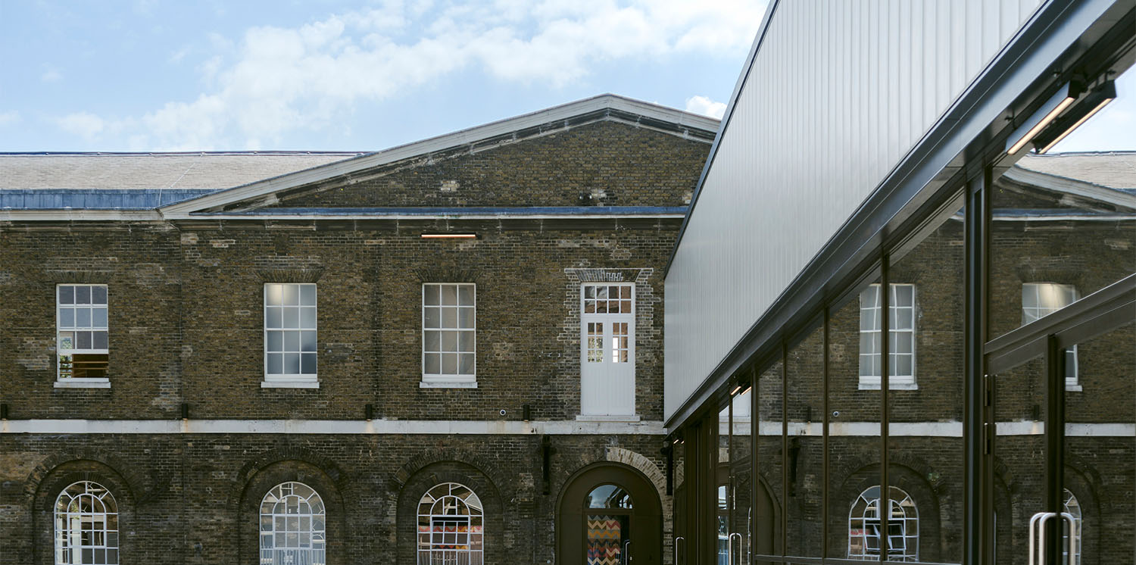
Photo courtesy of Buro Happold, from https://www.burohappold.com/projects/woolwich-works/
Woolwich Works is a multi-disciplinary cultural hub located on the historic Royal Arsenal in Woolwich, offering a wide range of artistic programming and community venue hire rates for local groups and organisations.
01) Getting there.
Woolwich Works is well connected via public transport. Woolwich Station on the Elizabeth Line provides step-free access, and the DLR also serves the area with step-free entry. Multiple buses stop near The Arsenal, including routes 129, 177, 180, 472, and 486. Pavements in the immediate area are mostly level. For those arriving by car, Blue Badge parking is available nearby, though spaces may be limited.
02) The Physical space
The venue is fully accessible, with level access throughout the building and lifts to all floors. It features two accessible toilets and a Changing Places facility. Entrances, doorways, and corridors are wide enough for wheelchair and powerchair users. Hearing loops are available in performance and meeting spaces, and BSL support can be arranged. Staff can facilitate sensory-friendly visits for visitors who benefit from quieter or low-stimulation environments. Accessible seating and viewing areas are provided in performance spaces.

Woolwich front room- 105 Powis St, London SE18 6JB. 020 4524 2685. woolwichfrontroom@gcda.org.uk

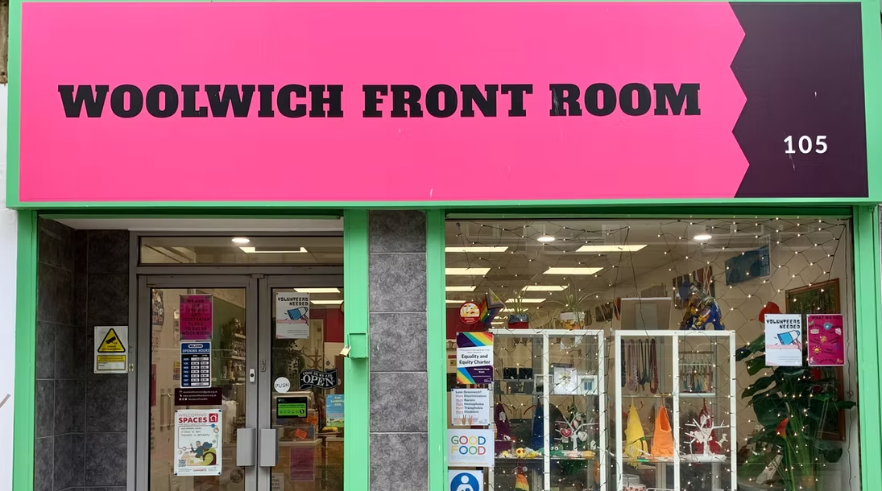
Photo courtesy of Woolwich Front Room, woolwichfrontroom.org.uk

Woolwich Front room is a community space and cafe with multiple rooms to hire.

01) Getting there.

Woolwich Arsenal station, which has step-free access via National Rail and the DLR and is about a 3–5 minute level walk via General Gordon Square and Wellington Street to Powis Street; Woolwich Elizabeth line station is also step-free and around a 5-minute walk away. Numerous London bus routes stop nearby at Woolwich Arsenal or General Gordon Square, including 51, 53, 54, 96, 99, 122, 161, 177, 178, 180, 244, 291, 380, 386, 422, 469 and 472. A taxi rank is available at Woolwich Arsenal station for closer drop-off if needed.

02) The Physical Space.

A ground-floor community space and café with step-free access from the street. An accessible toilet on site but no Changing Places Toilet, the nearest is at Woolwich Works, a 10 minute walk. The main public areas, including The Lounge and The Workshop, are fully accessible and commonly used for meetings, activities, and events, while upstairs rooms such as The Study and Attic are not wheelchair accessible as they can only be reached by stairs and there is no lift.

Greenwich GMV Community Centre- Block 203, 2 Oswald Gardens, London SE10 0SH. 020 8075 5242. Info@gmvcommunitycentre.org.uk

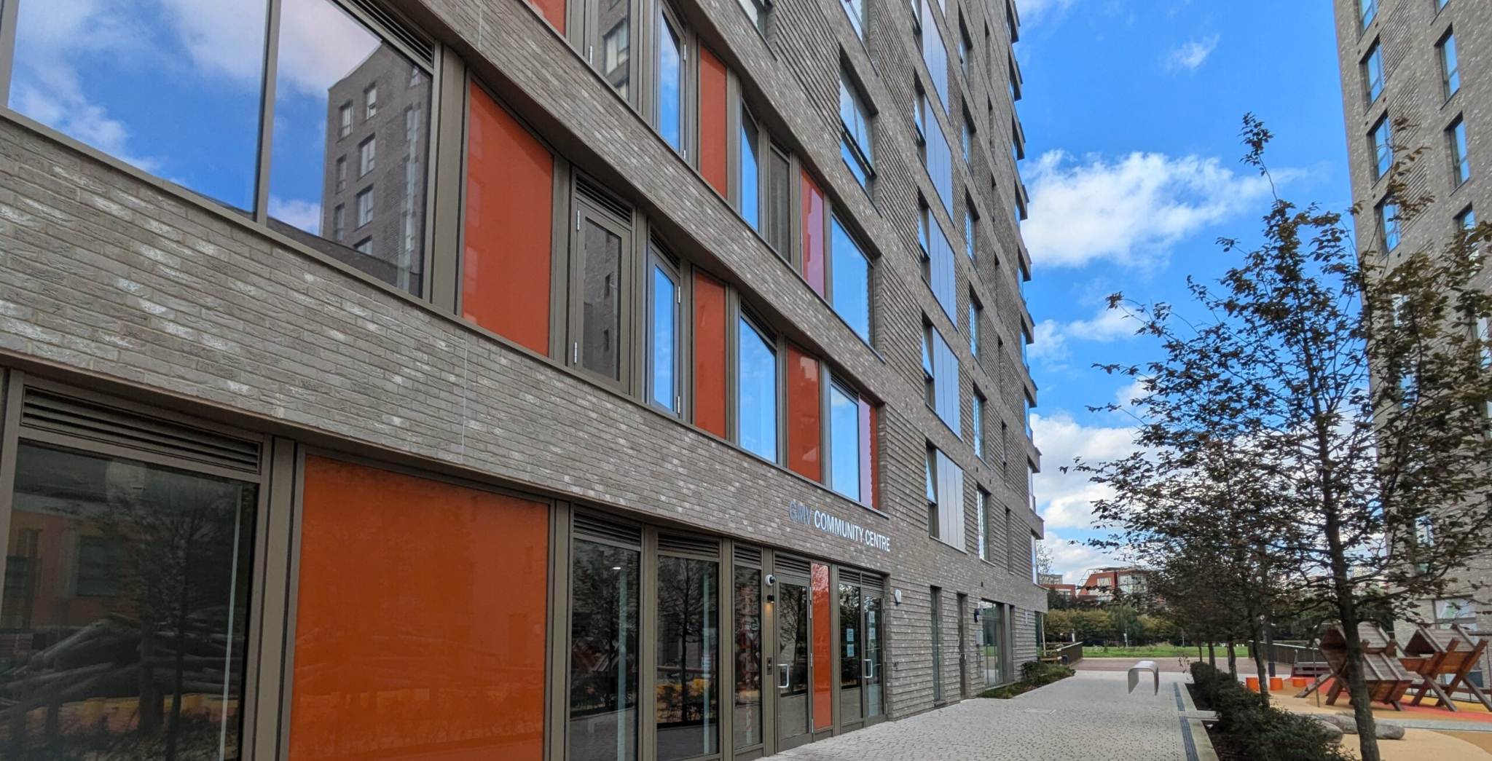
Photo courtesy of GMV Community Centre -https://gmvcommunitycentre.org.uk/contact/

​This centre is managed by London Development Trust, and offers four versatile spaces suitable for a variety of community activities.

01) Getting there.
The nearest Tube is North Greenwich on the Jubilee Line. The centre is also accessible by cable car, bus, or river boat. Transport links can get busy, particularly during events at the nearby O2 Arena. Blue Badge parking is available next to the O2 or at the large car park serving IKEA, B&Q, Burger King, and Nando’s, with free parking for up to 5 hours just across the road. The nearest bus stop is Millennium Village South, two stops from North Greenwich station, served by most buses from the station. The centre sits at the corner of Oswald Street and Rennie Street, with a children’s playground outside. Next to a concierge area. There is no on-site parking, and short-stay parking on Rennie Street requires a permit via the concierge.

02) The Physical space
The centre has level access, with an entrance and lift next to the Peartree Way concierge. Rooms are well-lit, spacious, and airy, and an accessible kitchen is available for hire. For BSL interpreters, note that some rooms may be slightly echoey. A single lift to the facilities. There is an accessible loo but no Changing Places Toilet, see here for details.

Deptford Lounge- 9 Giffin St, London SE8 4RJ. 020 8314 7299. deptfordloungedm@thealbany.org.uk

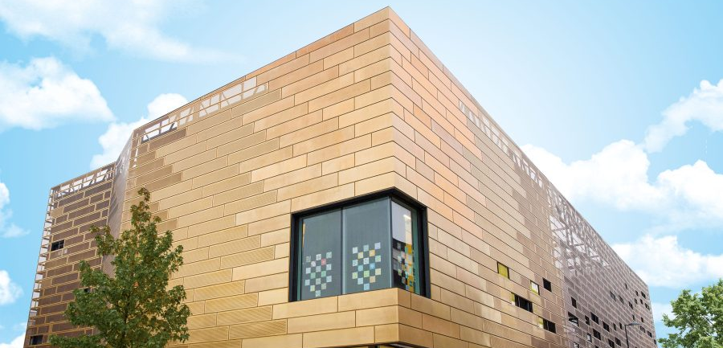
Photo courtesy of Deptford Lounge – https://deptfordlounge.org.uk/about/

Deptford Lounge is a purpose-built community hub offering a wide range of services and facilities for local residents. The venue is managed in partnership with The Albany, South East London’s leading arts centre, and Lewisham Council, which helps develop its community programmes.

01) Getting there.

The closest car park is Frankham Street, with seven accessible bays, 85m from the entrance. Additional parking is available at Deptford Market, Deptford High Street, and Wavelengths. Taxi drop-offs can be made on Giffin Street, directly next to the Lounge. The nearest stations are Deptford (150m, step-free rail) and New Cross (650m, rail and Overground). Multiple bus routes and a nearby DLR link also serve the area.

02) The Physical space

The building has level access, accessible toilets (including a Changing Places facility), and shower facilities. The Library and Café are on the ground floor, along with two meeting rooms. Lifts provide access to the first and second floors, serving the meeting rooms, main hall, studios, music rooms, food science room, terrace room, and ball court. Induction loops are available in all meeting rooms (hearing aids should be set to the ‘T’ position). In an emergency, a continuous alarm sounds and red ceiling lights flash. Refuge areas with an Emergency Voice Communication System and Evacuation Chairs are provided on all floors.

Woolwich Centre Library- 35 Wellington St, London SE18 6HQ. 020 3872 0099. greenwich.libraries@gll.org

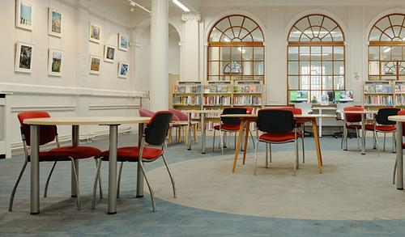
Photo courtesy of Better – Woolwich Centre Library (better.org.uk)
Woolwich Centre Library is part of the Royal Borough of Greenwich administration centre. Staff are helpful, and we have not been charged for using the venue.

01) Getting there.
The nearest stations are Woolwich Arsenal (rail and DLR, step-free), with multiple buses stopping within 150 m. Blue Badge and on-street accessible parking is available nearby, and some visitors use the Tesco supermarket parking adjacent to the library. Step-free access is available via the Love Lane entrance (automatic doors and small thresholds) or the lift from the main Woolwich Centre building.

02) The Physical space
The library has a few small meeting rooms but can support events in collaboration. It has level, step-free access throughout, including reception, reading areas, and computer stations. Accessible computers, large-print and audio book formats, and baby-changing facilities are provided. A Changing Places toilet is available upstairs at the Woolwich Centre, and additional accessible toilets can be accessed with a Radar key. While there is no dedicated hearing loop, staff can assist with accessibility needs, and documents can be supplied in large-print or Braille.

North London

The Greenwood Centre- 37 Greenwood Pl, London NW5 1LB. 020 7974 6051. greenwoodplace@camden.gov.uk

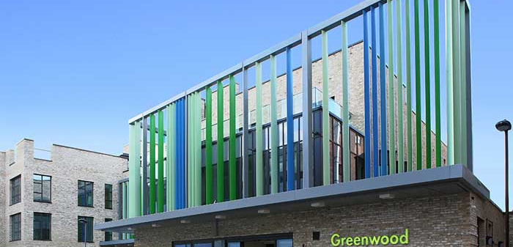
Photo courtesy of Camden Council – CIP Greenwood (cip.camden.gov.uk)

The Greenwood Centre is a purpose‑built, fully accessible community support and independent living hub in Camden. It opened in 2019 and houses Camden’s first Centre for Independent Living, which is run by and for disabled people and local voluntary organisations led by Camden Disability Action.

01) Getting there
Gospel Oak Overground Station is a 15-minute walk with step-free access. There are no nearby accessible Underground stations. Buses include 214 and 88, which stop directly at “Greenwood Centre” with onboard announcements in both directions. Route 134 stops at “Kentish Town Station” toward Archway and at “Fortess Walk” toward Camden Town. Blue Badge parking is available with three public spaces outside the centre on a first-come, first-served basis.

02) Physical Space
The centre offers step-free access throughout, lifts to all floors, several accessible toilets, and hearing loop facilities. Meeting rooms and flexible spaces accommodate small and large events, including a conference room and café, all designed inclusively. The centre also features a large Changing Places toilet, and ground-floor day services for people with learning disabilities and mental health needs.

The Museum of Homelessness- Seven Sisters Road, London, N4 2DE. mail@museumofhomelessness.org

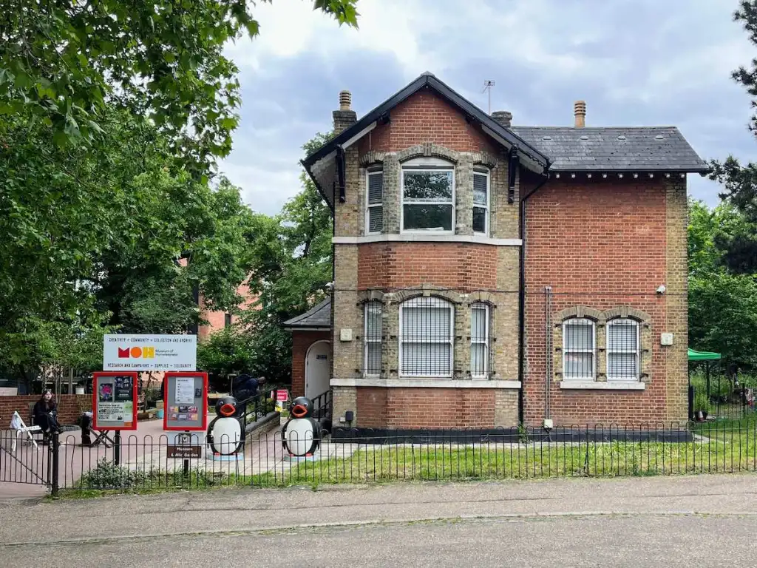
Photo courtesy of Living London History – “A Visit to the Museum of Homelessness” (livinglondonhistory.com)

The Museum of Homelessness is a social history museum created with and by people with lived experience of homelessness. It preserves personal stories, runs exhibitions, community activities, and campaigns to challenge stereotypes and influence policy around homelessness.

01) Getting there

The most accessible route to the Museum of Homelessness at Manor House Lodge is via Finsbury Park Tube station, which has step-free access, or by taking a bus to Manor House Station (Stop D), serviced by routes 253, 254, 259, N253, and N279. From either point, you enter Finsbury Park through the Manor House Gate, and the museum is located just inside, with level access suitable for wheelchairs and powerchairs. If arriving by car, the Endymion Road entrance is recommended for drop-off.

02) Physical Space
The Museum of Homelessness has both indoor and outdoor spaces suitable for wheelchair and powerchair users, level access on the ground floor, and an accessible toilet. The museum also provides a quiet room for visitors who may need a calm space. For sensory and communication accessibility, they offer creative captioning, audio interpretation for key art pieces on request, and BSL support if arranged in advance. All rooms are equipped with HEPA-grade air filters, and the museum takes a trauma-aware approach, with staff and events designed to support visitors’ wellbeing. As it’s located in the corner of Finsbury park, it’s good for warmer weather.

The Wellcome Collection- 183 Euston Rd., London NW1 2BE. 020 7611 2222. venuehire@wellcomecollection.org

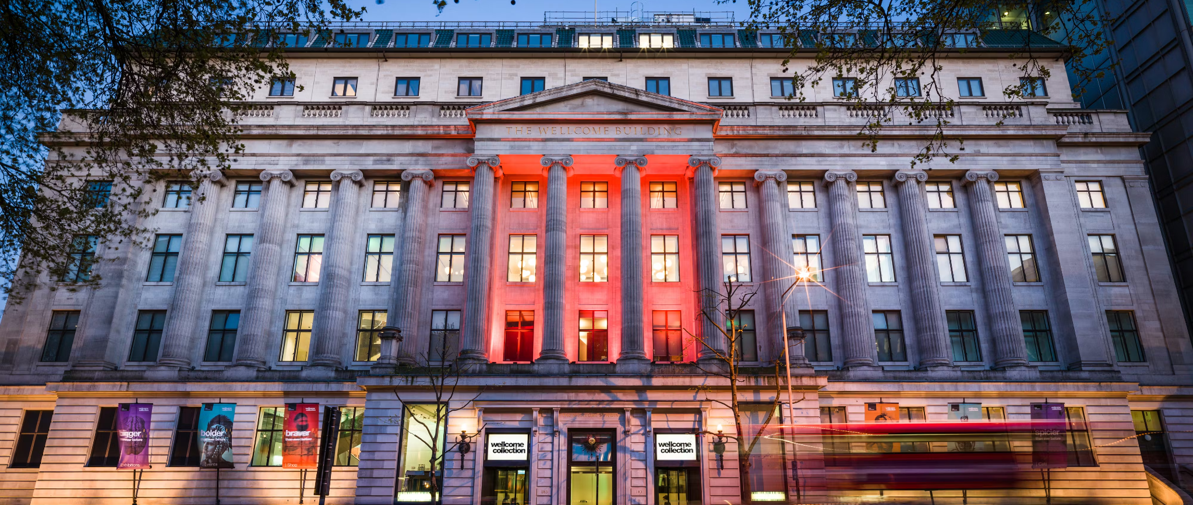
Photo courtesy of Wellcome Collection (wellcomecollection.org)

The Wellcome Collection in London is a free museum and library exploring health, medicine, and the human experience. It combines historical and contemporary exhibitions with rare medical objects, artworks, and manuscripts. The venue also offers a library, café, bookshop, and public events to inspire curiosity about science and society.

01) Getting there.
The nearest fully step-free train and Tube station is St Pancras International, from which there is a short, level walk along Euston Road. Euston Square also offers partial step-free access, while other nearby stations may have limited accessibility. Several bus routes stop close to the entrance, including the 18, 30, 73, 205, and 390. London black cabs can drop visitors directly outside the building, and limited Blue Badge parking is available.

02) The Physical space
The Wellcome Collection has step-free access throughout, with ramps and lifts providing access to all public floors, including galleries, the library, café, and shop. However, to get from street level to level 0, there is a platform lift. There’s a Changing Places toilet on level ‘0’ in addition to accessible toilets on every floor of the building. Seating is placed regularly across gallery spaces to allow visitors to rest. They welcome assistance dogs and offer wheelchairs for visitor use. There are quiet spaces, sensory maps, and clear visual signage to support easier navigation around the building. Information is provided in alternative formats, and exhibitions often include large-print text, subtitles on audiovisual content, and tactile or interactive elements. The Burroughs Room does not have natural light (no windows). It can be expensive to hire.

Kabannas London St Pancras (previously YHA)- 79-81 Euston Rd., London NW1 2QE. 020 7388 9998

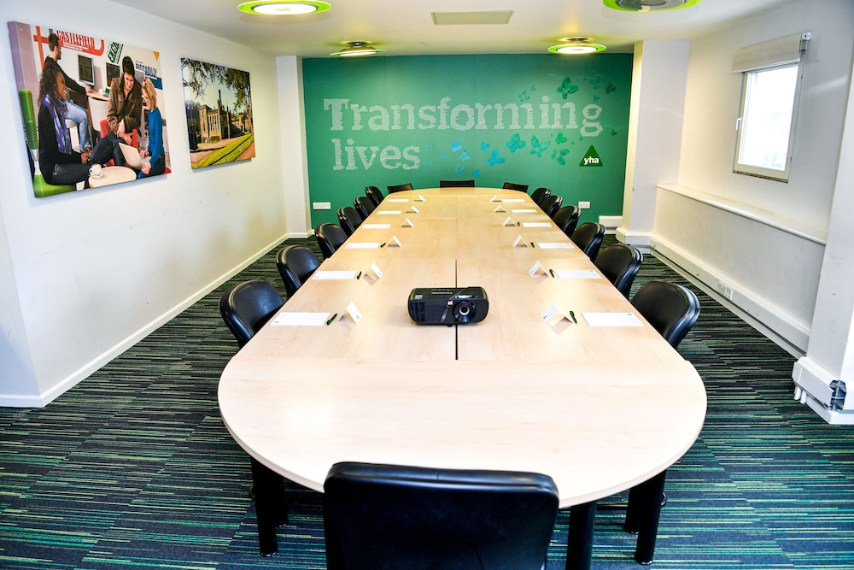
Photo courtesy of EaseMyTrip – Kabannas St Pancras hotel

Kabannas London St Pancras is a hotel located close to Kings Cross and St Pancras Stations. Kabannas has two meeting rooms. It also has hostel facilities. For central London, the hire price is reasonable. They are currently closed for a full refurbishment.

01) Getting there
Kabannas London St Pancras (formerly YHA) is easily reachable via step-free access from King’s Cross St Pancras station. From there, it’s a short, level walk along Euston Road (about 5–7 minutes). Several buses stop nearby, including routes 10, 17, 30, 45, 46, 73, 205, and 214, with ramps available on request. Accessible taxis and black cabs can also drop off directly outside the hostel.

02) The Physical space
The meeting rooms are located upstairs. There are two lifts (not big) and doors are not easy to manage alone. The accessible toilet is next to the stair ramp on the way up. Two meeting rooms, one is bigger than the other – there is natural light. The closest Changing Places toilet is located at Kings Cross.

Friend’s House- 173-177 Euston Rd., London NW1 2BJ. 020 7663 1000. events@quaker.org.uk

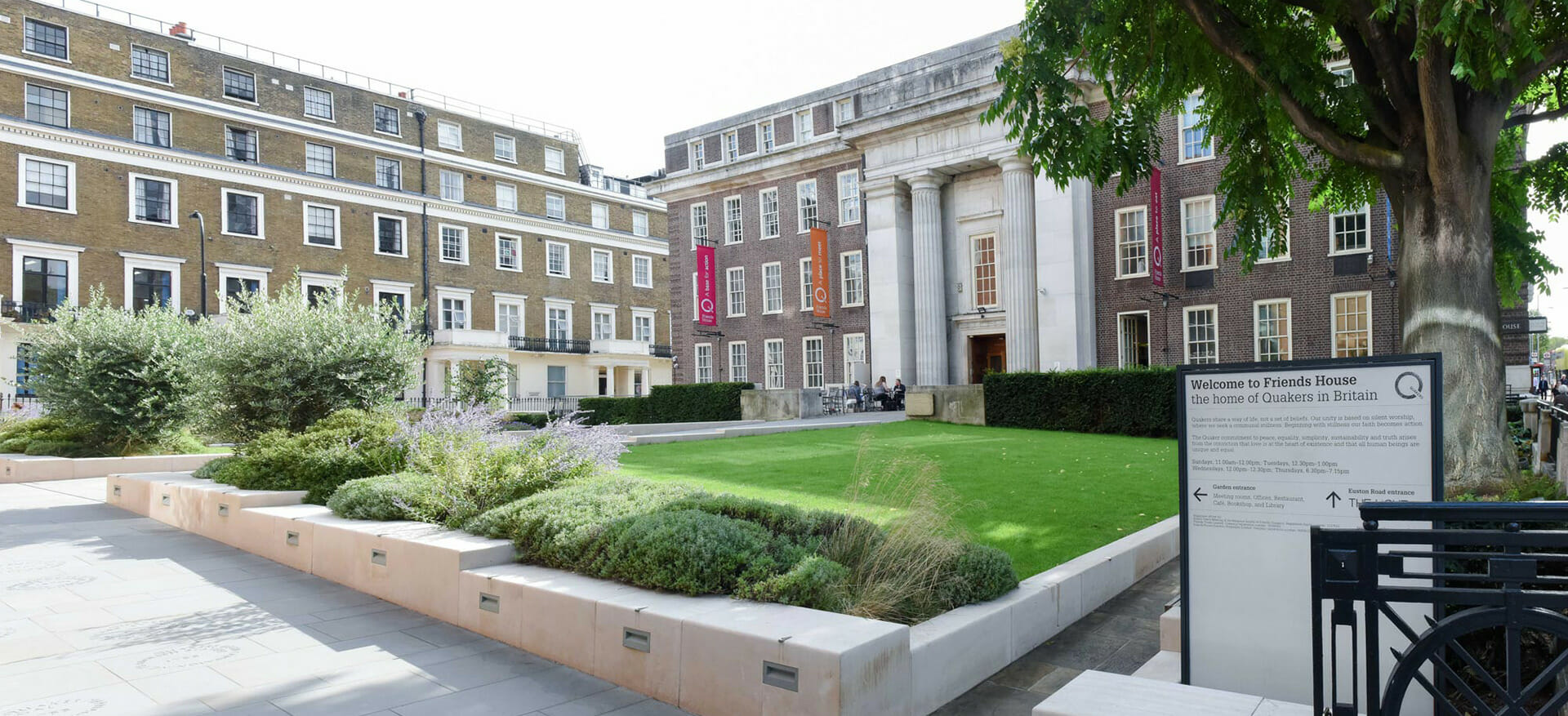
Photo courtesy of Friends Meeting House (friendshouse.co.uk)

Friends House, serves as the central offices of Quakers in Britain, worship, meetings, and community activities. Built in the 1920s, it also functions as a conference and event centre with over 30 meeting rooms and flexible spaces for gatherings ranging from small meetings to large conferences of up to around 1,000 delegates, as well as a café and bookshop.

01) Getting there.
Friends House on Euston Road is directly opposite Euston Station, making it easily reachable via step-free access from the main rail concourse. For Tube travel, use King’s Cross St Pancras or Euston Square and continue via bus (e.g., 18, 30, 73, 205, 390). Blue Badge parking is available nearby on Endsleigh Gardens.

02) The Physical space
The venue features a step-free main entrance from the garden side, with lifts providing access to most upper floors and meeting rooms. Accessible toilets are available on multiple levels, hearing loops are installed in key spaces such as The Light auditorium, and assistance dogs are welcome. Most meeting rooms are step-free once inside and can be arranged flexibly to accommodate wheelchair users, though some lower-ground floor rooms are not fully accessible. The 35 meeting rooms and event spaces can host gatherings from 10 to 1,000 delegates, with complimentary WiFi and a wide range of audio-visual equipment available for hire. There is also an accessible open courtyard, which provides a pleasant outdoor space when the weather is good. Nearest Changing Places toilets are at the Wellcome Collection (2-minute walk) and Euston Station (3-minute walk).

Calthorpe Community Centre- 258-274 Grays Inn Rd, London WC1X 8LH. 020 7837 8019. info@calthorpecommunitygarden.org.uk

Calthorpe Community Centre in King’s Cross is a community hub and garden offering local residents opportunities to grow food, join activities, volunteer, and take part in workshops, supporting wellbeing, social connections, and inclusion for all ages.

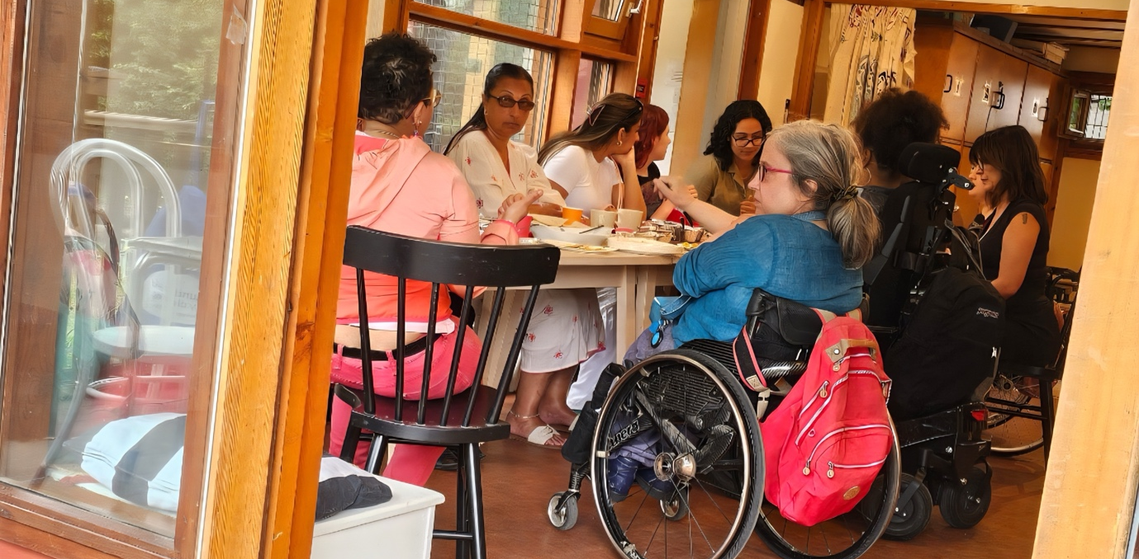
Photo taken by Eleanor Lisney

01) Getting there.
The centre is about a 10–12 minute walk from King’s Cross Station, which has step-free access from the street to many platforms. Wheelchair users can also take buses 46 or 17 from King’s Cross, which stop nearby. Blue Badge parking is limited in the area, so public transport is recommended. The path to the centre is step-free but not entirely smooth, with wheelchair access through the garden entrance. Taxis may not always know the exact location of the entrance, so it can help to provide directions in advance.

02) The Physical space
The centre has several rooms available from £35/hr, with discounts for charities, universities, and not-for-profit organisations. The entire site can also be hired for larger events. There is a cabin available for summer use, though activities from other groups on-site may sometimes be noisy or disruptive. The garden and centre aim to be welcoming and inclusive, with wheelchair access throughout. Meeting rooms are accessed via the garden along a step-free path, though the paving is not completely smooth. There is an accessible toilet on-site, but no Changing Places facility; the nearest are at King’s Cross Station or Great Ormond Street Hospital (8-minute walk).

St Luke’s Community Centre- 90 Central St, London EC1V 8AJ. 020 7549 8181. info@slpt.org.uk

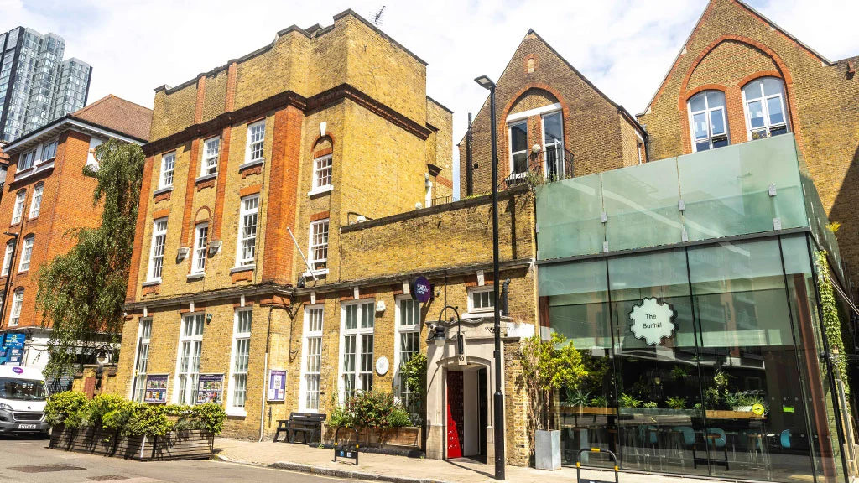
Photo courtesy of SLPT (slpt.org.uk)

St Luke’s Community Centre is a local community hub in Islington. It offers large and small rooms suitable for a variety of events. The centre also features an online hub with free WiFi and resources for all ages. Their fully equipped, accessible Cookery School can be hired, with all income supporting classes that teach the local community healthy, budget-friendly cooking and how to reduce food waste.

01) Getting there.
The nearest Tube is Old Street Station, which does not have full step-free access. Buses stopping nearby include routes 21, 43, 55, 215, and 243, all of which are low-floor and wheelchair accessible. For drivers, blue badge parking may be available on nearby streets, but public transport is generally easier. Once at the centre, level access and lifts are available to the main spaces and rooms.

02) The Physical Space.
The centre has a step-free entrance, automatic doors, level access to main areas, and accessible toilets (though turning space is somewhat limited). The reception has a lowered counter, and a hearing loop is available. Lifts provide access to the main spaces, but there is no on-site Blue Badge parking or Changing Places facility. Outdoor areas include an Edible Yard and a sunny terrace, while the Garden Room offers a private street entrance and a secluded terrace garden. See their rooms for hire here.

East London

Graeae Theatre Company- Bradbury Studios, 138 Kingsland Rd, London E2 8DY. 020 7613 6900. info@graeae.org

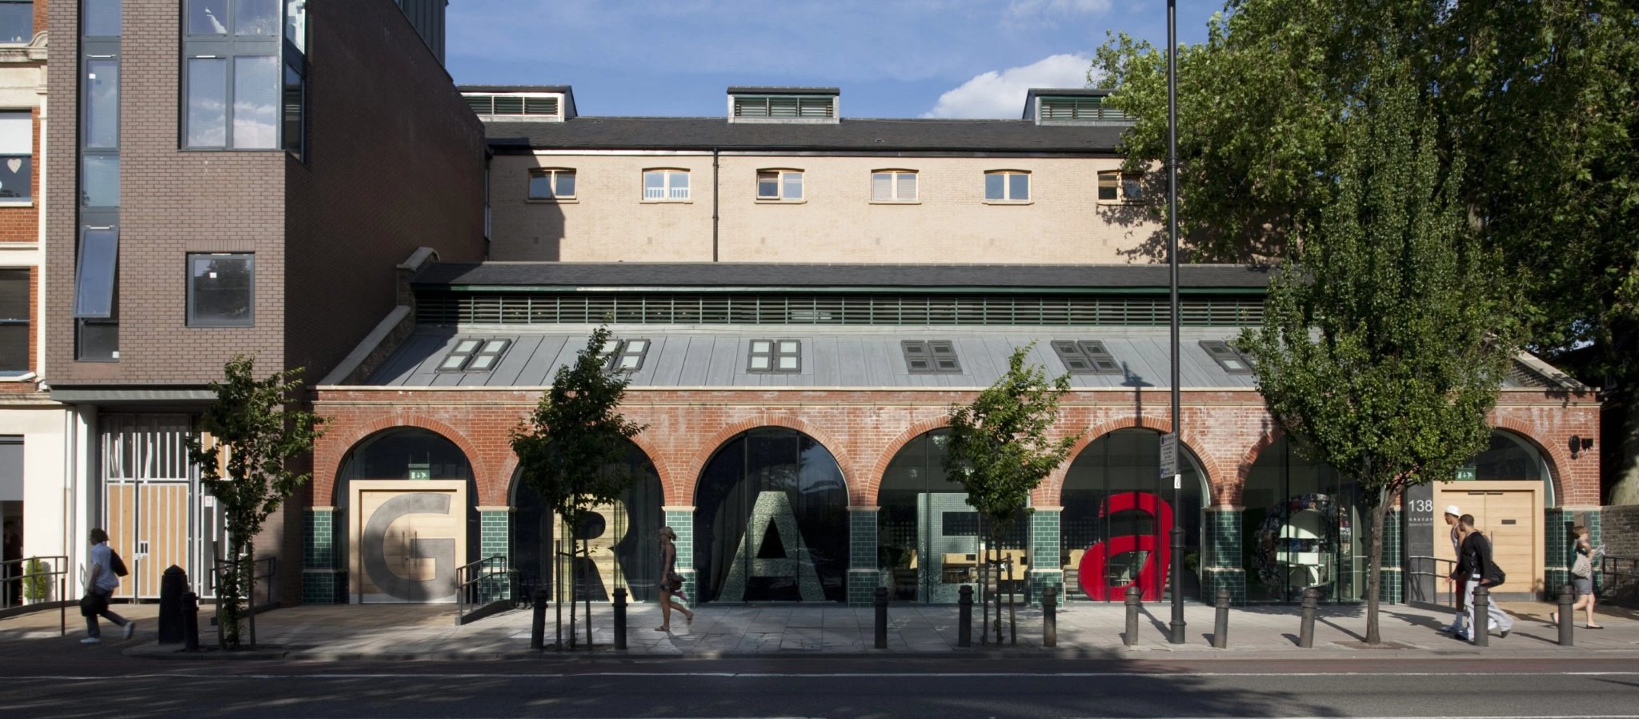
Photo courtesy of Graeae – Who We Are (graeae.org)

Graeae Theatre Company produces accessible theatre, reaching audiences who may have limited access to the arts, while training disabled artists.

01) Getting there

The closest station is Hoxton Overground (step-free), while Old Street Tube is nearby but not step-free. Buses stopping nearby include 149, 242, and 243.

02) Physical Space
The building offers fully accessible rehearsal studios, meeting rooms, and breakout spaces with height-adjustable lighting rigs. Facilities include two changing places toilets. An induction loop system, BSL interpretation, gender-neutral toilets, seating areas, and drinking water are available, with staff trained in BSL Level 1+. Blue Badge parking may be available on nearby streets. The theatre also provides hearing loops and sensory-friendly adjustments on request.

London Museum Studios- First Floor, Studio Smithfield, 1 East Poultry Avenue, EC1A 9PT. londonmuseumstudios@londonmuseum.org.uk

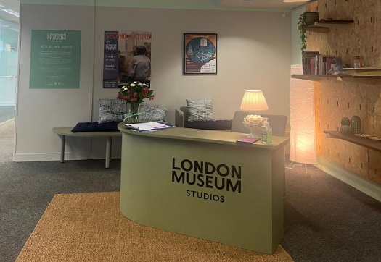
Photo courtesy of London Museum studios – Visual-Story-London-Museum-Studios.pdf)

London Museum Studios has two bookable rooms free for community partners in the City of London and Islington. Rooms can support meetings, film screenings, workshops and small-scale indoor fitness classes.

01) Getting there
The nearest station is Farringdon (served by Circle, Hammersmith & City, Metropolitan, Thameslink and Elizabeth line) which is step free and about a 4-minute walk to the venue, and several London buses (40, 63 and 341) stop close by for a step-free journey right to the area. Car parking can be found at Smithfield Car Park – 3-minute walk.

02) Physical Space
London Museum Studios is a fully wheelchair accessible venue, found on the First Floor of Studio Smithfield. There are two lifts available and accessible toilets. A quiet space is available in the studios. There’s no Changing Places Toilet, the closest is at the Barbican centre, which is a 10 minute walk away. You can also view their visual story to get to know the Studios better before arriving.

London Museum of Docklands- No 1, West India Quay, Hertsmere Rd, London E14 4AL. 020 7001 9844. venuehire@londonmuseum.org.uk

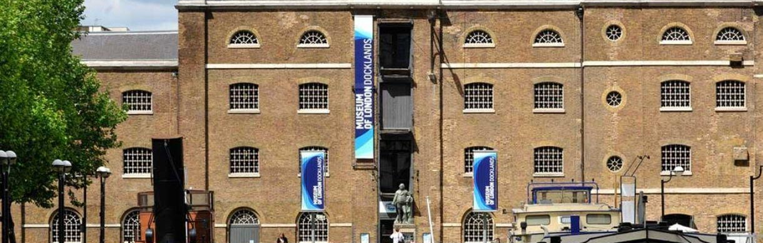
Photo courtesy of Visit Greenwich – Museum of London Docklands (visitgreenwich.org.uk)

London Museum Docklands is a museum that explores the history of the River Thames, the growth of the Port of London and the docks' historical link to the Atlantic slave trade. There are meeting rooms available to book.

01) Getting there

Step-free options are by Docklands Light Railway (DLR) and nearby buses: West India Quay DLR (about a 3-minute walk with step-free access) and Canary Wharf station (DLR, Jubilee and Elizabeth line, around a 7-minute step-free walk) are both good step-free choices. For buses, several London bus routes stop a short walk away- including 135, 277, D3, D7, D8, N277 and N550 at West India Avenue (around 300 m) and 15, 115, D6, N15 and N551 at Upper North Street (about 700 m). You can also use the accessible Uber Boat River Bus to Canary Wharf Pier and walk about 8 minutes along level pavements. From all these stops and stations there are clear pedestrian routes to the museum’s main entrance on the quayside, and if cobbled surfaces are difficult, the staff can welcome people via a ramped rear entrance on Hertsmere Road with advance notice.

02) Physical Space
The building has lifts on every floor so you can reach all gallery levels without stairs, assistance dogs are welcome everywhere, and there are accessible toilets on the ground and third floors with a Changing Places facility. The museum offers visual story guides and sensory maps, and other sensory aspects of the exhibits, and seating and folding seats are available throughout the galleries. If cobbled pavements around the main quayside entrance pose difficulty, the staff can welcome you via the staff entrance on Hertsmere Road with a ramp, just press the buzzer or arrange ahead with the Box Office. Wheelchairs and mobility scooters can be borrowed by advance request, and staff are available to assist. The museum also runs quiet sessions and sensory-friendly events.

Sadlers Wells East- 101 Carpenters Rd, Stratford Cross, London E20 2AR. 020 7863 8198. events@sadlerswells.com

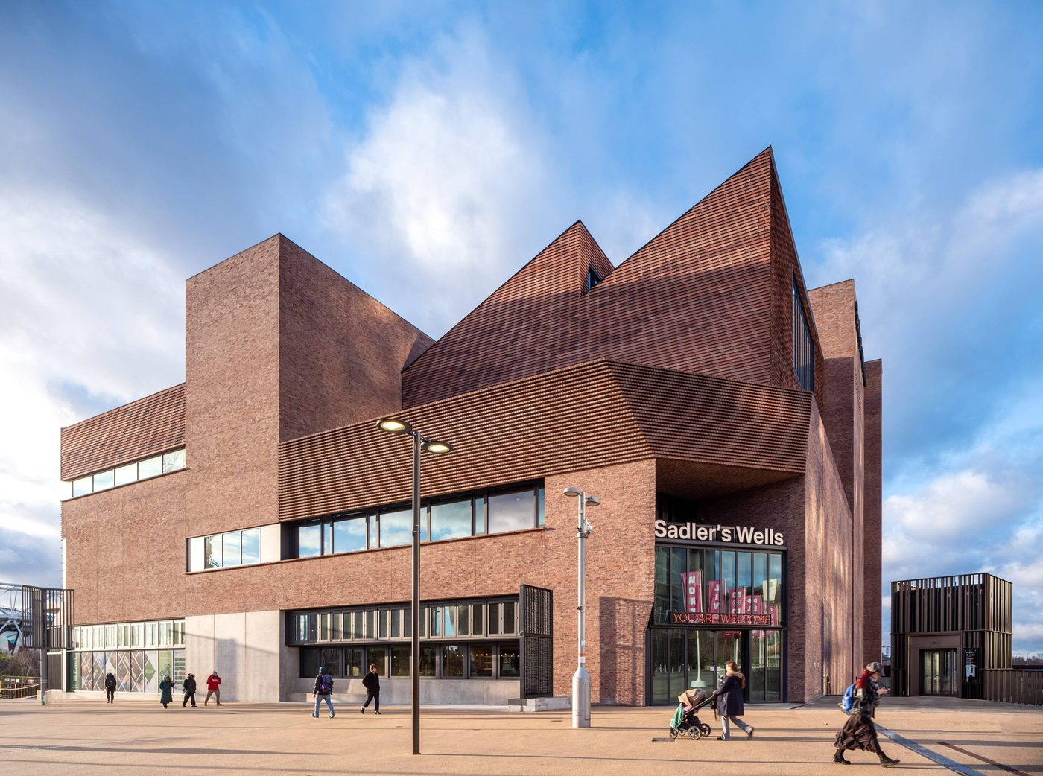
Photo courtesy of Architecture Today – Sadler’s Wells East (Peter Cook)

Sadlers Wells East is a newly built space with accessibility in mind. As well as a theatre space, it also has hireable meeting rooms.

01) Getting there
Step-free access is available from Stratford Station (Central, Jubilee, Elizabeth Lines, DLR, Overground & National Rail) and Stratford International (650 m walk), with level, paved paths through Queen Elizabeth Olympic Park. Several bus routes serve the venue, including 108, 339, 97, and 388, with stops near the London Aquatics Centre or Westfield Avenue. From these stops, it’s a short, step-free walk to the theatre entrance. The surrounding paths are fully paved, making it straightforward to reach the venue from multiple transport options.

02) Physical Space
Step-free access throughout the building, lifts to all public areas, wheelchair-accessible seating in the auditorium, and accessible toilets on site, including a Changing Places toilet. In addition to performance spaces, there's hireable meeting rooms and studios suitable for workshops, presentations, and conferences, which all have hearing-loop systems.

The Barbican- Silk St, Barbican, London EC2Y 8DS. 020 7870 2500. business.events@barbican.org.uk.

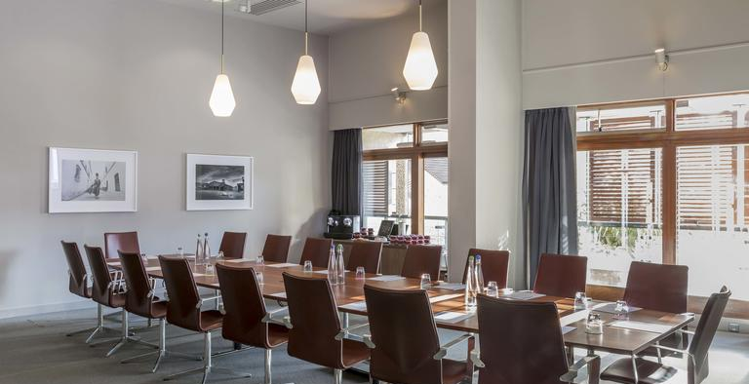
Photo courtesy of Barbican Centre – Frobisher Boardroom (barbican.org.uk)

As well as being a cultural space, The Barbican has meeting rooms available to hire.

01) Getting there
The 153 bus stops closest to the main Silk Street entrance, with additional services like the 4 and 56 stopping near Barbican tube station. The nearest step‑free stations for tube/train are Moorgate and Farringdon, both offering lifts from street to platform and then an easy paved walk to the centre; Liverpool Street also has step‑free access with a slightly longer walk. On arrival, the Barbican building itself has step‑free access from Silk Street and internal lifts to all public areas. The Centre’s own car parks off Silk Street and Beech Street include designated Blue Badge bays in Car Park 3 and Car Park 5, providing level access into the venue and lifts to key floors.

02) Physical Space
Accessible meeting room hire and other events, offering step‑free access from its main Silk Street entrance with lifts serving all public levels and ramps throughout the complex, accessible toilets on multiple floors. In addition to a wide range of conference rooms and meeting spaces available for hire with level access, the Centre also includes a Changing Places facility located in the Beech Street cinema complex. Assistance dogs are welcome, and the Barbican runs an access scheme to support booking needs.

East and South East Asian Community Centre- 12-14 Englefield Road, N1 4LS. +44 (0)20 8986 6171. info@seeac.org.uk

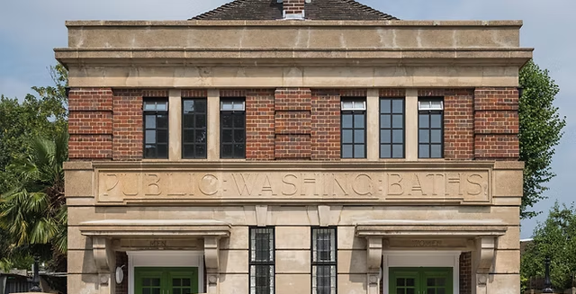
Photo courtesy of Hackney Chinese (hackneychinese.org.uk)

The East and South East Asian Community Centre is a community hub supporting people of East and Southeast Asian heritage in the UK, offering services like welfare advice, mental health support, advocacy, and social activities to promote inclusion, wellbeing, and community connections.

01) Getting there
The closest Overground station is Dalston Junction (8-minute walk), which has full step-free access and a Changing Places toilet. Hoxton Overground is also nearby and step-free. Multiple buses stop along Kingsland High Street, including 30, 38, 56, 277/N277, 149, 243, 242/N242, 67, 76, and 488. Pavements along both the station route and the high street are newly built with low kerbs. There is no on-site parking, but Blue Badge holders can use shared pay-and-display bays on Haggerston Road or park on single/double yellow lines for up to three hours with a badge.

02) Physical Space
The main entrance has a step, but a portable ramp is available, and there is wheelchair access via a side entrance, though turning can be tight for power wheelchair users. They also have a ramp they can use for the front entrance. Inside, the venue is step-free throughout, with a square open-plan café at the front and long, wide corridors leading to modern, airy halls at the back. The accessible toilet is step-free, with grab rails and a changing bench, but there is no on-site Changing Places toilet - the closest is at Dalston Junction (8-minute walk).

Haggerston Community Centre- 8 Lovelace St, London E8 4FF. 020 8356 7845. Haggerstoncc@hackney.gov.uk

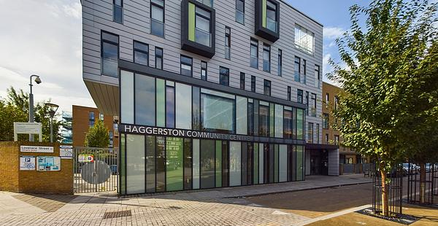
Photo courtesy of Hackney Council – Haggerston Community Centre

Haggerston Community Centre is a council-run community hub in Hackney offering versatile halls and meeting rooms for local events, classes, workshops, and private functions, supporting community activities and engagement.

01) Getting there
The centre is a 4-minute walk from Haggerston Overground Station, which is step-free (Category B1) with lift access, accessible toilets, and a Changing Places facility. Hoxton Overground is another nearby step-free option. There is no on-site parking, but Blue Badge holders can use shared pay-and-display bays on Haggerston Road or park on single/double yellow lines for up to three hours. Nearby bus stops serve routes 149, 242, N242, 243, 236, 67, 76, 277, and 488. Pavements surrounding the centre are even, newly built, and have low kerbs, making routes easier for wheelchair users.

02) Physical Space
The venue is newly redeveloped, modern, and spacious, with wheelchair access to ground-floor spaces and accessible toilets. Amenities include Wi-Fi, a kitchen, and open hall spaces, making it suitable for a wide range of activities and events. However Dalston Junction is the closest Changing Places toilet, a 10 minute walk.

City Hall- Kamal Chunchie Way, London E16 1ZE. 020 7983 4000. visits@london.gov.uk

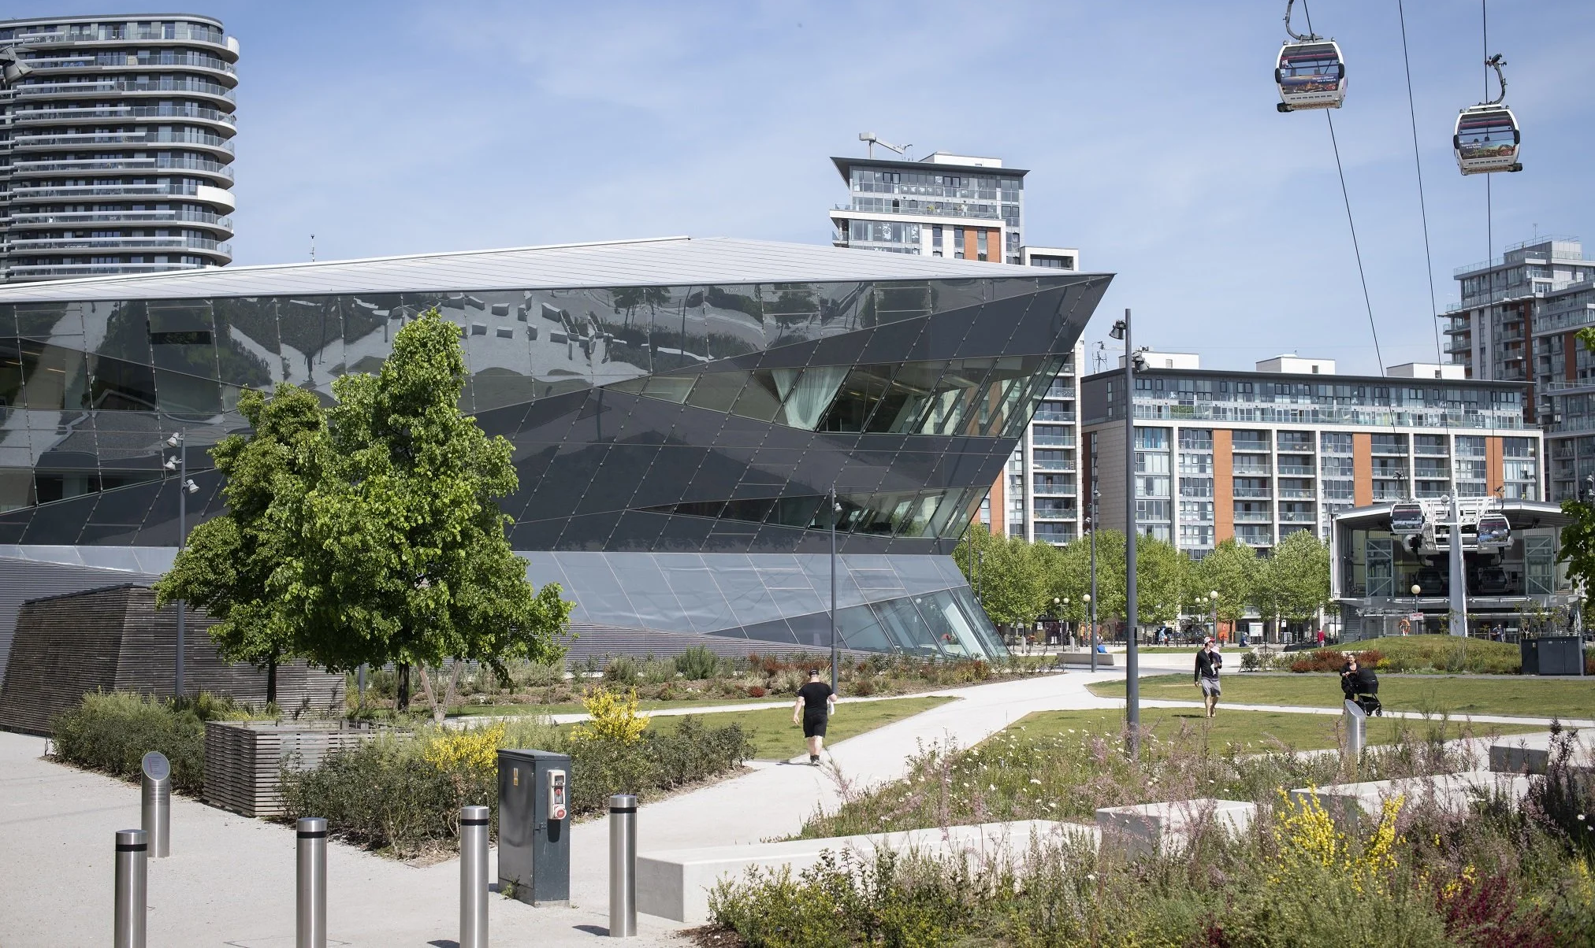
Photo courtesy of Open City – “Discover London’s New City Hall” (open-city.org.uk)

The headquarters of the Greater London Authority (GLA), located in the Royal Docks area of Newham.

01) Getting there

The nearest step-free stations are Royal Victoria (DLR), Custom House (DLR and Elizabeth Line), West Silvertown (DLR) and Canning Town (Jubilee line). City Hall is served by bus routes 474, 147, 241, 325 and 678. You can also travel by boat to North Greenwich Pier or via the IFS Cloud Cable Car to Royal Docks. Covered bike racks are available behind City Hall on Kamal Chunchie Way. There are two parking bays reserved for Blue Badge holders, and it’s recommended to contact them in advance to reserve one.

02) Physical Space
City Hall has step-free entrances, lifts, and accessible toilets throughout. They include a Changing Places toilet. The building provides facilities such as hearing loops in meeting and event rooms and can arrange BSL support for visitors. Sensory-friendly access can also be coordinated in advance for groups requiring a quieter environment. There is a security check when entering the building, which can take time.

The Sundial Centre- 11 Shipton St, London E2 7RU. 020 3828 3928. bookings@sundialcentre.org

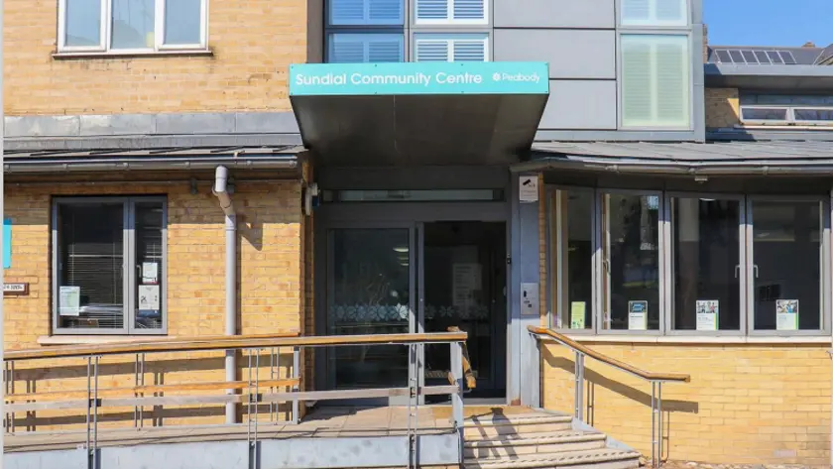
Photo courtesy of Peabody – Sundial Centre (peabody.org.uk)

Sundial Centre is a community and day‑care centre in Bethnal Green, East London (Tower Hamlets). It’s a local public space run in partnership with Peabody and other community services that provides social, recreational and support services for people in the area.

01) Getting there

Hoxton Station (Windrush Line) is a step-free station just a 5-minute walk away with a Changing Places toilet. The area is served by bus routes 26, 55, 149 and 510. There is no on-site parking.

02) Physical Space
Available for weekend hire. The centre offers a fully equipped assisted bathroom and wet room with easy access, two wheelchair-adapted minibuses for transport, hoists and lifting aids, a built-in entrance ramp, a lift to the first floor, and a hearing loop.

West London

Action on Disability Centre for Independent Living- Ground Floor Office, Mo Mowlam House Clem Attlee Court, London SW6 7BF. 020 7385 2098. info@aod.org.uk.

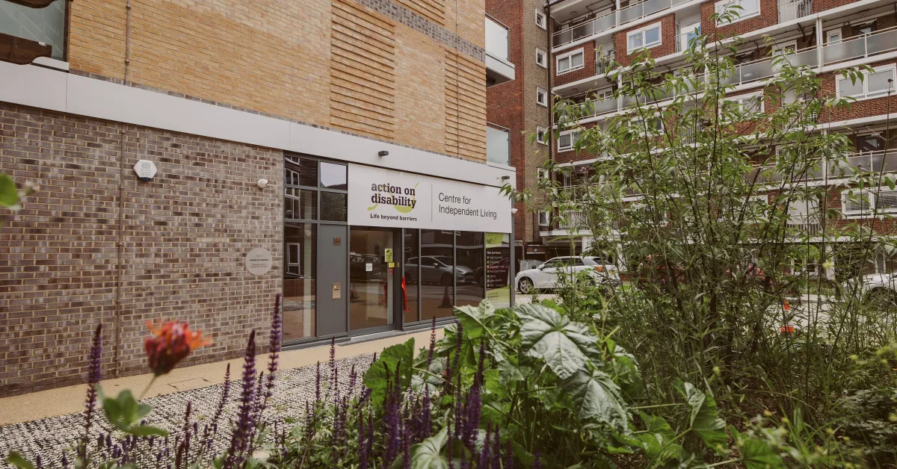
Photo courtesy of Greater London Authority – Action Disability Centre / Independent Living West London Disability Hub (london.gov.uk

The Action on Disability Centre for Independent Living in Fulham is a disability-led hub supporting disabled people to live independently. It offers advice, advocacy, training, peer groups, and community activities. The centre is run by disabled people, for disabled people, to promote inclusion and independence.

01) Getting there

The centre is located at Mo Mowlam House, Clem Attlee Court, London SW6 7BF. Nearest Tube stations include Fulham Broadway which has step free access. The closest bus stop is on Mulgrave Road, which hosts the 74, 190, 430, N74, N97. There are disabled parking bays you can book in advance.

02) Physical Space
A dedicated disability‑led community centre in Hammersmith & Fulham. The space was developed with full accessibility in mind, with step‑free access and full wheelchair access, including wide doorways. There is a Changing Places toilet and an accessible community garden, including raised beds. The centre can usually accommodate BSL and interpreter support on request.

Wilditch Estate Community Centre- 48 Culvert Rd, London SW11 5BB. events@enablelc.org
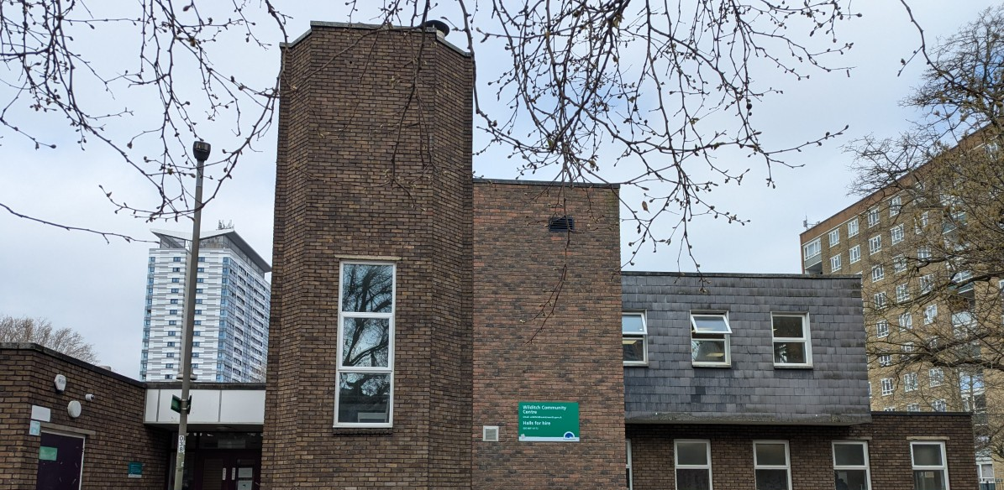
Photo courtesy of AccessAble – Wilditch Community Centre (accessable.co.uk)

Wilditch Estate Community Centre is a local community centre and public hall in Battersea. It’s a multi‑purpose venue run on behalf of Wandsworth Council that offers rooms and a main hall for hire for community activities, classes, meetings, exercise groups, rehearsals, and private events.

01) Getting there
Wilditch Estate Community Centre is well served by public transport, particularly buses, with several routes (including 44, 49, 319, 344 and 345) stopping within a 4–7 minute walk. Clapham Junction is the nearest step-free train station (24-minute walk), while Battersea Power Station (Northern line) provides a step-free Tube option but is a longer walk (28 minutes). There is no on site parking, but on-street parking is available nearby.

02) Physical Space
Wilditch Estate Community Centre has step-free access via a sloped entrance and level access throughout the building, with a lift connecting the ground and first floors. There are adapted toilets on both floors but no Changing Places toilet. Most rooms are accessible to wheelchair users, though some internal walkways are narrow and doors are mainly manual. There is no hearing loop. Assistance dogs are welcome, lighting is generally good, and signage is clear. The nearest Changing Places toilets are at Clapham Junction station (24-minute walk) and Battersea Power Station (28-minute walk).

Open Door Community Centre- Keevil Dr, London SW19 6TF. 020 8871 8174. events@enablelc.org

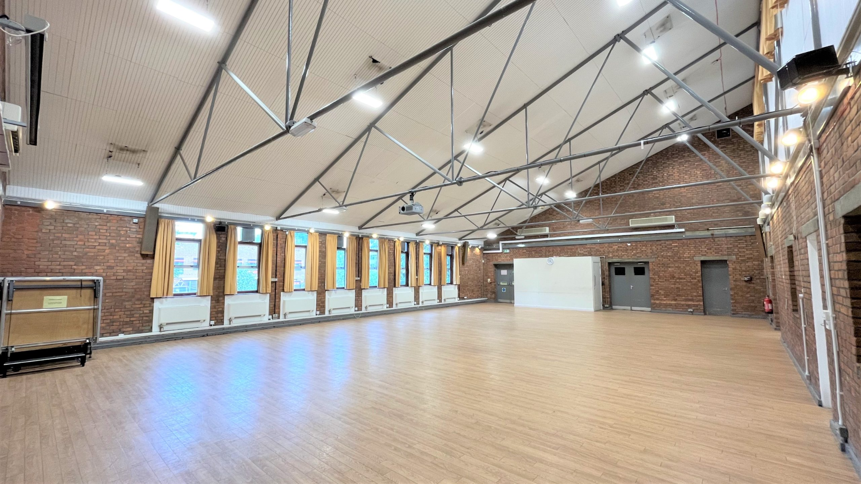
Photo courtesy of Welcome to Wandsworth – VW Open Door Community Centre (welcometowandsworth.com)

Open Door Community Centre is a local community centre in Southfields, Wandsworth, London that provides a multi‑use public hall and rooms for groups to hire.

01) Getting there

The main entrance has step‑free access with a gentle ramp.. There is at least one Blue Badge parking space nearby, and on‑street parking is also available. There are several London bus routes, including 39, 493, and 639. The nearest Tube station is Southfields on the District Line, about a 10–12 minute walk, though step‑free access may be limited at certain entrances. Community transport services, like Wandsworth’s accessible minibuses, are another option.

02) Physical Space
The main hall is spacious and airy. Step‑free access via a sloped entrance, level access through most areas, wheelchair‑accessible rooms and an adapted accessible toilet with right‑hand transfer space. However, some parts (like specific teaching rooms or basement areas) may involve steps, and there is no Changing Places toilet or built‑in hearing assistance system.

Acton Gardens Community Centre- Munster Court Bollo Bridge Rd, London W3 8UU. 020 8075 5240. info@actongardens.community

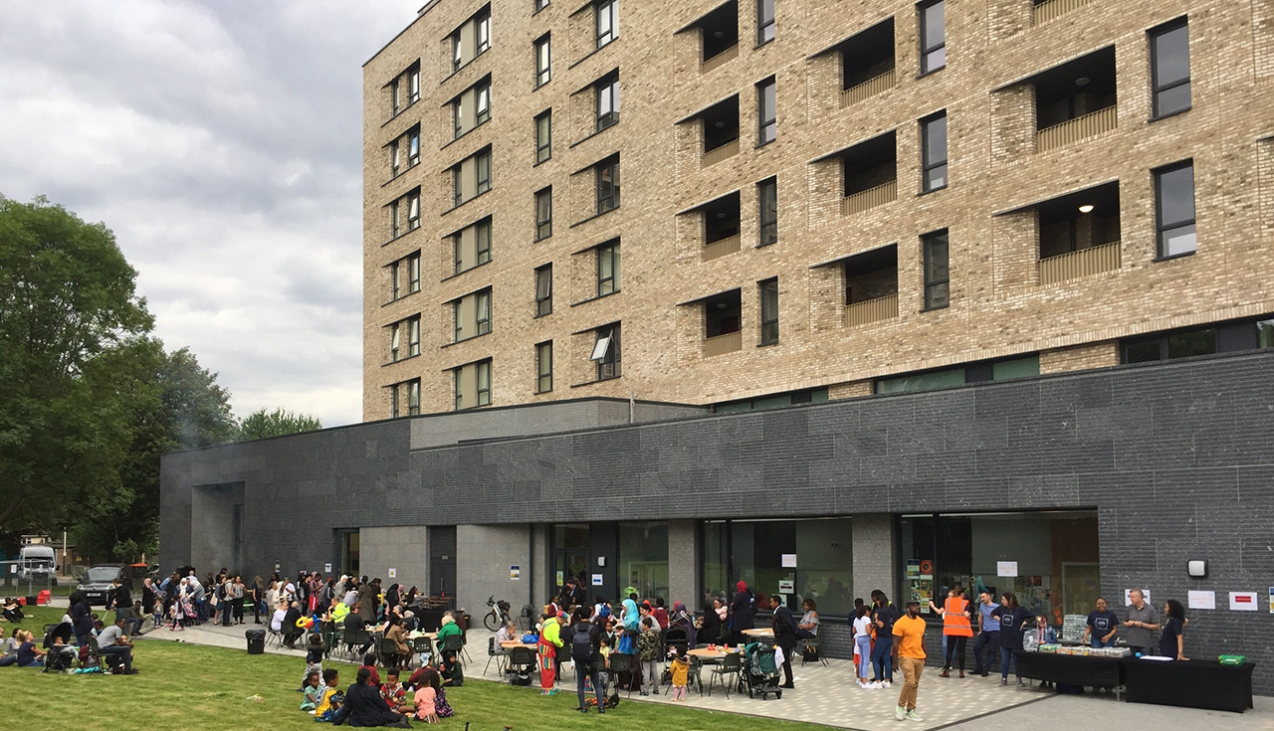
Photo courtesy of LDT Group – Acton Gardens (ldtgroup.org.uk)

Acton Gardens Community Centre is a modern, purpose‑built community hub in South Acton, West London that opened in 2019 as part of the Acton Gardens regeneration project. It provides flexible spaces for community and voluntary groups, classes, meetings, events, and social activities, with multiple halls, meeting rooms, and kitchen facilities available for hire

01) Getting there

The centre is very close to public transport, a 5 minute walk from South Acton Overground station (step-free) and roughly 10 minutes on foot from Acton Town Tube station (step-free). Buses in the area include local routes that serve Acton High Street and surrounding streets (such as the E3, 207, 266 and N11 at nearby stops). Walking routes from stations and bus stops are mostly level.

02) Physical Space
Acton Gardens Community Centre is a modern, purpose‑built community hub in South Acton with step‑free, wheelchair‑accessible entrances and level access throughout the building. It has mobility‑adapted toilets available but no Changing Places facilities. The pavements around the centre are level and newly built, and there is also a large, well kept green, good for summer months.

Sands Arts Community Centre- Peterborough Rd, London SW6 3EZ. 020 3196 9431. welcome@seacc.uk

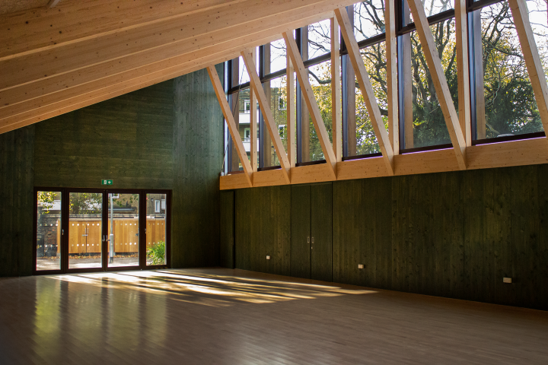
Photo courtesy of SEACC – Hire a Space (seacc.uk)

Sands End Arts & Community Centre is a modern arts and community hub in South Park, Fulham, London designed to bring people together through creative, social and cultural activities. It’s run by a local charitable trust

01) Getting there

Served by routes like the C3, 28, 295, or 306 stopping within a short walk of the centre. The nearest Overground station is Imperial Wharf, about a 20–30 minute walk.. The closest Tube station is Fulham Broadway on the District Line, around 15–20 minutes’ walk. There’s also the Chelsea Harbour River Bus nearby if traveling via the Thames.

02) Physical Space
A single‑storey building with step‑free, level access throughout. There are accessible toilets, an accessible bathroom and baby‑changing facilities, as well as family‑friendly amenities, and nearby accessible parking helps visitors arriving by car. The centre also has a café and flexible spaces that are all on ground level. Its main hall and meeting room are spacious with natural light. The nearest Changing Places toilet is a 33-minute walk away, at Chelsea and Westminster Hospital.

