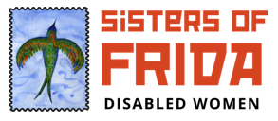

Sisters of Frida’s Guide to Accessible Online communication - a Toolkit

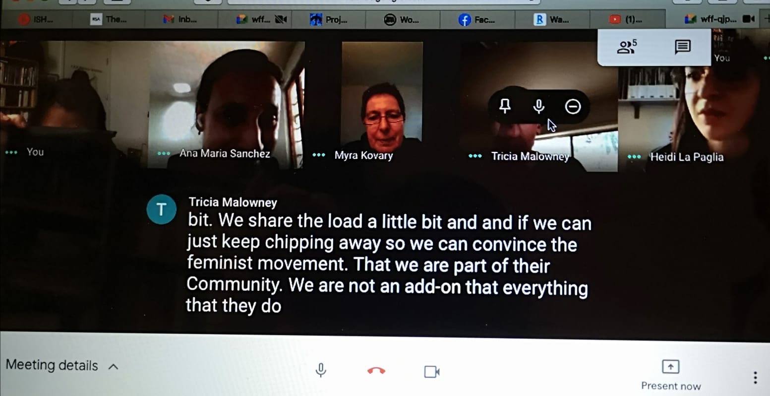

Image 1. Screenshot of an online meeting using Google Meet by International Network of Women with Disabilities with live captioning. Participants were from Mexico, Australia, USA and UK.

Accessibility for Online Communication

Introduction

Disabled people have equal rights to participate fully in all aspects of life. However, we are often obstructed by lack of access, ignorance and poor attitudes. This isn’t simply an inconvenience for disabled people, it can be a matter of life or death.

Lack of access prevents us from having control over our lives and is a stark reminder to disabled people that our rights and our value as human beings can be so easily disregarded.

Accessible and inclusive environments for disabled people create a better experience for everyone. However, accessibility is rarely made standard unless non-disabled people recognise that it benefits them too – for example, dropped kerbs and step-free access that improves access for parents with prams, and the recent dramatic increase in subtitled videos online.
If disabled people are not expected and not thought about from the start, then the resulting design or format will exclude people who may wish to take part and have a right to do so.
Throughout the COVID 19 pandemic, disabled and non-disabled people alike, have increased their online communications, through a range of platforms. Accessible information and inclusive communication is important for everyone but it is especially vital for our independent living.

This document provides information on disabled people’s rights and the action you can take to create accessible and inclusive information and events online. This is not an exhaustive guide but we have tried to add resources from around the world. There are many online platforms for events and meetings and we have not covered all these but reference some throughout.

Table of Contents
Introduction 1
The Social Model of Disability 3
Linguistic model 4
Neurodiversity 4
Disability rights 4
Equality Act 2010 (UK) 4
The Public Sector Bodies (Websites and Mobile Applications) (No. 2) Accessibility Regulations 2018 5
Reasonable adjustments 5
“Nothing about us, without us” 6
Making online communication accessible 6
Considerations: Making online events accessible 7
Communication support 8
Preparatory information 8
During the event 10
Post event 13
Video Conferencing Platforms 13
Suppliers 14
Glossary 14
Deaf and Disabled People Organisations (DDPOs) 15
Resources 16
Acknowledgements 17

The Social Model of Disability
This document embeds the principles of the Social Model of Disability throughout. This model was developed by the disability movement in the UK and challenges medical and charitable approaches to disability (see Glossary for further information).
The Social Model states that it is not a person’s impairment that disables them but barriers that exist in wider society that cause the exclusion of people with impairments. These barriers may be physical, environmental and attitudinal and prevent people with impairments from having equal access to their rights.
A social model approach involves identifying potential barriers to access and inclusion and taking action to address them, before they cause exclusion. The social model is important because it makes clear that collective action is needed to address disability and this is something that everybody is responsible for. It means that we need to address and challenge society’s negative attitudes towards disabled people.
Before the Social Model was developed, disabled people were viewed as passive, helpless objects of charity who needed to be looked after. Non-disabled people would decide what was best for disabled people and we often had no voice or control in decisions made about our lives. Disabled people were expected to be grateful for what they were given, even if it didn’t meet their needs. Many disabled people were deliberately excluded or institutionalised if they couldn’t be ‘fixed’ to fit in better with society. These attitudes still exist. If we are viewed as being less valuable or less deserving than non-disabled people, it becomes acceptable to ignore our rights and exclude us.

The social model does not prevent people from using medical interventions to manage their impairment. It argues for disabled people to have control over their own lives but it also argues that society needs to change to become inclusive instead of expecting disabled people to change or put up with lack of access.
Disabled people who request access are not causing an inconvenience or making trouble, they are asking for their rights to be met in the same way that anyone else would take for granted.
Not everyone who is protected under the disability provisions of the Equality Act will identify as being a disabled person and may prefer to refer to themselves in a different way.

Linguistic model
Deaf people who use British Sign Language as their first language may consider themselves to be part of a linguistic and cultural minority and may not identify as being disabled people.

Neurodiversity
Neurodivergent people (including those with autism, ADHD, dyslexia, dyspraxia) may consider themselves to have a cognitive difference and not an impairment.
Disabled, Deaf and neurodivergent people collectively face similar barriers that prevent full access and inclusion – it is these barriers that the social model seeks to address.

Disability rights

Let us start by reminding of our Rights as Deaf and Disabled people.

Accessibility is not a ‘special need’, it is a right.

Article 9 of the UN Convention on the Rights of Disabled People is about our right to live independently and participate fully in all aspects of life. It states that Governments should take appropriate measures to ensure that disabled people have equal access to; the physical environment, to transportation, to information and communications, including information and communications technologies and systems, and to other facilities and services open or provided to the public, both in urban and in rural areas.

The measures should identify and eliminate obstacles and barriers to accessibility, and apply to:
a) Buildings, roads, transportation and other indoor and outdoor facilities, including schools, housing, medical facilities and workplaces;
b) Information, communications and other services, including electronic services and emergency services.
The UNCRPD is based on the social model of disability. Although the language of the Convention refers to ‘people with disabilities’ it supports individual countries to discuss disability and the Convention in their preferred terminology. The UK disability movement uses the term ‘disabled people’.

Equality Act 2010 (UK)
The Equality Act 2010 replaced the Disability Discrimination Act 1995 (DDA). Disability is one of the protected characteristics in the Equality Act. This means that disabled people must not be discriminated against when using any service provided publicly or privately. It applies whether the service is paid for or not.
For online access, the Equality Act requires service providers to anticipate the needs of potential disabled customers.
The Equality Act is an important tool for us to use. However, it is based on a medical model of disability and not the social model. This means that access to our rights is highly individualised, difficult to enforce and it is very hard to seek justice when our rights are breached.
The Equality Act is anti-discrimination legislation but is not built upon our human rights as outlined in the UNCRDP. Disability activists have been calling for the UNCRDP to be incorporated into UK legislation to provide greater access to our rights.

The Public Sector Bodies (Websites and Mobile Applications) (No. 2) Accessibility Regulations 2018
The accessibility regulations came into force for public sector bodies on 23 September 2018. They say you must make your website or mobile app more accessible by making it ‘perceivable, operable, understandable and robust’. You need to include and update an accessibility statement on your website and provide new and recent documents in accessible formats.
Although these guidelines are for the public sector, we encourage all to follow these as a minimum good practice.

Reasonable adjustments
The accessibility regulations build on existing obligations to disabled people under the Equality Act 2010 (or the Disability Discrimination Act 1995 in Northern Ireland). These say that all UK service providers must consider ‘reasonable adjustments’ for disabled people.
For example, somebody might ask for information in an alternative, accessible format, like large print or an audio recording. There are a number of factors that determine what makes something a ‘reasonable’ adjustment.

Disabled people repeatedly have to justify asking for reasonable adjustments and access. This is a stressful and demoralising process for people to keep going through. Many reasonable adjustments are straightforward to achieve, and organisers should get into the habit of allocating a budget to facilitate access to online services or events.

If disabled people need to ask for adjustments, it means that the environment does not provide good enough access or inclusion. Use this feedback to improve your services. Ensure that the language you use welcomes disabled people who may wish to take part and makes it clear that an effort will be made to provide support that is needed.
Provide opportunities for people to let you know what access requirements they have. Although many disabled people will know what they need to participate equally, not everyone will know what could be available that might benefit them.
Build up your knowledge of common reasonable adjustments and how you can plan for and provide them. There are links to suppliers and resources at the end of this document to help with that.

“Nothing about us, without us”
Disabled people are the experts

If you wish to gain a better understanding of disability rights, access and inclusion then working in coproduction with disabled people is the best way to achieve that. Deaf and Disabled People’s Organisations (DDPOs) are led by and run for disabled people. They are often employers of disabled people and experienced at organising accessible events and services.
Many better-known large disability charities are run by non-disabled people providing services for disabled people and may not have the social model of disability at the core of their work.

Making online communication accessible
Inclusion needs to be built into all communications.

Throughout the pandemic where many disabled people were either socially isolating or shielding, communication became dominated by online meetings such as with Zoom, Google Meet, Teams and the like.

We have consulted Deaf and Disabled about digital issues with using online resources and communication for work, leisure and social contact.

"British Sign Language is a recognised indigenous language of the UK. For deaf people who use BSL as their first language, BSL is vital in providing accessible information and ensuring full access to their rights."
- Dr. Natasha Hirst, Disabled Members’ Rep on the NUJ National Executive Committee

Here are the results from our own observations, research, experience and consultations. We are grateful to Dr. Aimi Hamraie for their reminder that:
“Disabled people have been using online spaces to teach, organize, and disseminate knowledge since the internet was invented. Disabled people are leading survival praxis in apocalyptic times.”

They make the connections between accessibility, accessible design, disability justice and disability culture. Accessibility has to go beyond the bureaucratic “codes” i.e. simply meeting criteria and embracing the participation and leadership of disabled people.

The pandemic has created a rise in people experiencing mental distress and online communication has been vital for providing opportunities for disabled people to participate, reduce isolation and protect their mental health.

In this document, we are providing a ‘minimum’ toolkit – because very often, the minimum is not even understood or followed but we hope you do not consider it as just a tick box exercise. The resources support you to improve your own knowledge beyond the information given in this toolkit.

Considerations: Making online events accessible

Assume that disabled people will want to participate in your events and be aware that there will be a diversity of access and communication requirements.
Preparing for an online session can take a lot longer than physical sessions: here are some considerations for making them more accessible. Disabled people are very diverse and many impairments are not visible. You do not need to know what a person’s impairment is, just what is needed to meet any access requirements.

Some people experience fluctuating conditions such as fatigue or pain that can affect concentration or mean that at short notice someone may be unable to attend or stay for the whole session. This is not a reflection on someone’s interest or commitment.

Communication support
Disabled, Deaf and neurodivergent people have diverse needs, and different communication preferences and learning styles. Ask everyone what communication methods are best and if they have any access requirements. Check whether there are preferred support providers.

If doing training, ask participants if and how they wish to make others aware of their access requirements.

- British Sign Language (BSL) Interpreters translate BSL to English and vice versa. If events will be recorded, check that the BSL interpreter is aware of this and provides consent to be recorded.
- Live Captioners/Speech to Text Reporters (STTRs)/Palantypists provide fast and highly accurate live transcripts which can be accessed through a browser window with adjustable text and colours, or as captions on a Zoom screen. There may be an extra charge to save and share transcripts after the event.
- For long events or meetings, two STTRs/BSL interpreters may need to work together, alternating every 15 minutes or so. Check how often rest breaks are needed.
- They are often in high demand and need booking as far in advance as possible (sometimes weeks). Trying to book a BSL interpreter or STTR/live captioner at short notice will be difficult.
- Individual BSL users may have preferred interpreters since dialects vary but ensure that you book fully qualified interpreters.

- Communication Support Workers (CSWs) or Personal Assistants (PAs) may facilitate participation and/or take notes. If your events have a ticket fee, CSWs and PAs should not be charged for attending.
- Many disabled and neurodivergent people benefit from recording events to listen back to so information can be retained more effectively. This should be facilitated where possible and consent encouraged on the understanding that any recordings are for personal use only and will not be published in any form.
- Auto captions are never a suitable substitute where BSL or live captioning has been requested. It can be a useful tool in some small meetings. Enable saving of transcripts if available (eg on Zoom).

Do not expect attendees’ friends or family members to provide communication support.

Preparatory information

- To ensure inclusion, the culture of an event or meeting is as important as trying to arrange the most appropriate technology. Ensure that promotional materials are accessible and welcome disabled people. Promote events through networks of Deaf and Disabled People’s Organisations.

- Email participants in advance (and phone if necessary) to check in if they are attending, Let them know what is available (e.g. BSL interpretation, live captioning) and check what other online access requirements they might have. Ask for permission if you intend to record the meeting.

- Although this toolkit is mainly for a UK audience, you should take note that British Sign Language would not work for non-British participants.
- If there will be shared slides it is often helpful to send these in advance electronically to people with visual impairments. Give advance notice to presenters of the deadline for slides so they can be sent to participants to read in time. Advance slides and agenda documents are also needed for BSL interpreters and live captioners to know what to prepare for. Slides or shared screen content need to be described or read out, for the benefit of attendees with a visual impairment, dyslexia and those who may be accessing the event via phone or using a small screen.

- Any videos or audio should have captions, and visual content should be described.

- If people with learning difficulties are attending, Easy Read (text with pictures) versions of documents will support inclusion. See the resources for further information. It is good practice to use plain English and avoid jargon.

- Ensure that information makes it clear what to expect. An agenda should make the content, speakers and break times clear and indicate if breakout rooms/group work will be involved. If an attendee needs their communication support/BSL interpreter to remain with them, any breakout rooms must ensure they are in the same room.

  - Include all the links and information needed to join the session.

  - Outline how you are meeting their access requirements if they’ve made a request.

  - Let everyone know if there is any prep or pre-work they should do.

  - Be clear that people may leave for any reason without any embarrassment or judgement and do not need to give a reason.

- Realise that there might be a digital divide. Not everyone has access to a stable internet connection. If there is such a problem, it might be worth enquiring at a local library or community centre if they are willing to facilitate the zoom call.

During the event

- Have a Co-facilitator to help you in case you need support, like letting people in or reading out chat discussions or collating questions.

- Access to and confidence with technology will vary. Have someone there for tech support in case of any hitches or if there are participants who need specific help, this one-to-one support will prevent time lost by not holding up the whole group to wait for resolution. Start at least 15 minutes before the actual event to check for possible technical problems. Tech support can also respond to people who cannot locate the meeting link.

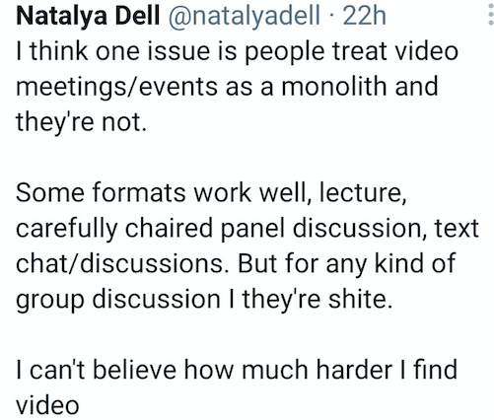

Fig 2 Twitter comment from Natalya Dell @natalyadell. ‘I think one issue is people treat video meetings/events as a monolith and they’re not. Some formats work well, lecture, carefully chaired panel discussion, text/chat/discussions. But for any kind of group discussion I they’re shite. I can’t believe how much harder I find video’.

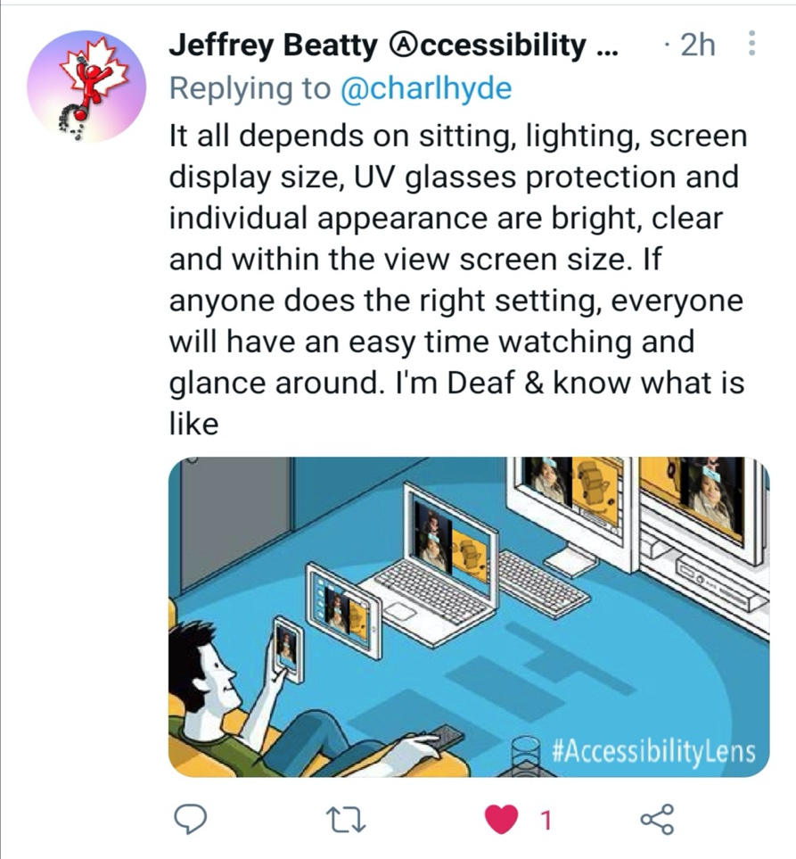
Fig.3. Jeffrey Beatty @macjbby ‘It all depends on sitting, lighting, screen display size, UV glasses protection and individual appearance are bright, clear and within the view screen size. If anyone does the right setting, everyone will have an easy time watching and glance around. I'm Deaf & know what is like’
We do not know the source of this image: description: white man on sofa holding a mobile in one hand and controls with other through a laptop, desktop and big screen (smart tv or monitor)

- British Sign Language (or other native sign language) interpreters will need to be pinned on a Zoom screen. If two are working together, check if they will both need to be pinned or if this will alternate.

- Build in regular comfort breaks. Do not go for longer than 90 minutes without giving people a break.

- Try to schedule shorter recurring sessions if you’re doing training. Give people time to have comfort breaks to help manage fatigue and to provide enough time for people with PAs to provide a break for the PAs also.

- Avoid having too many speakers and give space and time to absorb information, reflect and do Q and As or discussions.

- Summarise the key points of a conversation or comments and questions posed by other members of a group in case this has been missed.

- Provide opportunities for quieter members of a group to contribute. Some people may need time to process information so provide an opportunity to follow up with questions afterwards where needed.

- People who use screen readers told us that they work well with Zoom but the chat function may interfere with this. Some people find it easier to use the chat box than to contribute verbally so set out at the start of a session how these different requirements can be managed. If running a webinar, ask people to comment using the Q&A function and switch off the chat.

- During discussions, some people with screen readers or those dialling in may not be able to use the raise hand feature. Invite contributions from those individuals first and allow time to unmute. However, on consultation screen reader users have mentioned that they have been satisfied with the most current version of Zoom.

- Record the event if possible, for people who could not make the event and for those who may need to refer back to absorb information more effectively. Some people dislike the online visuals and distractions of a group of people. Remember to ask the consent of the group whether a recording is for selected viewing or for the general public or private note keeping. Remember to ask the BSL interpreters as well.

“…(BSL) are great opportunities for Deaf people and Deaf women in particular to get involved and find out more about Sisters of Frida and their work. We have really lacked access to this type of information in British Sign Language. There is much that we share including lack of access, lack of information, lack of opportunities to grow and become informed. I hope there will be more opportunities for Deaf people to discover new information and new experiences.”
- Geraldine, a BSL user

Geraldine, here, stress on how important it is to include Deaf people by having BSL so that they can also engage with online events and meetings.

Post event
After the event, ask for feedback and if there are any comments, questions or clarifications needed. Use any feedback to improve the organisation of the next event.

Video Conferencing Platforms

Zoom is generally found to be more accessible than other options. Auto captions can be enabled within Zoom by logging into the account through the browser and changing the settings: ‘In Meeting (Advanced)’ > allow ‘Closed Captioning’ and ‘Enable live transcription service’. There is an option for transcripts to be saved which may be needed as a reasonable adjustment to support recall. When a meeting starts, the host selects the CC icon at the bottom of the screen to select ‘enable auto transcription.’

Attendees then click on the CC icon to choose running captions in the Zoom box or a side window with the full transcript. Further details:
- https://support.zoom.us/hc/en-us/articles/207279736-Closed-captioning-and-live-transcription
- Zoom keyboard shortcuts: https://support.zoom.us/hc/en-us/articles/205683899-Hot-Keys-and-Keyboard-for-Zoom
Teams and Google Meet have automatic captioning although these cannot be saved as a transcript at the time of writing this guidance.

Teams accessibility information
https://support.microsoft.com/en-us/topic/accessibility-overview-of-microsoft-teams-2d4009e7-1300-4766-87e8-7a217496c3d5

Google Meet accessibility information
https://support.google.com/meet/answer/7313544?hl=en-GB

Suppliers

- Find qualified BSL interpreters on:
  - https://asli.org.uk/
  - https://nubsli.com/
  - http://london-bsl-interpreters.info/ (for London)
  - There is also Signalise, a new coop https://signalise.coop

- You can book live captioners/STTRs here:
  - https://avsttr.org.uk/
  - https://www.ai-media.tv/products/live-content/live-captions-cart/
  - Academic Audio Transcription Ltd hello@academicaudiotranscription.com (disability-led) remotely. http://server.academicaudiotranscription.com/index.php/s/TEnenGsk8ma2snx
  - 121 captions provide live captioning services and live electronic notetaking

- Zoom plans to roll out support for automatic closed captioning (Live transcription) to free accounts from Autumn 2021 as part of its efforts to make the service more accessible, the company has announced. It is now available for pro (paid) accounts.
- Some individuals may require lip speakers, who work in a similar way to BSL interpreters: https://www.lipspeaking.co.uk/
- If materials need translating into BSL, qualified translators can be found via https://www.wcdeaf.org.uk/
- Translation of materials into Easy Read: https://www.changepeople.org/getmedia/923a6399-c13f-418c-bb29-051413f7e3a3/How-to-make-info-accessible-guide-2016-Final
- Taster and accredited BSL courses: local colleges – ensure these are taught by Deaf people and include Deaf culture and history.

Glossary

Social Model of Disability
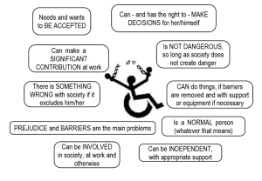
Figure 4. (Image from the TUC) Diagram of Social Model of Disability with stick figure on a circle (symbol of disability/ wheelchair with upstretched arms breaking chains. Tabs surrounding the figure say: (on the left) Needs and wants to be accepted, Can make a SIGNIFICANT CONTRIBUTION at work, There is SOMETHING WRONG with society if it excludes him/her, PREJUDICE AND BARRIERS are the main problems, Can be INVOLVED in society, at work and otherwise. (On the right) Can and has the right to - MAKE DECISIONS for her/himself, is not dangerous as long as society does not create danger, CAN do things, if barriers are removed and with support or equipment if necessary, is a NORMAL person (whatever that means), Can be INDEPENDENT, with appropriate support.

The Social Model of Disability is a civil rights model of disability.
The Social Model was developed by disabled people. It takes the view that society creates barriers that ‘disable’ people from participating fully and on an equal basis with others and that these barriers must be removed. By creating barriers in buildings and structures or by not producing information in different formats such as Braille or Easy Read, people with impairments/health conditions are ‘disabled’. This way of thinking takes the focus away from what is ‘wrong’ with a disabled person (their impairment or condition) and puts the emphasis on what we should all do, in alliance, to identify and remove barriers.

Deaf and Disabled People Organisations (DDPOs)
According to Inclusion London, an organisation is a DDPO if:
- Their Management Committee or Board has at least 75% of representation from Deaf and Disabled people and;
- At least 50% of their paid staff team are Deaf or Disabled people with representation at all levels of the organisation and;
- They provide services for or work on behalf of Deaf and Disabled people.
Here is their directory of DDPOs in London.
Independent Living Alternatives has PAs and support workers for short term need.

Resources

The Council of Europe’s paper written by Professor Anna Lawson: Accessibility of information, technologies and communication for persons with disabilities Contribution to the Council of Europe Strategy on the Rights of Persons with Disabilities
(https://rm.coe.int/final-study-accessibility-of-information/168072b420)

The Critical Design Lab is a good space for exploration into accessible communication albeit academic in tone.

We have not added web accessibility in this toolkit. We suggest Web accessibility in Mind (US centred), we have been guided by Jim Byrne (UK) on web access in this website. He did the access auditing of the Sisters of Frida website.

We would like to thank Nim Ralph for this helpful resource Going virtual: Top tips for trainers and facilitators. Covid-19 means many campaigners and activists will be turning to online meetings to organise. Lead Bootcamp trainer Nim shares their top tips for running engaging virtual trainings.

Here are links to Microsoft Teams accessibility tips for accessible meetings
https://support.microsoft.com/en-us/topic/accessibility-overview-of-microsoft-teams-2d4009e7-1300-4766-87e8-7a217496c3d5
https://support.microsoft.com/en-us/topic/accessibility-tips-for-inclusive-microsoft-teams-meetings-and-live-events-fa0cb694-0fcd-4019-b67c-8270ea4e0c54

The Women of Disabilities Australia has some good resources on their website. These links were suggested (with thanks to Heidi La Paglia):
- Under ‘accessible boards and committees.’ https://oursite.wwda.org.au/lead-and-take-part/information-for-supporters-and-services
- Zoom Meetings fact sheet: https://oursite.wwda.org.au/resources/zoom-meetings
- Internet Society: Checklist for Accessible Online Meetings: https://oursite.wwda.org.au/resources/internet-society-checklist-for-accessible-online-meetings
- There are also good videos such as ‘Worried about online meetings? Here are some tips to be prepared and professional’ - https://cid.org.au/our-stories/worried-about-online-meetings-here-are-some-tips-to-be-prepared-and-professional/

Acknowledgements

We would like to thank everybody that has helped us to write this by contributing advice and their experiences.
We would also like to thank people who have shared experiences and suggested resources to us, too many to name, globally.

This toolkit is co-authored by Eleanor Lisney, MSIS, FRSA, MA and Dr. Natasha Hirst for Sisters of Frida. Both are also activists within the National Union of Journalists (NUJ).

Funded by the London Community Response Fund

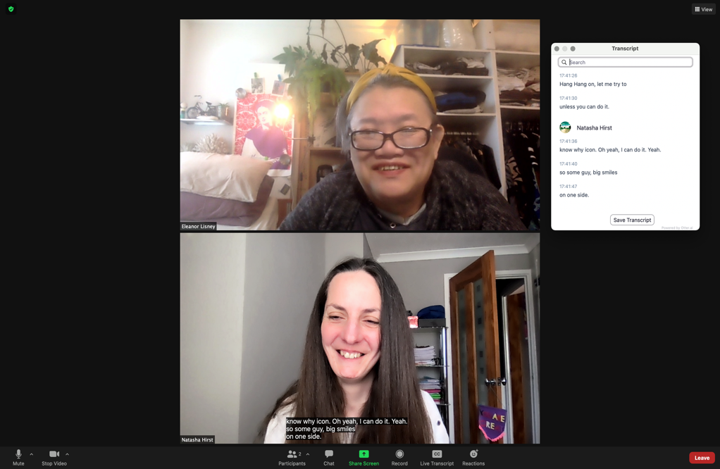
Figure 5. Eleanor, an East Asian woman with glasses and yellow head band, with Natasha, a white woman with long dark brown hair, trying out caption facility (live transcription) on Zoom Pro account. They are in a black box with a live transcript white box.

Twitter:
Eleanor Lisney @e_lisney,
Dr Natasha Hirst @HirstPhotos

