Disabled women’s perspectives on
Independent Living during the pandemic

A report by the Sisters of Frida collective

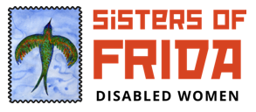
(Image Description: Sisters of Frida rectangular logo. A green bird in a blue square and next to the square is written: Sisters of Frida in red and Disabled Women in black)

CONTENTS

CONTENTS 1
EXECUTIVE SUMMARY 3
Introduction 3
Terms 4
Research Methods 6
Key Findings 7
RESEARCH FINDINGS 9
Financial Impacts 9
Social Care Provisions 16
Social Security 19
Mental Health Deterioration 22
Access, community belonging & social attitudes 28
Access to healthcare and vaccinations 31
NEXT STEPS 34
Full list of recommendations 37

Acknowledgement

We’d like to thank the Smallwood Trust and the National Lottery Community Fund for their financial endorsement of this project. We’d also like to thank our focus group participants for volunteering their time and lived experiences to us. We’d finally like to thank Alice Armstrong, our Coordinator, msunnia, our Researcher & all those who have provided advice and guidance to make this project possible.

EXECUTIVE SUMMARY

Introduction

The ‘Disabled Women’s Perspectives on Independent Living During the Pandemic’ report provides an insight into the experiences of Disabled women during the Covid-19 pandemic. It introduces the ways in which policies pertaining to managing the pandemic by the government, local authorities and other bodies have affected Disabled women’s ability to live independently. Our report provides Disabled women's perspectives on a number of issues, such as: financial struggle, experiences of ableism in the employment sector, issues with local authorities and the social care system, getting the appropriate healthcare, struggles in accessing food and other household supplies, and importantly a stark deterioration in mental health.

These issues are a culmination of longstanding government policies which have been detrimental to Disabled women’s lives from 2008 to now. For over a decade, we have witnessed the dismantling of services in the NHS and a reduction in local authority and social security provisions that have left Disabled people struggling, even prior to the pandemic. It further led to Disabled women being subjected to having our rights to independent living and dignity of life eroded. This was exacerbated during the pandemic and we received little to no support from services run by the NHS, local authorities and social security. The lack of information on basic health matters such as shielding and vaccination have caused a great deal of confusion and stress. Notwithstanding the eugenicist deaths of countless of Disabled people and people of colour, it is our view that our struggle and destitution could have been avoided.

Our briefing ‘The Impact of COVID 19 on Disabled Women from Sisters of Frida’ illustrates that most Disabled women are already on low income. We are more likely to provide domestic care, less likely to be employed, and are less financially independent. We also know that women do not all have the same life experiences and this needs to be reflected in policy making. For example, Disabled women of colour are disproportionately disadvantaged due to racism, disablism and sexism. Disabled lesbians face social exclusion from the LGBTQIA+ community and disability rights groups. While some data exists on some matters affecting Disabled women such as unemployment, intersecting identities such as race, class, sexuality and gender diversity are not taken into account. Therefore, when considering policy on disability issues, it is important that different Disabled women’s experiences are included. This report attempts to incorporate some intersectional depth to Disabled experiences of the pandemic.

Terms

The Equality Act 2010 states that disability is a protected characteristic. The law defines disability as a “physical or mental impairment that has a ‘substantial’ and ‘long-term’ negative effect on your ability to do normal daily activities”. It is also inclusive to those who suffer from illnesses such as cancer and HIV. Due to the complex nature of disability (such as diagnosis), the Sisters of Frida’s definition also includes those who self-identify as Disabled.

We are further inclusive of all self-identifying women, girls, non-binary, and gender non-conforming Disabled people. As a collective, we do not claim to speak for all Disabled women. We value different women’s experiences, and we seek to build networks of Disabled women, share experiences and explore intersectional possibilities.

The social model of disability maintains that Disabled people are not marginalised by their symptoms, health conditions or their impairments. Rather, the structure of society and notions around ‘ability’ create barriers for Disabled people. For example, institutions create barriers for Disabled people through lack of access to buildings and services. Therefore, Disabled people’s freedom is shaped by what is around them, and the structures (or lack thereof) in place for them to live an independent and fulfilled life.

For Disabled people, Independent Living means our ability to have the same freedoms as non-Disabled people. It is about our ability to live well, in dignity and to be able to make our own decisions. Independent Living encompasses our access to transport, healthcare, education, employment and the means to be financially independent.

The United Nation Convention on the Rights of Persons with Disabilities (UNCRPD) recognises that all disabled people have the right to live in dignity, without discrimination, and have the right to services that are responsive to our needs. The UNCRPD further recognises that disabled women “are subject to multiple discrimination”, and that measures need to be undertaken to ensure that our rights are protected and advanced in society.

Research Methods

This project started in January 2021 and over the course of February and March we held 3 focus group discussions with 11 participants. We spoke to Disabled women about their experiences of the pandemic from March 2020 to March 2021. The qualitative data presented in this report is drawn from a call for participants to explore the impacts of Covid-19 on Disabled women. We invited contributions from stakeholders of different organisations such as Disabled people’s organisations, women’s groups, LGBTQIA+ groups and Black and other People of Colour groups. Furthermore, we reached out to Disabled women through social media marketing, namely through the Sisters of Frida Facebook group, page and Twitter account.

Some of our participants self-define as LGBTQIA+, non-binary, Black Indigenous People of Colour (BIPOC), Muslim, working class, in receipt of welfare benefits, employed (full time and part time), parents and shielders (clinically extremely vulnerable). There is little research that documents the lived and in-work experiences of Disabled transgender women in order to form policy to improve their lives. Transgender people’s voices are also under-represented in queer communities, women’s rights groups and the disability rights movement. Similarly, we recognise that Disabled refugee and incarcerated women are often under-represented in policy considerations on disability and gender. Due to time constraints and UK lockdown restrictions, the focus groups were held online. This has meant that we were unable to reach out to a number of Disabled women such as transgender women, those in hospitals, care homes, psychiatric facilities as well as refugee and incarcerated women. To meet access requirements, some participants submitted their views in alternative formats. Participants were geographically located in various parts of the UK, including Wales and Scotland. All participants have been anonymised and remunerated for their participation. The discussions held during the focus groups were coded and common themes were examined.

While this report is limited by qualitative participant interaction, our use of secondary quantitative data analysis adds depth to provide an analysis into the impacts of Covid-19 on different Disabled women. This report incorporates secondary research data from higher education institutions, research organisations, media articles and non-governmental organisations. The next section provides an insight into the concerns of Disabled women and our recommendations. Our aim is to provide an insight into different Disabled women’s experiences of Independent Living during the past year. A list of recommendations can be found at the end of this report.

Key Findings

Our research found that since the pandemic began:

- The cost of living for Disabled women increased however income decreased. Many Disabled women were not eligible to access the government’s £20 uplift of Universal Credit. Discriminatory work practises and the government’s failure to implement fair employment regulations led to unemployment, reduced work hours and reduced pay.

- Disabled women became more reliant on partners, family members and friends for financial support and care needs. Despite this, Disabled mothers were predominantly responsible for domestic duties, to the detriment of their impairments.

- The sourcing of food, basic household products, medication (including menstrual hygiene products) was made inaccessible by supermarkets, the medical system and local authority services.

- Our social care needs were not met, and many Disabled women found themselves without any personal assistance. Information on their social care needs was inaccessible, unreliable, often wrong and many struggled to get basic support such as PPE.

- Disabled women’s mental health deteriorated sharply since the pandemic. Those with care responsibilities felt under-supported. Many Disabled queer people and shielders felt abandoned and experienced extreme loneliness and depression.

- Disabled women felt let down by the public’s attitudes to social distancing and mask wearing. This impacted on their access to the community and green spaces.

- Disabled women’s health got worse as their healthcare needs were drastically deprioritised by medical professionals. Many have also been deprioritised in the vaccine prioritisation process.

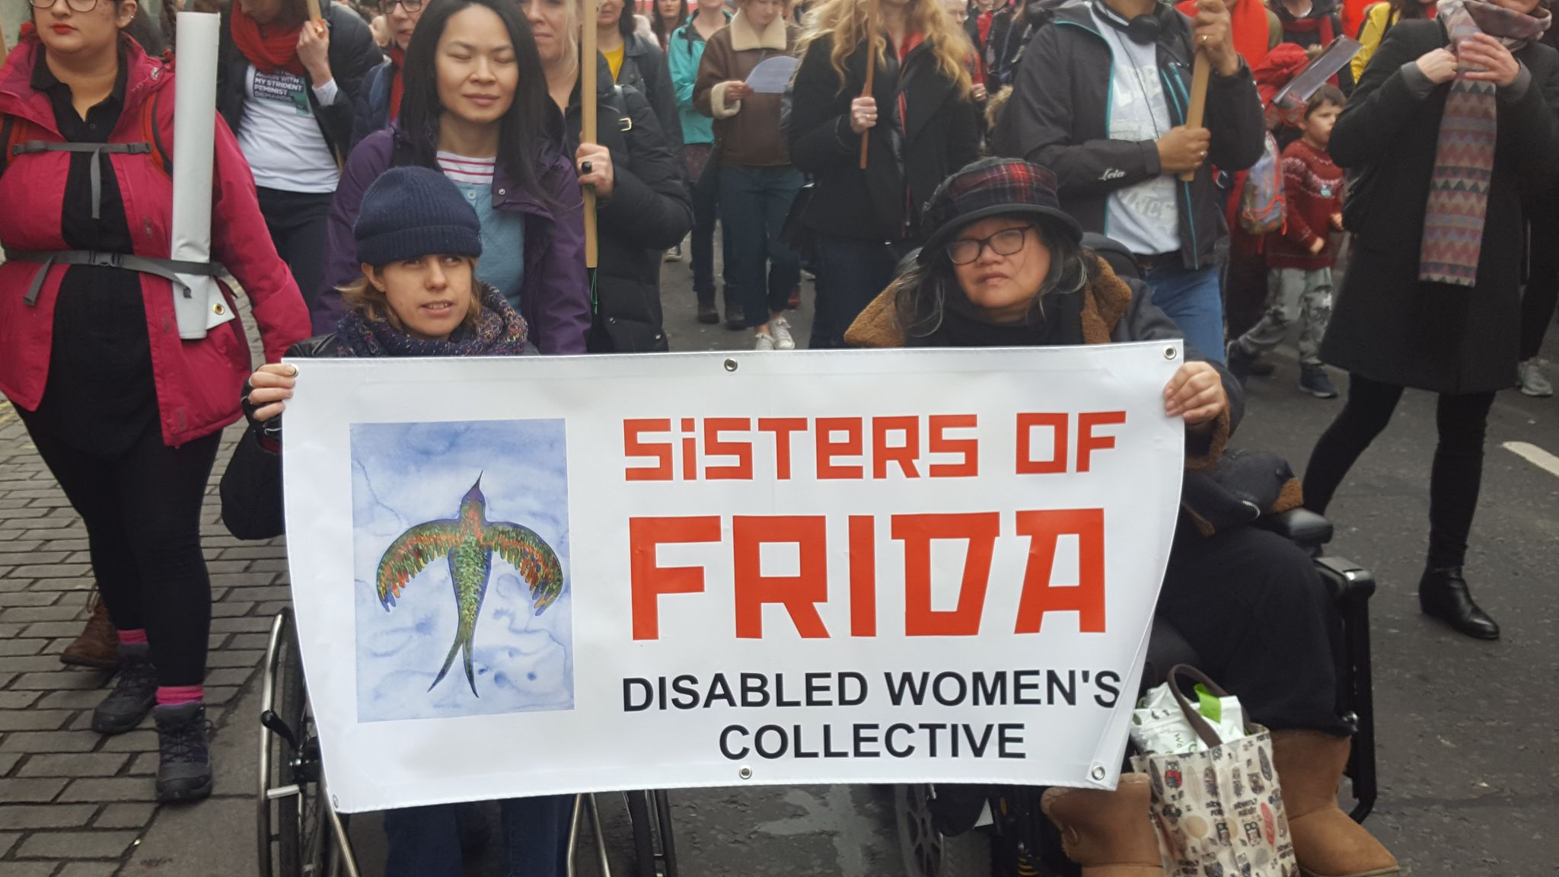
(Image description: Two disabled members of Sisters of Frida collective, both in wheelchair and holding the Sisters of Frida (with logo) banner at a gender rights protest)

RESEARCH FINDINGS

Financial Impacts

According to recent data published by the ONS, 52.1% of Disabled people of working age were in employment in 2020, meaning that approximately half of the UK's Disabled population are unemployed and economically precarious. In comparison to this, 81.3% of non-Disabled people were in work. With the current employment gap between Disabled and non-Disabled people at 29.2%, Disabled people remain disadvantaged in employment. Moreover, Disabled workers are least likely to hold senior positions, such as line managers, directors or be in professional employment. 34.6% of Disabled workers are on part-time hours. We are often reduced to undertaking low paid work and are more likely to be under-employed, such as working part-time, having shorter contracts (such as zero-hour contracts) and taking up casual employment. This renders Disabled employees more vulnerable to redundancies, cutbacks and low pay.

A concerning factor has been the impacts on Disabled women’s finances. While the employment rate of Disabled men and Disabled women is similar, Disabled women are more disadvantaged in work than non-Disabled women. There is an employment gap of 18.4%, with only 53.4% of Disabled women working compared with 71.8% of non-Disabled women. With Disabled women being underemployed and in low pay, their overall finances are precarious. This was exacerbated during the pandemic as our participants have told us that they have either taken unpaid leave, cut back on working hours or became unemployed. This overall loss of finances has meant that Disabled women have been left financially dependent on their partners or on the welfare system, or both. This has increased poverty among Disabled women and it has meant that they have struggled to pay rent and other bills, afford food, medicines and other basic needs and to support their families .

Studies show that Disabled women are undertaking less paid work and are carrying out more household duties than men during the pandemic . With Disabled women already at a disadvantage in terms of pay and working hours, our participants echoed that financial repercussions are already felt. As illustrated below, gendered expectations at home intertwine with the existing wage and career gap in employment to perpetuate already gendered norms that exist both at home and in the workplace.

CASE STUDY: Participant 1 is an archaeologist and has had to ensure that her work pressures meet the demands of her family and husband. While her husband is supportive of her, she acknowledges that in terms of employment:

“...we always try to make sure that my husband doesn't have the time off because his job is more important. I mean, although I have gone into further education and have got a Masters and have really worked really hard to get my job, so in that way my job is really important to me but his job is more important for the money and the stability. So it is always his that is prioritised so I always take time if the children were off sick or I've done all the home schooling, or my mum has, but when I've taken the time off on the days I don't work that always falls to me. So yeah, it has put a lot of extra pressure on in those ways. Yeah, just everything is just, I mean he is really good at doing things but you have to ask them, don't you?”

Whilst the ONS 2020 estimates on Disabled workers illustrate that the employment figures for Disabled people have not changed greatly from 2019, data collected by Citizens Advice shows that in 2020, 1 in 4 Disabled people were facing redundancy. Moreover, half of those who are clinically extremely vulnerable (shielders) were facing redundancy. Citizens Advice further reports that during the pandemic, there has been a 370% increase in their services being accessed by people seeking advice on fair redundancy processes. Employers have been unwilling to provide adequate support for Disabled staff (especially those who are clinically vulnerable and clinically extremely vulnerable) and for those with caring responsibilities such as childcare (thereby impacting Disabled women). Despite existing legal guidance and frameworks, employers have increasingly undertaken unfair and discriminatory actions to dismiss Disabled staff and those with caring responsibilities. Due to the UK government’s refusal to administer fair employment regulations, Disabled workers, more specifically women, and people of colour have been consistently marginalised. This is illustrated in the following case study.

Case Study: Participant 2 is an experienced carer and started a new job looking after a Disabled person. After disclosing her fibromyalgia diagnosis to her employer, she was made redundant after her first week of work. While the employer did formally not acknowledge that it was due to her chronic illness, Participant 2 says:

“So I did ask my boss at the time, is it to do with my fibromyalgia, I want you to be honest with me. And she said no, but I do wish you would have told me before I took you on and so that I could have made an informed decision about it. So basically it was about my fibromyalgia.”

She sought out advice from Citizens Advice and applied for Personal Independence Payment (PIP), however this was denied as the DWP claimed that her chronic condition fluctuated. Participant 2 estimates that she lost approximately £2000 during the first lockdown. She eventually secured work as a trainer for a health and social care organisation (in a key worker position). After expressing her concerns about her working conditions and workplace stress, she was referred to occupational health without her knowledge.

Participant 2 felt that it was the early stages of institutional discrmination yet proceeded to engage in the process. While engaging with occupational health procedures, in which an individual risk assessment was proposed, Participant 2 felt further antagonised and threatened at work. Her mental health deteriorated further. After assessing her working conditions and the organisational culture, Participant 2 felt she had no choice but be pushed out of her job. She currently relies on her partner to support her.

The above case study does not solely illustrate how Disabled workers are unfairly treated in the workplace, but it provides insight into a number of factors that sustain structural disableism. Disabled women undertake a lot of care work, some are paid, some not. Disabled women in paid care work operate in precarious conditions which make them easily prone to discriminatory practices. Such working conditions have arisen as a result of government’s inaction to protect the rights of Disabled employees. Due to the lack of implementation of employment rights, Disabled women are caught in a cyclical pattern of workplace discrimination. This has not only resulted in the loss of jobs, hence loss of personal finance, but a deterioration in mental health as a result of workplace trauma.

Further, a recent report by Inclusion London highlights that the Access to Work scheme is failing Disabled workers. This is due to administrative delays and the Department for Work and Pensions’ (DWP) refusal to accommodate reasonable adjustments. The Trade Union Congress (TUC) have also raised concerns about Disabled workers’ inability to get support when in work through the Access to Work scheme. The following case study shows that without support, Disabled women are unable to remain in work and fall into the trap of poverty.

Case Study: Participant 3 is a Disabled woman of colour who has worked for a Disabled people’s organisation since 2019. During the pandemic, she started to rely more on her partner as her local authority was not providing the care she requires - as a result of that the DWP stopped her PIP care package altogether. Additionally, she was led to resign from her work as the DWP’s Access to Work scheme refused to meet her access needs. In Participant 3’s words:

“I had to use a lot of public transport and carry lots of paperwork and other things on these aspects of the job like work travel, were becoming very difficult. Access to Work were really fighting me on providing me a P.A to do such things. They said, we've given you enough computer equipment because I also have dyslexia and I needed particular adaptations on the computer such as Dragon and Note Taking software. They argued with me and said, well, you've had enough from us basically and it was a long, arduous time. I am a Disabled person who uses an electric wheelchair a lot of the time, I can walk but it's very limited and I walk with mobility aids. Doing my in-community work was becoming very difficult because I had to rely on public bathrooms and it was becoming difficult to manage my women's needs with my disability and not having that in work support.”

Participant 3 is currently out of work and relies on her partner to provide for accommodation and her care needs.

Women of colour are more likely to be in insecure work than white employees. Structural barriers such as lack of workplace adjustments and accessibility are an additional barrier for Disabled women of colour. Due to intersectional discrimination pertaining to race inequality, gender discrimination and disableism, Disabled women of colour are at a disadvantaged position at work. The above case study illustrates a systemic failure in creating and upholding access and inclusion so that Disabled women can remain at work. During the pandemic, a breakdown in the care package meant that our participant could not access a care assistant to help her with domestic duties nor could she have access to food. She further stated that she was unsuccessful during job interviews as employers refused to meet her access needs. This struggle to gain work and convince employers to provide reasonable adjustments was also echoed by other participants.

Over the past few years, the Access To Work scheme has received many complaints, including about the DWP’s refusal to meet the accessibility needs of Deaf people. Issues with the scheme have gotten more complicated during the pandemic as Disabled workers struggled to have their access needs met. An urgent review is required to ensure that the scheme ceases its perpetuation of systemic disableism so that workplaces become safe and inclusive spaces for Disabled workers.

Those on welfare benefits have been particularly affected by the high cost of living during the pandemic. Our participants who are in receipt of social security and who are shielding reported that due to a lack of infrastructural support, they struggled to access food and other basic products during the pandemic. Many struggled with placing orders with supermarkets for online food delivery. Due to their low income, some struggled with having internet access at home to carry out online shopping. Others could not meet the high delivery costs and therefore had to rely on occasional help from friends to deliver food to their residence. Most of these participants have relied on help from community volunteer schemes and food banks. As the lockdown eases, we remain skeptical the finances of low income Disabled women will improve. We are crucially and extremely concerned about the long term impacts of the welfare cuts, including the reinstatement of punitive sanctions on low income Disabled women. In that frame, there needs to be crucial reconsideration on how the social security system that is meant to support Disabled women is failing. In our view, low income Disabled women will remain in a cycle of poverty if the structure of welfare support does not change.

Sisters of Frida recommendations:

- That the government urgently addresses the issue of workplace dicrimination, from the job advertising stage to keeping Disabled women in employment. More needs to be done to provide Disabled women with decent employment, pay and accessibility in the workplace.
- That more is done to examine the ways in which Disabled women are impacted by gender and disableist discrimination in the workplace. We believe that all Disabled women should be equitably paid, and that caring duties should not solely be women’s responsibility.
- Sisters of Frida calls on the government to urgently review the Access To Work scheme in order to increase funding to meet the support needs for all Disabled people. In our call, we urge the government to relinquish caps used to limit Disabled people’s support in work, as well as to uphold an equitable assessment and administrative system that is person-centred and non-discriminatory to Disabled people.
- We call on the government to end all sanctions and work conditionalities for all social security recipients.
- We are supportive towards initiatives to hold supermarkets and other service providers accountable for failing to provide affordable and accessible services to Disabled people during the pandemic.

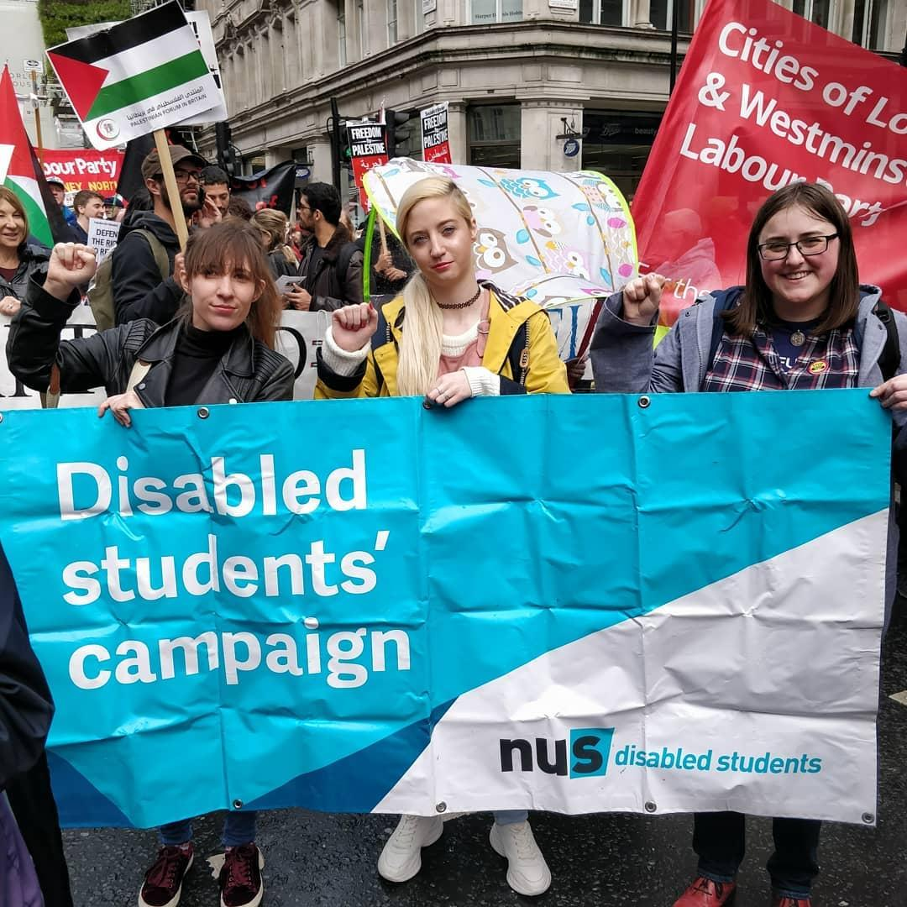
(Image Description: Three disabled women holding a banner that says ‘Disabled Students’ Campaign’ at a protest. The women are raising a fist with their hands.)

Social Care Provisions

Our overall data illustrates that the British state currently does not provide the necessary social care support for all Disabled women who require it. Those who do receive social care support, have had either their treatments or care packages stopped. Others have been enmeshed in bureaucratic systems that have entrenched their experiences of poverty and social care abjection. We spoke to participants who have raised concerns, complaints and advocated for their rights to social workers, local authorities and care providers. Often, this resulted in their being ignored or implied that they were “not Disabled enough” to receive help. In cases where complaints are upheld, local authorities have either not implemented recommendations or have delayed these implementations. As a result, Disabled women in need of social care during the pandemic have been left to survive with very little support.

The lack of flexibility with local authority care packages meant that users couldn’t change the way they spent their budgets. This left Disabled women unable to spend their personal care budgets on useful items such as buying accessible technologies. Our participants also expressed concerns over delayed medical appointments, the cancellation of crucial treatments and an overall misinformation on PPE provisions and basic social care rights. Further impacts of the cuts to social care packages are illustrated below.

Case Study: Participant 3 had a care package provided by the local authority’s social services team. However this stopped during the pandemic and she states:

“They said you're not as priority as some of our other Disabled people and they conveniently forgot about me on many occasions so I would be left without help with a tea call...So then I ended up needing more help in the house and my flatmates tried where they could to help but it was getting to the point where I was going without food, was ending up having to wear very wrinkly clothes, trying to do my own washing...I was only getting PIP and housing benefit as a top up to my part time job when I was working but when I lost the job, I became fully dependent on benefits and we were conscious that with my partner, when my landlord was bullying me, that if we became an official couple that lived together, I would have to declare that and lose my income...”

The above experience is not uncommon. The impacts of the actions taken by the local authority and the DWP precipitated our participant into financial and care precarity, thereby curtailing her ability to live an independent life. Losing her care package and her job meant that she had to rely on the occasional kindness of her roommates to help with food and clothing. It also meant that her partner took on unpaid caring responsibilities and as a result of that they were instigated to pay a higher rent by her landlord. The DWP’s policy on taking account of partners' finances when assessing social security provisions for Disabled people has been detrimental for Disabled women’s ability to live independently. It forces Disabled women to rely on their partner’s income. This policy is an exemplary form of intersectional discrimination in which disableism, classism and sexism are intertwined. It is a concerning issue in cases of domestic violence, where Disabled women’s financial independence are already curtailed by abusive partners. Therefore, crucial policy change is required so that Disabled women are able to live independent lives so that they do not have to rely on their partners.

Sisters of Frida recommendations:

- We urgently request the reinstatement of council and other social care provisions for Disabled women.
- Local authorities need to ensure that Disabled people are treated with dignity and respect and that they receive appropriate advice and information when they request it. We also request that more funding be allocated to ensure support needs of Disabled people are appropriately being met.

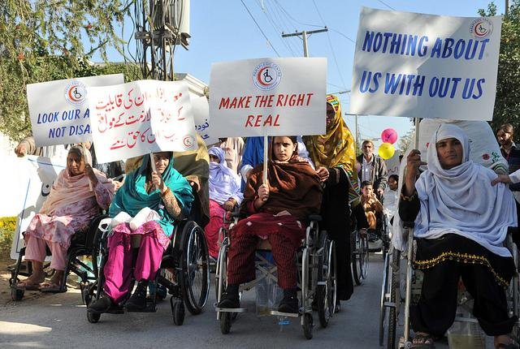
(Source: http://www.ipsnews.net/2018/08/children-women-disabilities-likely-face-discrimination/)
(Image Description: A group to Muslim women protesting for disabled women’s rights. They are holding placards saying: Make The Right Real, Nothing About Us Without Us, and other slogans in Urdu).

Social Security

During the pandemic, the government’s temporary £20 uplift for those who receive Universal Credit was not applicable to those on legacy benefits such as Employment Support Allowance (ESA) or those entitled to PIP . Our participants reported that this uplift would have been beneficial due the unexpected rising costs of living during the pandemic. Over the past few years, the government has implemented drastic policy measures to eradicate legacy benefits, thereby shifting those on such benefits to the Universal Credit system, a more streamlined, and one size fits all approach. Serious concerns have been raised over such plans as many Disabled people who move to Universal Credit lose out financial support thus making it harder for them to live an economically active and independent life. The refusal to provide the uplift to those who remain on legacy benefits has been criticised as “blatant discrimination”. A legal action has been filed against the DWP’s decision to not provide the uplift to all Disabled people in receipt of social security.

Case Study: Participant 4 requires regular medical care and is on ESA. She says:

“I am on Employment Support Allowance, which is like a legacy benefit and most people have been moved over to Universal Credit. There was an extra £20 given to people on Universal Credit...The people who were on the old-style benefits didn't get the £20, including me. And there were extra costs in terms of, for example, I go to the hospital a lot. A lot of the appointments were cancelled for people at hospital and they were taking place by a telephone call...I still had appointments, but then they were moving me to hospitals, which were miles and miles away from where I live, and I used patient transport, which is like part the ambulance service for getting to appointments and then that wasn't running because of COVID and then when it was running, it was only for cancer and dialysis patients. So I was expected then to go to hospital, say about, you know, 30-40 miles away and pay for it. I can't get there. I was a shielding patient. So I was having to use taxis paid for out of my benefits, which was taking the whole benefits. And I went to the general office of the hospital because I'm on a low income and tried to claim some of these costs back and all they did was bully me and refuse to pay me, even questioning my disabilities. And then I came home and I had no money for food.

Research carried out by the Disability Benefits Consortium reports that those on 82% of those legacy benefits have had a sharp rise in their costs of living, with many having to use food banks and being unable to pay household bills. The above case study illustrates the impacts of the flawed government policy to withhold the £20 uplift from those who are on legacy benefits. The decision to withhold the uplift can be viewed as a political decision to coerce those on legacy benefits to shift to Universal Credit. An overall improvement of the social security system is required, as the system currently operates in a punitive way for Disabled people.

Sisters of Frida recommendations:

- For Disabled women to be independent, their social requirements need to be assessed independently and not tied to their partner’s salary or other finances.
- Urgently demand the indefinite extension of the £20 uplift for Universal Credit claimants and for the £20 uplift to be extended to all social security recipients.
- We reiterate our demand on the government to end all sanctions and work conditionalities for all social security recipients (especially those on Universal Credit and ESA)

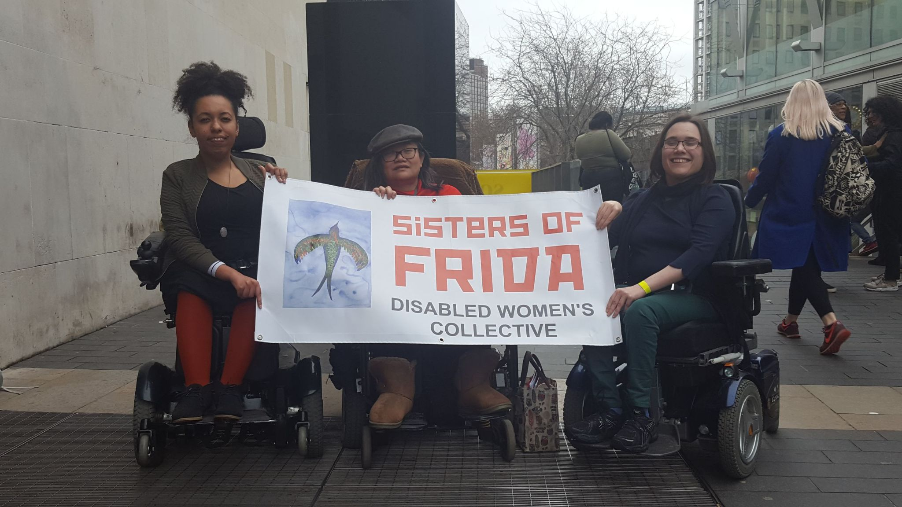(Image Description: Three Sisters of Frida members in wheelchair holding the Sisters of Frida banner)

Mental Health Deterioration

Recent data from the ONS shows that two thirds of Disabled people (65% compared to 50% of non-Disabled people) stated that the pandemic was detrimental to their wellbeing. With unprecedented changes to healthcare provisions (e.g medical appointments, treatments, etc), loss of employment, rising costs of living and deaths as a result of Covid-19, Disabled people continue to report a stark deterioration in their mental health. Disabled people with mental distress were the most psychologically distressed, with feelings of extreme anxiety, depression and loneliness.

Our participants overwhelmingly concurred that their mental health worsened during the pandemic. Some felt like a burden to their families or partners, while others reported that they were made to feel like a burden by health and social care providers. Those who were told to shield stated that the lack of public health guidance on their conditions influenced the deterioration of their mental health. The loss of income by those who were made redundant and those on already low income experienced a loss of confidence, leading to depression and low self-esteem. More broadly, our participants felt that there was a stark lack of consideration for Disabled people’s lives in terms of national policy and decision making. This led to feelings of insecurity, fear, abandonment and Disabled women were made to feel that their lives were unworthy and disposable.

Disabled women with caring duties such as looking after children felt unsupported to do so and this amounted to an increase in stress. The gendered impacts of the pandemic on women has been reiterated in a recent report by the Centre for Economic Performance at the London School of Economics. The report illustrates that women are more likely to take up unpaid labour such as household chores and childcare whether they were in paid employment or not. Like most women during the pandemic, Disabled women in work have either taken unpaid leave, cut back on hours, or lost work altogether. The following case study illustrates the gendered implications of managing work and domestic life as a Disabled woman.

CASE STUDY: Participant 1 had to take unpaid leave to attend to her family, she currently works on reduced hours. On Disabled motherhood during the pandemic she states:

“Yeah, just I think that is a thing with being Disabled, you always have to rely on other people, don't you? It can be a bit straining when you are already tired from doing all these things and you have to ask people to do more than you would normally ask them to do because you are so exhausted. You might have to ask for help more than normal and it makes other people tired...I do think, if I can say one more thing, I think in terms of the women's load more than men, the guilt in my life always lands on me. I will live with the guilt that I'm not home schooling properly or not being there for the kids enough.”

Disabled mothers felt responsible in undertaking gendered roles such as cooking, cleaning and looking after the family. As restrictions relaxed after the first lockdown, the above participant started to receive help from her parents. They moved into her accommodation in order to help with childcare costs and domestic duties. Her mother helps with cooking, cleaning and looking after the children while she works. As such, gendered household labour during the pandemic is intergenerational, thus perpetuating the generational cycle of domestic gendered labour. Due to their impairments, many Disabled women struggle to fulfill these gendered expectations and as a result feel reproachful and guilty. Disabled mothers told us that, “the parental load lands on women” and that they were in ‘survival mode’. It is our view that Disabled mothers should receive support from the government and local authorities to aid them in childcare and household duties.

Case Study: Participant 5 is a Disabled mother with chronic illness. She is in receipt of PIP and works for the NHS part time. The pandemic has meant that she could not access services that alleviate her chronic illness & other impairments. Caring responsibilities have exacerbated her fatigue and mental distress. She says,

“I absolutely love my children and my family, I make that perfectly clear, but I think the pandemic has just completely changed our quality of life. It has decreased, being a Disabled person and being a Disabled parent in the pandemic has decreased our quality of life completely, for me quite a lot physically in terms of I'm in a lot more pain, a lot more fatigue therefore my inability to be able to interact with my children, I am basically keeping them alive and that is all I can do at moment...I've had to go back on anti-depressants and I've been off them for 4 years. It just got to a point where I thought no, I can't carry on any more.

Our participants felt completely abandoned by the systems in place to protect them. This has particularly been the case for single and queer Disabled participants who particularly experienced extreme loneliness during the pandemic. Those who were shielding felt particularly locked in, isolated and unsupported by healthcare professionals. The lack of clarity relating to the provision of guidance, information and support through a difficult time caused a lot of distress.

Case Study: Participant 6 is a Muslim woman. As a shielder, her mental health during the pandemic deteriorated over the lack of support she received. She’s also a carer for her younger sibling. For her shielding has been very difficult:

“I have been shielding since March last year. So this very much impacted me quite significantly...that level of isolation and loneliness because I do also live by myself for access reasons and disability reasons. It led to a crisis point I couldn't really handle anymore, especially when Boris was saying three, up to three households and I had, you know, friends and colleagues saying "oh you can come over to mine in London" and I knew I couldn't because I was shielding. So it was just a certain level of loneliness that I don't know, once you hit, which reaches that point, I don't know when something happens with cortisol and it suddenly reaches a crisis point so that's where I was and in terms of mental health support... there wasn't really a great deal of mental distress support because unless they were going to section me there wasn't much to do.”

Due to medical racism and wider structural inequalities, those who have ‘underlying health problems’ and who are Black and people of colour have been most likely to die from Covid-19. Like many clinically extremely vulnerable people, the above participant felt abandoned and isolated during the pandemic. Additionally, she felt unsupported to undertake the necessary caring duties such as supporting her younger sibling. The impact of being unable to access food, the caring pressures and having to live alone led to a mental health crisis. Mental health services across the country had been unable to support the needs of Disabled people and people of colour. While the government promised an increase in funding for mental health services, the funding allocated does not meet the required amount needed to invest in adequate long-term support.

Additionally, NHS mental health services do not take into consideration intersecting health inequalities, such as the impacts of the pandemic on Disabled people of colour, Disabled women of colour or Disabled people on low income. Importantly, there has been little consideration on the mental health impacts of pandemic on the LGBTQIA+ community. This is concerning there is already an existing lack of information and disaggregated data collection on this protected characteristic. It has made it harder to draw analysis on the wellbeing of Disabled LGBTQIA+ people. Despite this, it is known that the LGBTQIA+ community are more vulnerable to facing health inequalities . The LGBT Foundation reported a 13% increase in calls relating to mental health support between 16th March 2020 to 5th April 2020 alone. A recent study also found that since the pandemic, the transgender community were the most mentally distressed group of the queer population. In that frame, increased data collection and statistical analysis on Disabled LGBTQIA+ people by Disabled people’s organisations, women’s groups, LGBT organisations, research institutions and governmental bodies is imperative for monitoring and policy purposes.

Sisters of Frida Recommendations

- We ask that more mental health funding be allocated and for such funding to be prioritised for those experience intersectional discrimination such as Disabled people, Black and people of colour, LGBTQIA+, trans/non-binary and those on low incomes.
- Family life for Disabled parents can be difficult and Disabled mothers often have to attend to their gendered duties with little help. We believe that more should be done to support Disabled mothers, and that they should receive state funded childcare and other support at home.
- Aggregated data collection on Disabled intersectionalities are important as this helps us to understand the needs of different Disabled people for policy-making and equality. We invite research organisations, higher education bodies, governmental departments and equality groups to consider intersectionality in data gathering, research and statistics.

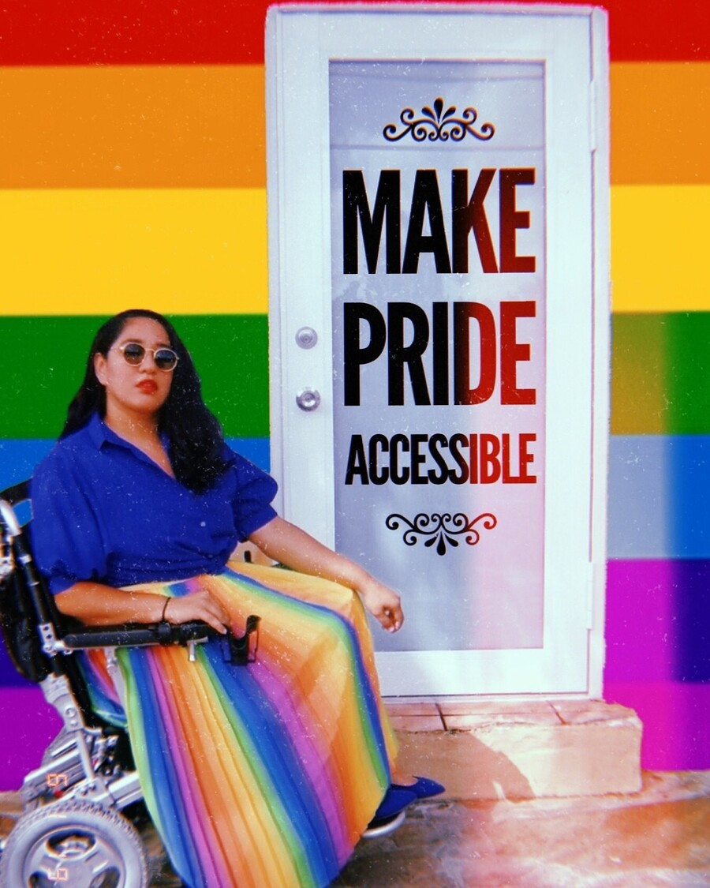
(Source: https://www.bitchmedia.org/article/ableism-in-queer-spaces)
(Image Description: A disabled woman in blue top and rainbow skirt sitting in their wheelchair. The background is a rainbow LGBTQIA+ Pride flag wall, with a white door and with a step. The slogan on the door reads: Make Pride Accessible)

Access, community belonging & social attitudes

Disabled people felt that the pandemic has been “punitive”, “violent and hostile”. For example, hate crimes against Disabled people have increased sharply. The over-representation of Disabled people in Covid-19 death counts and the structural and cultural disregard for our lives and dignity have caused long term distress. Disregard for access and inclusion included the government’s failure to provide sign language interpreters for Deaf people, supermarket’s discriminatory practises that hindered Disabled people from shopping online and the lack of physical access to open spaces and public transport. It is further reported that Blind people have been refused online delivery slots despite their inability to adhere to social distancing measures. As a result of disablism, one of our participants reported being kicked off of a bus, while another stated being overly questioned about their exemption from wearing a mask in a supermarket. One wheelchair user expressed distress over non-consensual ‘helping’ from others, thereby meaning that they could not properly social distance nor keep their wheelchair hygienic.

Unclear and confusing communications about social distancing and mask wearing have resulted in inconsistent behaviour which meant that non-Disabled people sometimes adhered to the rules and sometimes not. This has caused a great amount of stress for Disabled people, especially those who are clinically vulnerable and extremely vulnerable, as the behaviour of others impacts on their ability to be safe in public. Some participants expressed frustrations at the improper ways masks are worn (such as under the nose, and/or on the chin). Others experienced bouts of anxiety over the lack of safety measures employed by maintenance people when carrying out repairs. Another concern has been about the anti-lockdown sentiment which felt inconsiderate towards the lives of Disabled people. As the pandemic lengthens, a noticeably relaxed attitude to wearing masks and social distancing has been observed and the implications of these are echoed in the case study below.

CASE STUDY: Participant 5, who has underlying conditions and works for the NHS added that her personal relationships changed as a result of the pandemic. More broadly she feels that now:

“People are not obeying the rules, just doing whatever they want because they are bored of it. The pandemic didn't go away because you got bored of it. And then the other thing about social distancing is how much people take away, like the access needs for Disabled people to accommodate social distancing is beyond me. How they put cones in parking spots and all that kind of things, so they alienate all the Disabled people so the non- Disabled people can crack on with their lives.”

Many of the participants have been dismayed over the violent disregard for accessibility needs that enable Disabled people to live independently. For example, those who use mobility scooters have been unable to use them as pavements and park paths have been blocked or rendered inaccessible. Those who are told to self-isolate had their personal assistants stripped away from them, therefore they were unable to look after themselves, such as taking the bins out or cooking food at home. Some participants on low incomes, and others with certain impairments were hindered from seeking cultural connections online. Others found that for the first time they could accessibly belong to online community spaces and attend events such as queer night clubs.

CASE STUDY: Participant 7 is a disabled queer person who has been unable to attend community spaces prior to the pandemic. On access and inclusion she says:

“…it can be frustrating because people are finally understanding what access needs are, people are putting things online, but it's only because the majority need now. Now that abled people need it rather than for Disabled people. So that has felt a bit of a slap in the face. But at the same time, I've benefited from it in many ways. So I'm glad it's finally happening. And yeah, I think things like socialising can be different, and in some ways it's being more inclusive. So I've been to an event called Queer House Party online...I have been out clubbing, but it's really hard for me to go and stay out late or, you know, to be dancing sitting down...Or if you try and take mobility aid into a club it's such a nightmare and often it's not an accessible place anyway. So it's really nice to be able to be like in a kind of club environment with people my own age, and stay until the end. Like I switched off my camera halfway through and just went to sleep for an hour and then came back and the party carried on.”

Sisters of Frida recommendations:

- We are supportive of legal actions being taken by Disabled people on accessibility and independent living, e.g. BSL interpretation and supermarket online booking systems. We urgently request an inquiry into accessibility and independent living during the pandemic.
- Given the lockdown easing and the presence of mutations, it is crucial that the government messaging about the social distancing and masks is clear, consistent and widespread. It is important that Disabled people feel safe when they are being asked to stop shielding.
- That online accessibility improvements made during the pandemic remain, and be made more widespread. Many Disabled people remain house-bound despite the lockdown easing, online accessibility must be inclusive of free internet broadband services and accessible technologies for those who need it.

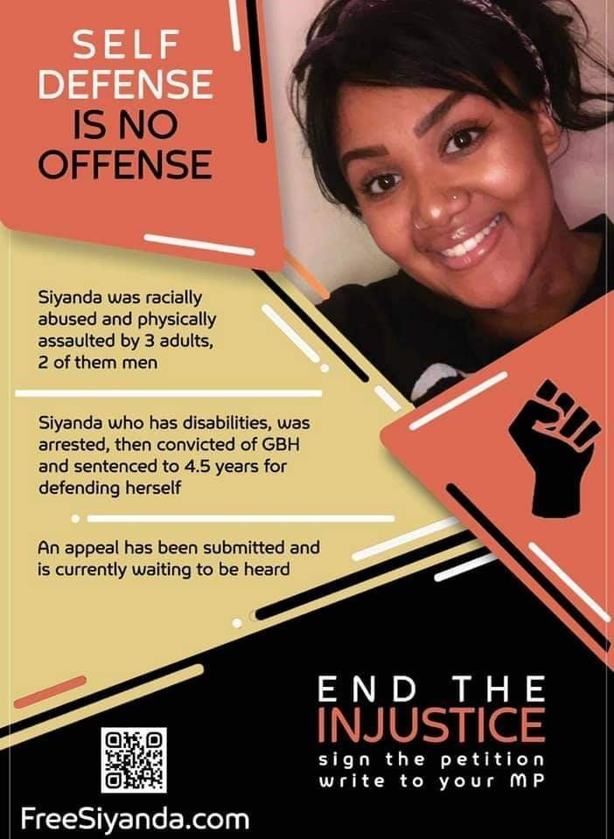
(Source:https://twitter.com/ukblm/status/1370754230169047044)
(Image Description: A poster promoting a campaign for the release of Siyanda a disabled Black woman who is imprisoned for trying to defend herself against three racist white perpetrators. The police failed to investigate the racist incident and she was sent to prison. Her website is FreeSiyanda.com)

Access to healthcare and vaccinations

During the lockdown, Disabled women’s access to healthcare decreased with our participants stating that their care was deprioritised. Some have reported having appointments and treatments cancelled whereas others have attended some appointments online. Serious concerns have been raised at the lack of good healthcare as a result of the pandemic, with short online appointments or telephone conversations failing to meet the needs of Disabled people. One Black Disabled participant stated that medical professionals have been more amenable to their needs due to the colour blindness that occurs with telephone appointments. Due to medical racism and wider structural oppression, Covid-19 has disproportionately affected Black and other people of colour. Some of the Disabled people of colour who participated in this research lost family members during Covid-19 and expressed feeling let down by the lack of bereavement support such as counselling. The loss of family members added to the distress of living as Disabled people of colour during the pandemic. The isolation felt was the result of lack of bereavement support, and this compounded their feelings of not being cared for by the state. There is also a sense of being “culturally isolated” due to the insensitivities pertaining to their inability to attend to cultural rituals.

At the beginning of the vaccination roll out Disabled people who were classed as clinically extremely vulnerable were being vaccinated. Participants who were shielding but had not been added to the clinically extremely vulnerable list expressed concerns and frustrations at being left out of that priority group. Due to outcry and campaigning from different disability groups, the process was changed to include some more Disabled people . However, many are still waiting to be vaccinated, and some of the participants who have chronic illness and other conditions that do not fully meet the government priority list have been concerned to be yet again let down by the system. Due to Disabled women’s high likelihood at dying as a result of Covid-19, our participants have yet again felt cast aside by the government’s mismanagement of the pandemic. All of our participants were favorable towards being vaccinated and many expressed concerns about the prioritisation process for vaccination.

Sisters of Frida recommendations:

- Priority categories for vaccination must be reflective of those who are disproportionately affected by Covid-19, and this should be inclusive of race, gender, class and sexuality considerations.
- It is imperative that the government holds an inquiry into the deaths of Disabled people during the pandemic.

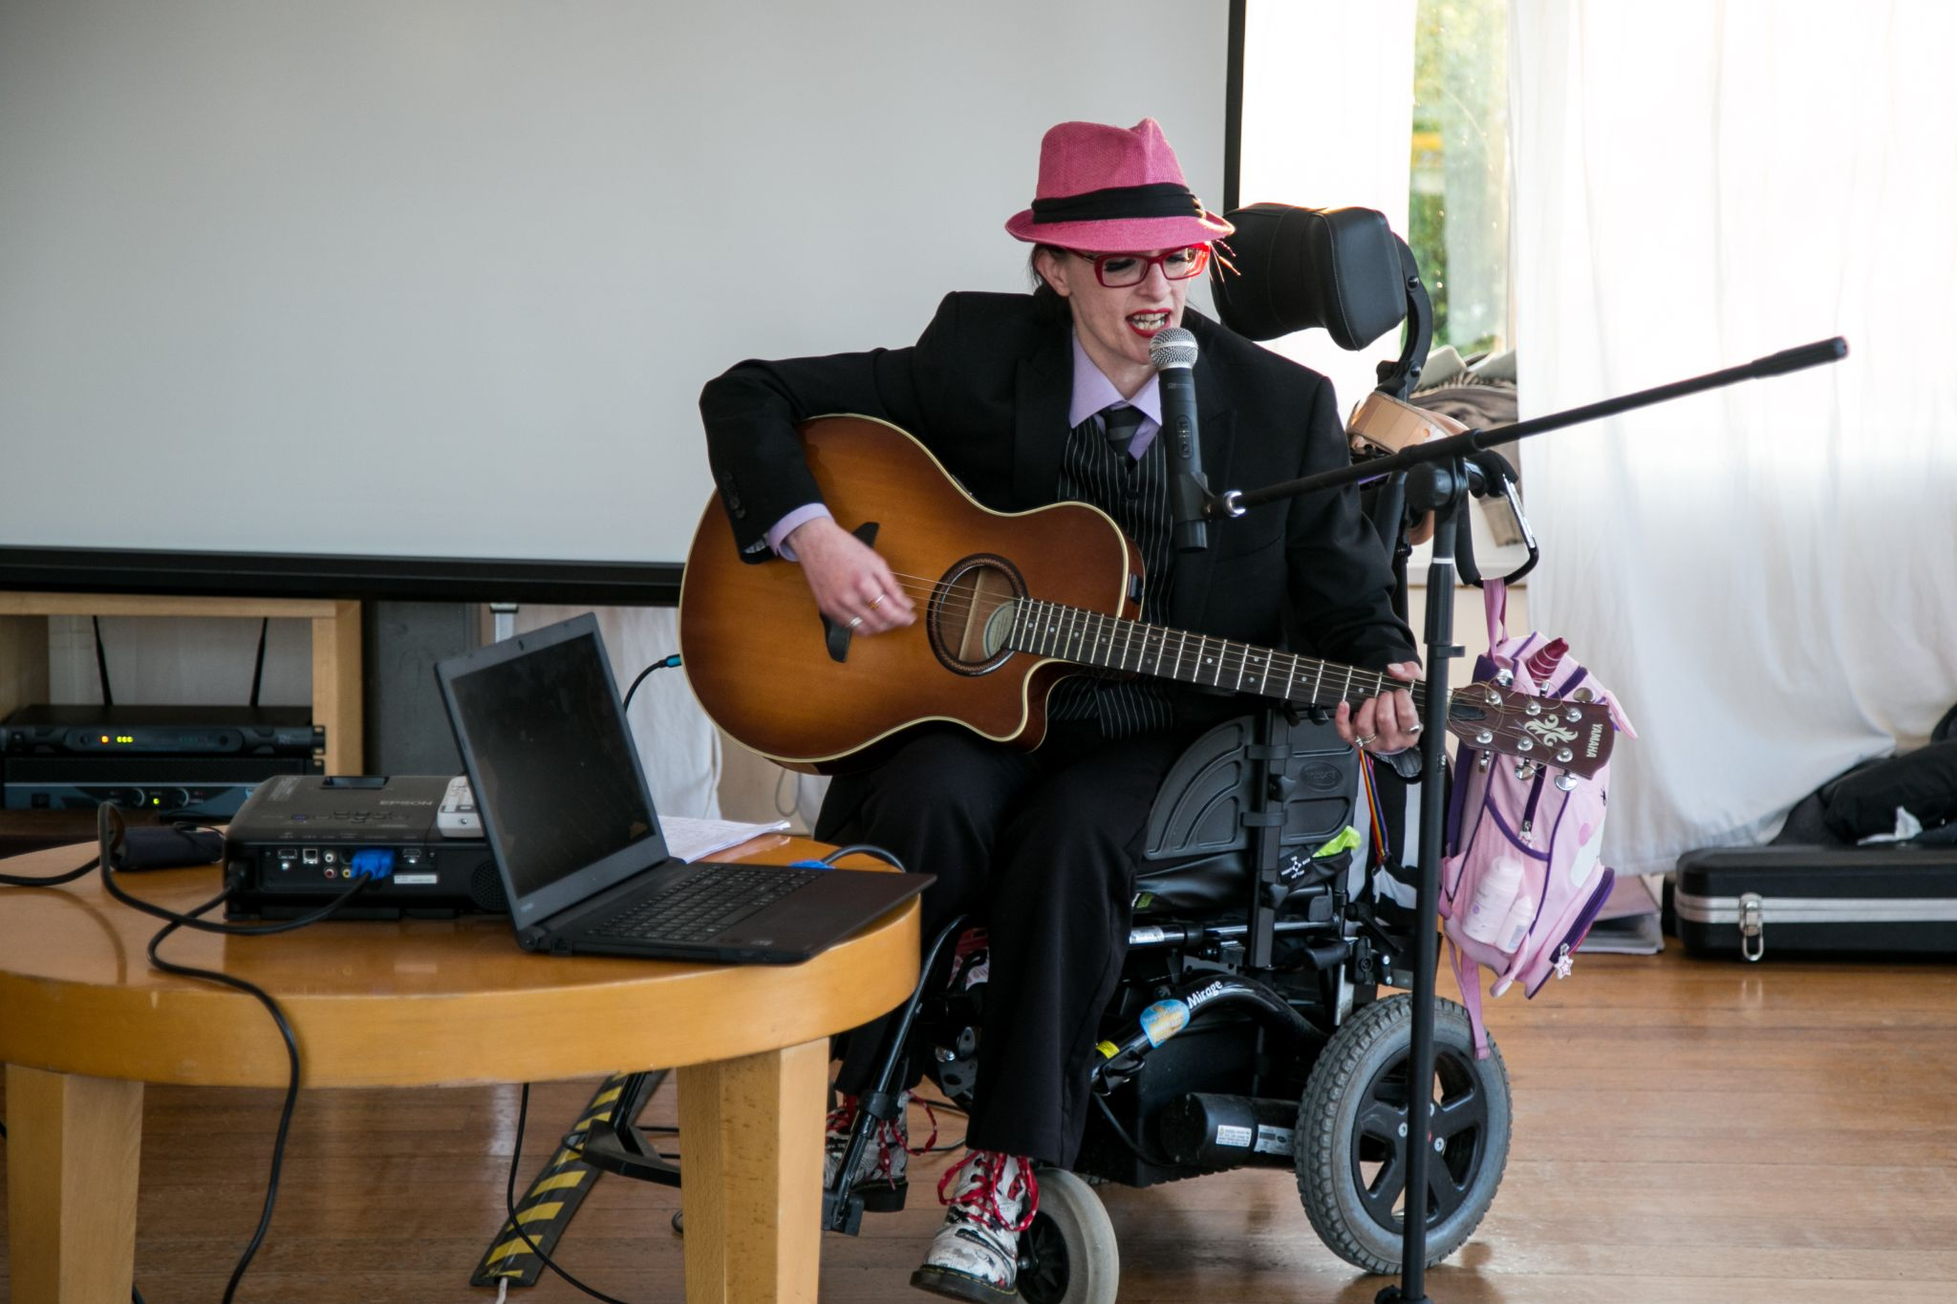
(Image Description: A disabled LGBTQIA+ person in a wheelchair. They are playing their acoustic guitar and singing into a microphone)

NEXT STEPS

This report provides an insight into Disabled women’s experiences of the pandemic between March 2020 to March 2021. The government’s handling of the pandemic has been the brutal on the lives of Disabled people, especially those who face intersectional forms of discrimination (on social security, women, BIPOC, transgender women and more). When contextualising the current government’s legacy on disability rights, from the austerity cuts to the eugenicist pandemic, it is our view that these policies and decisions have been actively detrimental to our lives. It is imperative that a review of the government’s handling of the pandemic, with regards to Disabled lives, is independently investigated. Importantly, we call for an immediate reversal of cuts to state funded services. It is crucial that the voices of Disabled people are actively sought out, through Disabled-led people’s organisations, and for these voices to be valued and listened to. A full list of our recommendations are at the end of the report.

We asked our participants for their thoughts on how they envisaged society could enact the principles of Independent Living. The following is a collation of their voices for future considerations on access, inclusion and Independent Living. Their voices are also echoed throughout this report:

“In an ideal world, there would be much broader definition of access, I think. And for me personally, with a chronic illness, I think if healthcare and social care took a chronic illness into account rather than just acute injury, that would make a big difference to my life. Like planning for long term sickness, I think, yeah, lessons learned from long COVID is now that it affects a lot of people and is in the media. If people don't forget about that. So research into things like chronic fatigue syndrome and yeah, that would help independent living”

“I think in an ideal world, I wouldn't... I wouldn't have conversations where I go to a building and say, "hey, you've got an accessible entrance and you've got an inaccessible entrance. Why is your main one the inaccessible one? Why do you make it so that I have to go press a bell to get in?" And they're like ‘oh, well, this one looks nicer. The customers prefer the look of this one. And if we change to the accessible one, someone would complain that it doesn't look nice and you know you can't win either way. One person thinks it's not safe… safe enough to get in’. And they think that they're equal arguments”

“When my mom passed away, I couldn't accept my share of the inheritance, which wasn't a lot of money. It would have probably kept me going for half a year or something, but it would have been good to have on the side, so if I needed to move house, I could you know, or if these electric bills go so high, I could've paid for them for a year. But I couldn't access it because if I did, I would lose all of my income (benefits). So just couldn't take that. That's not very nice. You want to be able to keep on to anything to your parent, your past parent, you know wanted you to have at least”

“...we're living on our own, and it isn’t seen as such a thing for us, but I know that, um especially for Disabled people, we're quite at risk of intimate partner violence. And I know that, like other times in my life, if COVID had happened, it would have been a really difficult situation domestically. So I think it's certainly worth like if there's any other research going on, like incorporating that for Disabled people that live with a partner. I think people, I guess, I don't know there's probably like safety concerns around it

“For me, it's the finances that's the intersectional thing. Um, if I had enough of my own financial independence, I would be nowhere near as worse off than I am right now. Even though I don't feel worse off because I feel healthier being unemployed right now, I would definitely be able to enjoy it for longer”

“Specifically, being a working-class woman of colour, I would say, what has impacted me the most are exacerbated inequalities -- existing inequalities in the pandemic, because, um, yeah, again, it's to do with finance really. If I had parents that could be guarantors, I would be able to bypass the racist letting agents or my landlord trying to intimidate me...I've had friends that, you know, specifically don't apply for things like Access to Work or DSA because their parents have said you shouldn't, that's for people that need it, you know, if I wasn't a working-class woman, and I didn't experience the racism that comes with that and also the, um, the class sort of violence that we experience then a lot of my issues just wouldn't be issues”

“...why are we fighting for equality in work, obviously in terms of harm reduction like yes, please give us equality in work, but like, also give us equality out of work. Like, that's what I want more than anyone else is like, if I do work it is my genuine choice to and it is under conditions that suit me, rather than, oh, I'm working because I have to. Because for my health, nine times out of ten it'll be better if I don't”

“So going forward really, we need services that mean that...it needs to be a position where we're not in a dependent relationship. So whatever that relationship is, with housing, or with work, or benefits, we just need to be treated with respect, dignity, given control and choice, and not be dependent on those services. So, like an example of housing is, and also, those services need to be culturally competent, and they need to be intersectional, and then need to be co-produced and co-designed, right from the very beginning with Disabled people making the decisions, involved in the decisions, not as an afterthought”

“These blanket generalisations, assessments to benefits and money. Why can't we have the society a bit like um, Finland, and... some of the other European countries, where we have a universal basic income? So all of our basic needs are met, our housing's met, and any other further development on an individual level, be it money, health or whatever, is given -- because of what the person can achieve but not taken away if they can't achieve it. You see what I mean? Having a universal basic [income] for us all to have equality of opportunity, basically, in practice. Meeting someone where they’re at and helping them from that, and working with them in the different intersections that we have and identities that we have to live life to the fullest.”

“I wish they would just put some more thought into things in the first place by asking people what they need. Just a lot of times things don't seem to be thought through very well, and that would be benefits systems really needs reworking because it is just so difficult, you are trying to go out to work, but you would be so much better with relieving the symptoms if you were not working but you can't afford not to do that. It is just a terrible circle because I think they should, everybody should have a certain level or something of income because we're at a massive disadvantage because we can't work full time because it makes us more ill. But there is this perception that we're getting something extra rather than we're being brought up to the same level as everybody else and I think that is what people seem to perceive. It is this culture of working so hard all the time, isn't it, whereas we really have to pace more and try to manage our symptoms, but the benefits system really needs reworking”

“I just think maybe like there needs to be a general awareness in society of how inaccessible life is. Like if you are Disabled and how inaccessible going out in the community is and it is shown in the pandemic how disposable that is to able bodied people, how they can just get rid of, how they can just change it to suit other people or something like that. They have clearly now, they have made all these things, working from home, I found that I can now go to all these conferences I want to go to because they are all online but are they going to keep these things afterwards? That is my main worry now. Because I found I can access all these things that I couldn't before but that is only because it is convenient for other people, not because of the thought beforehand. I'd love for that to be an option, when you start a job. Can I work from home because for a lot of Disabled people that is so much of a thing. Being able to work from bed is so much, sometimes if I'm just having a bad day, I only get to work from home, having a bad day when I can't cope and my body will do nothing, but I could use my laptop in bed if that was all I had to do.”

The Sisters of Frida collective believes in intersectional analysis and cross-movement collaboration. We are interested in working with equality groups, such as trade unions, women’s groups, BIPOC campaigns, LGBTQIA+ organisations and others. We share this report to all, in the hope of fostering spaces where we work together to create a fairer, more inclusive society for all Disabled people.

Full list of recommendations

- That the government urgently addresses the issue of workplace dicrimination, from the job advertising stage to keeping Disabled women in employment. More needs to be done to provide Disabled women with decent employment, pay and accessibility in the workplace.
- That more is done to examine the ways in which Disabled women are impacted by gender and disableist discrimination in the workplace. We believe that all Disabled women should be equitably paid, and that caring duties should not solely be women’s responsibility.
- Sisters of Frida calls on the government to urgently review the Access To Work scheme in order to increase funding to meet the support needs for all Disabled people. In our call, we urge the government to relinquish caps used to limit Disabled people’s support in work, as well as to uphold an equitable assessment and administrative system that is person-centred and non-discriminatory to Disabled people.
- We call on the government to end all sanctions and work conditionalities for all social security recipients.
- We are supportive towards initiatives to hold supermarkets and other service providers accountable for failing to provide affordable and accessible services to Disabled people during the pandemic.
- We urgently request the reinstatement of council and other social care provisions for Disabled women.
- Local authorities need to ensure that Disabled people are treated with dignity and respect and that they receive appropriate advice and information when they request it. We also request that more funding be allocated to ensure support needs of Disabled people are appropriately being met.
- For Disabled women to be independent, their social requirements need to be assessed independently and not tied to their partner’s salary or other finances.
- Urgently demand the indefinite extension of the £20 uplift for Universal Credit claimants and for the £20 uplift to be extended to all social security recipients.
- We reiterate our demand on the government to end all sanctions and work conditionalities for all social security recipients (especially those on Universal Credit and ESA)
- We ask that more mental health funding be allocated and for such funding to be prioritised for those experience intersectional discrimination such as Disabled people, Black and people of colour, LGBTQIA+, trans/non-binary and those on low incomes.
- Family life for Disabled parents can be difficult and Disabled mothers often have to attend to their gendered duties with little help. We believe that more should be done to support Disabled mothers, and that they should receive state funded childcare and other support at home.
- Aggregated data collection on Disabled intersectionalities are important as this helps us to understand the needs of different Disabled people for policy-making and equality. We invite research organisations, higher education bodies, governmental departments and equality groups to consider intersectionality in data gathering, research and statistics.
- We are supportive of legal actions being taken by Disabled people on accessibility and independent living, e.g. BSL interpretation and supermarket online booking systems. We urgently request an inquiry into accessibility and independent living during the pandemic.
- Given the lockdown easing and the presence of mutations, it is crucial that the government messaging about the social distancing and masks is clear, consistent and widespread. It is important that Disabled people feel safe when they are being asked to stop shielding.
- That online accessibility improvements made during the pandemic remain, and be made more widespread. Many Disabled people remain house-bound despite the lockdown easing, online accessibility must be inclusive of free internet broadband services and accessible technologies for those who need it.
- Priority categories for vaccination must be reflective of those who are disproportionately affected by Covid-19, and this should be inclusive of race, gender, class and sexuality considerations.
- It is imperative that the government holds an inquiry into the deaths of Disabled people during the pandemic.

https://www.cost-ofliving.net/disability-and-austerity/#:~:text=Austerity%20measures%20have%20had%20a%20strong%20impact%20on,people%E2%80%99s%20cultural%20recognition%20and%20political%20representation%20as%20well.
https://warwick.ac.uk/fac/soc/law/research/centres/chrp/spendingcuts/resources/reports-uk/#disabled
http://www.sisofrida.org/wp-content/uploads/2020/05/The-impact-of-COVID-19-on-Disabled-women-from-Sisters-of-Frida.pdf
https://www.jstor.org/stable/1229039?seq=1
https://www.jrf.org.uk/report/experiences-disabled-women
https://wbg.org.uk/wp-content/uploads/2021/03/Covid-19-and-economic-challenges-for-disabled-women.pdf
https://www.gov.uk/definition-of-disability-under-equality-act-2010
https://disability-studies.leeds.ac.uk/wp-content/uploads/sites/40/library/Barnes-implementing-the-social-model-chapter-2.pdf
https://www.disabilityrightsuk.org/independent-living-0
https://www.un.org/development/desa/disabilities/convention-on-the-rights-of-persons-with-disabilities/convention-on-the-rights-of-persons-with-disabilities-2.html
https://www.un.org/development/desa/disabilities/convention-on-the-rights-of-persons-with-disabilities/article-6-women-with-disabilities.html
https://journals.sagepub.com/doi/full/10.1177/0261018317732880
https://journals.sagepub.com/doi/full/10.1177/0038026120934684
https://journals.sagepub.com/doi/full/10.1177/0038026120934712
https://www.ons.gov.uk/peoplepopulationandcommunity/healthandsocialcare/disability/articles/outcomesfordisabledpeopleintheuk/2020
https://www.ons.gov.uk/peoplepopulationandcommunity/healthandsocialcare/disability/bulletins/disabilityandemploymentuk/2019
https://wbg.org.uk/wp-content/uploads/2021/03/Covid-19-and-economic-challenges-for-disabled-women.pdf
ibid
Ibid
https://www.jrf.org.uk/report/financial-impact-covid-19-disabled-people-and-carers
https://www.ifs.org.uk/publications/14860
https://data.unwomen.org/features/ipsos-survey-confirms-covid-19-intensifying-womens-workload-home
https://www.ons.gov.uk/peoplepopulationandcommunity/healthandsocialcare/disability/articles/outcomesfordisabledpeopleintheuk/2020
https://www.citizensadvice.org.uk/Global/CitizensAdvice/Work%20Publications/An%20unequal%20crisis%20-%20final%20(1).pdf
https://www.tuc.org.uk/sites/default/files/2020-05/WESC%20COVID_final%20%28002%29%20%281%29.pdf
https://www.tuc.org.uk/sites/default/files/2020-09/SocialCareReport.pdf
https://www.tuc.org.uk/sites/default/files/2019-11/Disability%20doc%20%28003%29%20%28003%29_2.pdf
https://www.gov.uk/access-to-work
https://www.inclusionlondon.org.uk/wp-content/uploads/2021/02/FINAL-Locked-Down-and-Abandoned-report-PDF.pdf
https://www.tuc.org.uk/sites/default/files/2020-05/WESC%20COVID_final%20%28002%29%20%281%29.pdf
https://www.tuc.org.uk/research-analysis/reports/bme-women-and-work
https://www.inclusionlondon.org.uk/campaigns-and-policy/act-now/barriers-work-deaf-disabled-employees-losing-due-changes-governments-access-work-programme/
https://stopchanges2atw.files.wordpress.com/2017/10/accesstoworkrecommendations_web.pdf
https://www.inclusionlondon.org.uk/wp-content/uploads/2017/10/AccesstoWorkRecommendations_web.pdf
https://www.ombudsman.org.uk/sites/default/files/Access%20to%20Work%20Report.pdf
https://www.disabilitynewsservice.com/coronavirus-disabled-workers-raise-concerns-over-access-to-work/
https://wbg.org.uk/wp-content/uploads/2021/03/Covid-19-and-economic-challenges-for-disabled-women.pdf
https://www.turn2us.org.uk/About-Us/News/Financial-recovery-from-Covid-19
https://www.disabilitynewsservice.com/coronavirus-return-of-benefit-sanctions-in-middle-of-pandemic-is-barbaric/
https://www.inclusionlondon.org.uk/wp-content/uploads/2021/02/FINAL-Locked-Down-and-Abandoned-report-PDF.pdf
https://safelives.org.uk/sites/default/files/resources/Disabled%20Women%20and%20DV%20-%20FINAL%20-%20SafeLives%202016%20-%20Ravi%20Thiara.pdf
https://www.jrf.org.uk/blog/20-weekly-uplift-must-be-extended-legacy-benefits
https://www.trusselltrust.org/wp-content/uploads/sites/2/2021/02/dignity-or-destitution-UC-standard-allowance-report-final.pdf
https://www.thecanary.co/uk/2018/10/05/the-dwp-is-confronted-by-the-most-staggering-evidence-over-its-flagship-policy-to-date-2/
https://www.theguardian.com/society/2018/jan/25/universal-credit-benefits-scheme-iain-duncan-smith
https://www.disabilitynewsservice.com/legal-action-launched-over-blatant-discrimination-of-dwps-20-a-week-uplift/
ibid
https://www.actionforme.org.uk/uploads/images/2021/02/Pandemic_Poverty_-_Stark_choices_facing_disabled_people_on_legacy_benefits_FINAL.pdf
https://www.ons.gov.uk/peoplepopulationandcommunity/healthandsocialcare/disability/articles/coronavirusandthesocialimpactsondisabledpeopleingreatbritain/february2021#concerns-during-the-coronavirus-covid-19-pandemic
Ibid
https://cep.lse.ac.uk/pubs/download/cepcovid-19-002.pdf
https://data.london.gov.uk/dataset/rapid-evidence-review-inequalities-in-relation-to-covid-19-and-their-effects-on-london
https://www.inclusionlondon.org.uk/wp-content/uploads/2021/02/FINAL-Locked-Down-and-Abandoned-report-PDF.pdf
https://www.bma.org.uk/news-and-opinion/covid-on-our-minds-the-pandemic-has-placed-even-more-strain-on-mental-health-services
https://www.gov.uk/government/publications/covid-19-mental-health-and-wellbeing-surveillance-spotlights/pre-existing-mental-health-conditions-spotlight
https://www.gov.uk/government/publications/covid-19-mental-health-and-wellbeing-surveillance-spotlights/ethnicity-covid-19-mental-health-and-wellbeing-surveillance-report
https://www.nuffieldtrust.org.uk/news-item/what-impact-has-covid-19-had-on-mental-health-services
https://ilcuk.org.uk/dismay-as-new-report-reveals-that-health-inequalities-continue-to-disadvantage-older-lgbt-people/
https://www.bmj.com/content/372/bmj.m4828
https://s3-eu-west-1.amazonaws.com/lgbt-website-media/Files/237f78f1-e06c-46d7-ae08-1c9d5f9ca0bc/The%2520Essential%2520Briefing%2520on%2520the%2520Impact%2520of%2520COVID-19%2520on%2520LGBT%2520Communities%2520in%2520the%2520UK%2520%2520-%25208%2520April%25202020.pdf
https://www.medrxiv.org/content/10.1101/2020.08.03.20167403v1.full-text
https://www.disabilitynewsservice.com/disabled-people-should-push-for-radical-overhaul-of-society-after-pandemic/
https://www.gov.uk/government/statistics/transport-disability-and-accessibility-statistics-england-2019-to-2020
https://www.disabilitynewsservice.com/coronavirus-bsl-users-launch-mass-legal-action-over-government-discrimination/
https://www.disabilitynewsservice.com/coronavirus-industry-brushes-off-ehrc-concerns-over-discrimination-by-supermarkets/
https://www.inclusionlondon.org.uk/wp-content/uploads/2021/02/FINAL-Locked-Down-and-Abandoned-report-PDF.pdf
https://www.politics.co.uk/comment/2021/02/22/why-are-you-out-disabled-people-and-the-pandemic/
https://www.inclusionlondon.org.uk/wp-content/uploads/2021/02/FINAL-Locked-Down-and-Abandoned-report-PDF.pdf
https://www.theguardian.com/society/2021/feb/12/we-feel-forgotten-high-risk-groups-missed-off-uks-vaccine-priority-list
https://www.disabilityrightsuk.org/news/2021/february/disabled-people-still-being-overlooked-roadmap-planning
https://www.vodg.org.uk/news/vodg-calls-on-government-to-ensure-disabled-people-are-not-left-behind-in-rollout-of-covid-19-vaccine/
https://www.disabilityrightsuk.org/news/2021/february/covid-19-and-rights-disabled-people
https://www.theguardian.com/society/2021/mar/21/housebound-yet-covid-vaccine-vulnerable-jab

