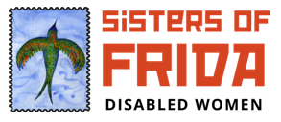

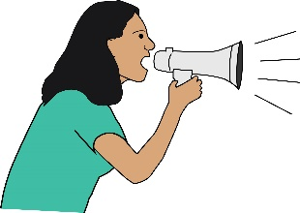
How has Covid-19 affected Disabled Women from Sisters of Frida?
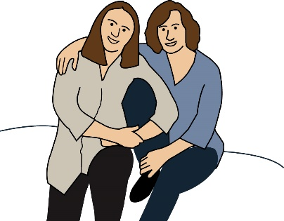
Voices of Disabled Women living through the pandemic.

Covid-19 or Coronavirus pandemic: this is the virus that has spread all over the world in 2020. It has changed the way that people live and work. It has affected Disabled people in particular because often, they are in danger of getting very ill if they catch the virus.
Sisters of Frida: we are a group of Disabled women. We want a new way of sharing experiences, support and relationships. We want to build different networks of Disabled women.
Pandemic: this is when a virus spreads all over the world.

You can get in touch with Sisters of Frida here:
Here is our website: http://www.sisofrida.org/
Here is our Email: hello@sisofrida.org
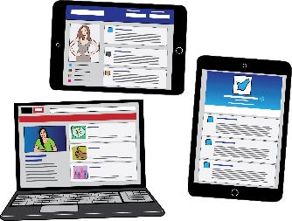
Here us our Twitter account: @sisofrida

Here is our Instagram account: @sisters_of_frida

This document was written in April 2020 by:
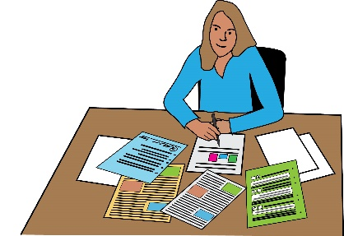
- Eleanor Lisney
- Naomi Jacobs
- Lani Parker
- Fleur Perry
- Emma Vogelmann

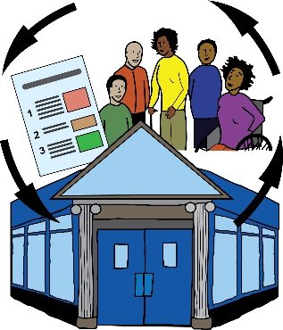
Introduction
About Sisters of Frida
Sisters of Frida is a disabled women’s group. As an organisation, we are not funded. We are all volunteers. We have directors who are led by a steering group. We work on disabled women’s issues.
Steering group: this is a group that looks at what is most important for our organisation, what we should be doing and what we should be pushing for.

We want to make sure that all disabled women can take part in our organisation. This means:
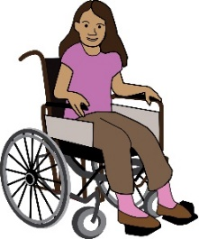
- People who see themselves as women

- Girls

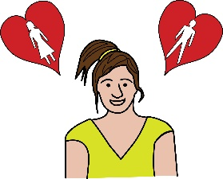
- Non-binary disabled people. This means people who don’t think about their sex and gender in a traditional way. For example, they might not see themselves as either a man or a woman.
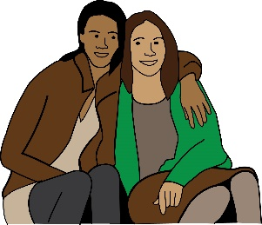
- Gender non-conforming disabled persons. This means people who don’t think, act or dress in the way that society expects them to because of their gender.

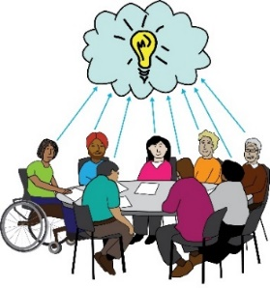
We don’t speak for all disabled women. We aim to build different networks of disabled women. We want to share stories from people with intersectional identities. We work with both women’s organisations and Disabled People’s organisations.
Intersectional identities: this covers many different groups of people. It means that when a person or people are members of many groups, they do not experience life as separate parts but as a whole person. So, for example instead of a person being seen as a woman, and as a black person and as a disabled person, the person is seen as a black, disabled woman.

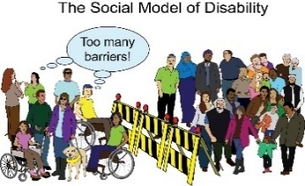

We follow the Social Model of Disability.
Social Model of Disability: This means that Disabled people are seen as people with impairments and health conditions who are ‘Disabled’ by the barriers in society. These barriers put Disabled people at a disadvantage and push us out of society. It is the way Society is run and organised that is the problem, not the Disabled person.

Who is Disabled?
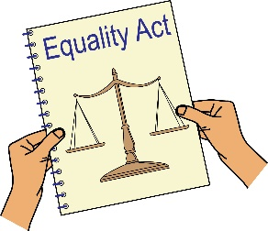
A person is disabled under the Equality Act 2010. The law says that a person is disabled if they have a physical or mental impairment. This impairment seriously affects how they carry out normal activities every day.
Equality Act: this is a law that aims to look after people’s rights and make sure that people don’t face discrimination.
Discrimination: in this document, this means when people are treated unfairly because of their disability, race, sex or gender.
Impairment: in the document, this is used to talk about a Disabled person’s medical condition, diagnosis or difference. This could be physical or mental.

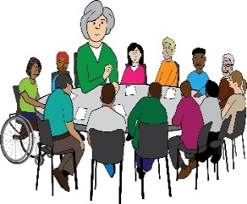
About this paper
This paper started because we wrote back to a report by the Women and Equalities Committee.
Women and Equalities Committee: this is a group that makes sure the government meets the laws and policies about equality.

This report looks at the different effects that Coronavirus has had on people with protected characteristics. Coronavirus has affected these people very badly.
Protected Characteristics: these are parts of a person that are protected by the Equality Act, such as a person’s age, if they are a Disabled person, their race, their sex etc.

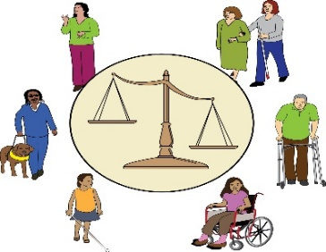
We know that the experiences of Disabled women have not been thought about when dealing with COVID-19. This paper aims to share the experiences of Disabled women.
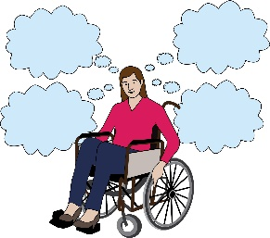
Nobody talks about the different roles that Disabled women have, as people who have intersectional identities.
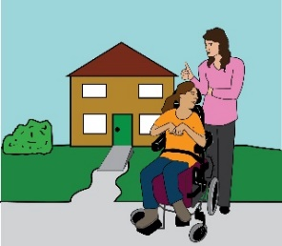
We know that the new rules under the Coronavirus Act go against our rights. They have had a very bad effect on our independent living and sometimes our lives.
Coronavirus Act: this is an act that was put into place in March 2020. It gives the government emergency powers to deal with Coronavirus.
Independent living: this means Disabled people living in the community with the same choices, control and freedom as anybody else.

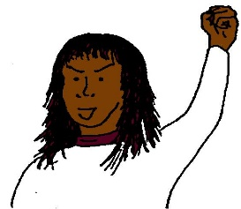
We were asked to join a group of women’s organisations who are pushing for the government to take action. We want to share stories from disabled women living through COVID-19.
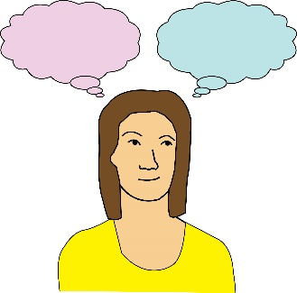
We asked disabled women to talk about their experiences of COVID-19 and how it affected their intersectional identities. We want to make sure the voices of Disabled women are heard, because they are often not listened to.

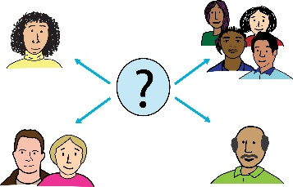
We are working with Inclusion London and the Reclaiming Our Futures Alliance. We are pushing for the rights of disabled people under the Care Act 2014.
Reclaiming Our Futures Alliance or ROFA: this is a group of Disabled people and organisations who have joined together to push for Disabled people’s rights.
The Care Act: this is a law made by Parliament which sets out the things that local authorities must do to give care and support to people who need it in their communities.

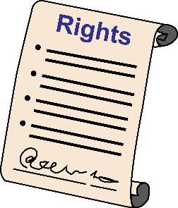
People’s rights are not being looked after during this pandemic. Disabled people and their personal assistants need access to food, services and Personal Protective Equipment.
Personal Protective Equipment or PPE: in this document, this means clothing you can wear to stop the spread of coronavirus. For example, you could wear a facemask and gloves when you go to the shops.

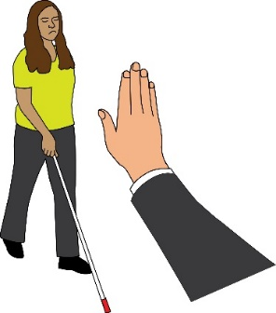
Disabled women’s needs under COVID-19 are just as important as the rest of the disabled community. However, disabled women face even more issues because of both their gender and their disability.

Statistics about disabled women
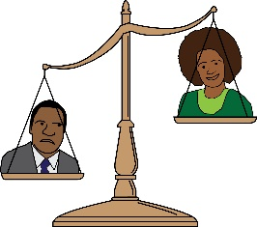
There are more disabled women than men in the UK. 23% women compared to 20% men.
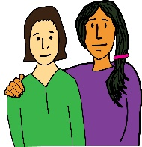
Women are more likely to care for family and friends than men, up until the ages of 65-74.
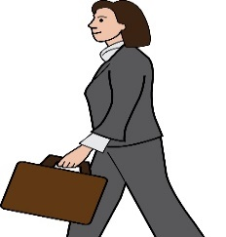
Women giving care to family and friends are much more likely to be working part-time than men. 23% of women worked part-time compared to 9% of men.
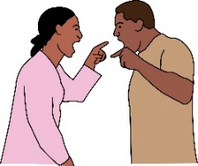
Disabled women are twice as likely to face domestic violence than non-disabled women.
Domestic violence: this means when abuse happens between people in a relationship. It can be any type of bullying, controlling or violent behaviour.

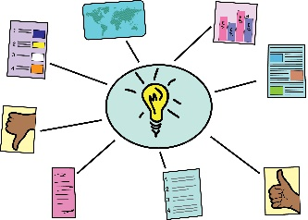
It’s hard to find lots of data about Disabled women, but these statistics show that Disabled women have a very unsteady position in society.

Most disabled women are in the lower position in society, because of their class and how much money they have.

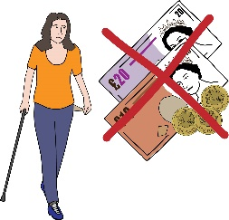
Another study found that around a quarter of households with a disabled person are poor, compared to 22% of the population. The actual number is probably higher.

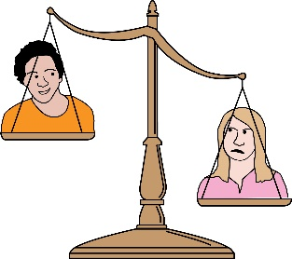
Around half of disabled people had a job but they were more likely to be in jobs with less pay or have less work. Disabled women earn around 20% less than non-disabled men. Disabled women earn around 10% less than disabled men.
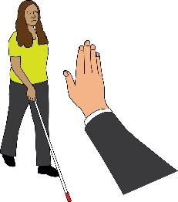
Now we will look at some of the most important issues that disabled women have faced during the pandemic.
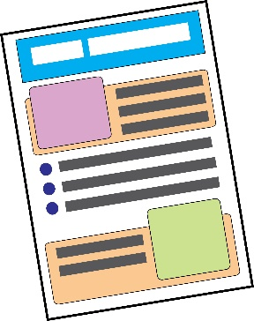
There is a separate Easy Read document with real life examples from Disabled women in a separate document called ‘Impact of COVID – Examples’.

Access to food
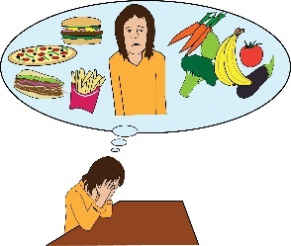
Panic buying has meant that some people can’t access enough food and household items. Disabled people have not been able to access things like toilet rolls, gloves and sanitisers.
Panic Buying: in this document, this means when people buy lots of food and household items in one shop because they are afraid that the shops might run out of these things.

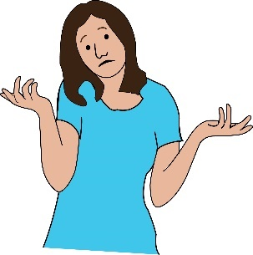
This is a big problem for people who can’t go on more than one trip to the shops or travel a long way to find things in other shops. Some disabled people also need certain food for their health conditions and impairments. This is a problem when shops run out of these foods.
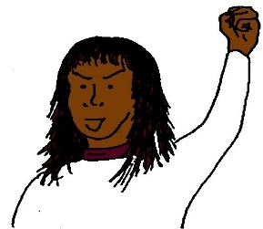
Lots of Disabled people are now taking action by law against supermarkets.

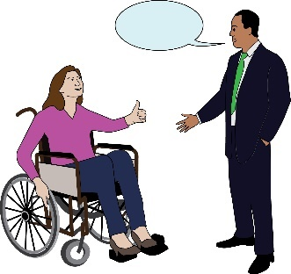
What actions need to happen?
- The government and local councils must work with supermarkets. They must see that disabled people and women's needs for shopping are the most important.
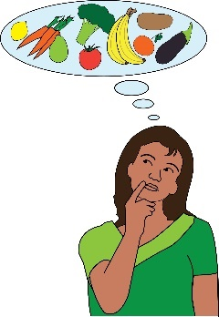
We don’t think the lockdown for disabled people will end anytime soon. The needs of lots of disabled people are not being met. This will be even worse for women from Black, Asian and Minority Ethnic communities.
Lockdown: in this document, this means the rules that have been put in place to stop the spread of Coronavirus. People have been told to stay inside unless they need to go to shops or work. Schools, restaurants and gyms have also been closed.
Black Asian and Minority Ethnic communities or BAME: this means people living in the UK who are not from white communities.

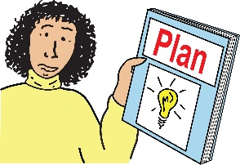
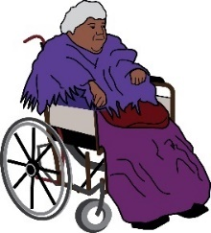
- There should be plans for emergencies that might happen in the future. We need to make sure that Disabled people will be able to access food if an emergency happens again.

We must remember that people with protected characteristics and intersectional identities face even more problems in emergency situations.
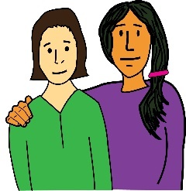
- There should be good safeguarding policies so that disabled people are not put in even more danger.
Safeguarding: this means rules that make sure that people who could be at risk, can live safely.

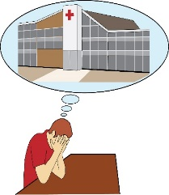
- Access to Health and Medical Services

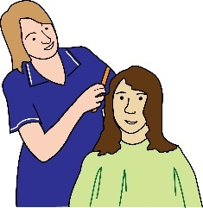
Covid-19 has affected women more, when accessing money and health care. Most people who are giving care are women. Sometimes they get paid for giving this care and sometimes they don’t. Most health workers are women too.
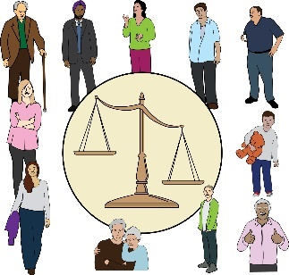
Older people and disabled people with health conditions, such as breathing problems and diabetes, are in the most danger of getting very ill if they get COVID-19.
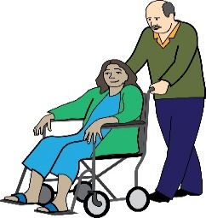
Older and disabled people who need social care from personal assistants might find it harder to self-isolate.
Self-isolating: this means staying inside and keeping away from all other people all the time, to stop the spread of coronavirus. Lots of Disabled people have to do this to stay safe during the pandemic.
.

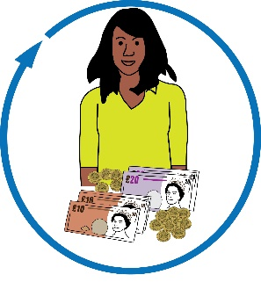
People might find it harder to self-isolate if they are:
- Getting direct payments, this is money from the government to pay for care and support needs.

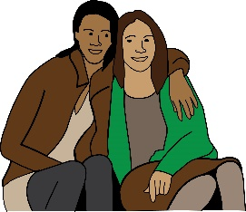
- Getting personal health budget, this is money from the government to support health and well-being needs

- Caring for family members

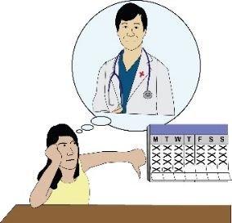
Hospitals and other health services have cancelled or delayed appointments. Older, sick and disabled people are waiting longer for treatment. This is making their health problems even worse.

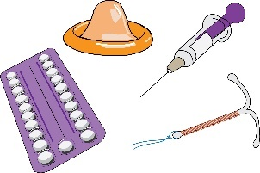
Lots of women and girls are missing important medical check-ups because they don’t want to catch the virus. For example, less girls and women are using family planning services.
Family planning services: this means services that support women and girls with sex and sexual health.

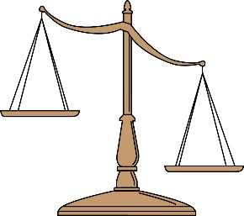
This week, a report said that that BAME groups are already being affected more by the new coronavirus. The virus is showing that society is not equal.
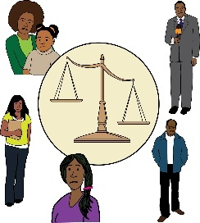
Rabina Khan, a Liberal Democrat councillor, said coronavirus affects the BAME community more, because they already have worse living conditions.

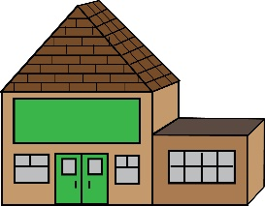
A lot more people are dying in care homes. In March, there were nearly three times more deaths. Around half of Europe’s COVID-19 deaths were people in long-term care homes.
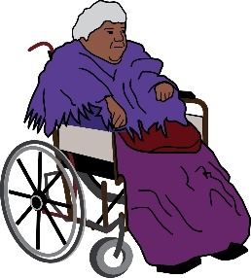
Women are affected more by the dangers of living in care homes, because there are a lot more women in care homes than men.
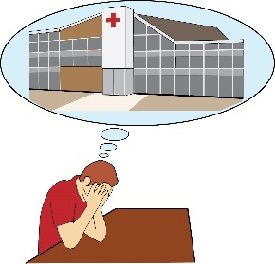
Disabled people are really scared that if they do catch the virus, they might not get treatment, because they have less chance of surviving.

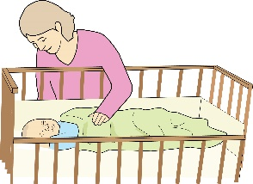
The guidance only lets visitors go with patients to hospital in four situations:
- If they are giving birth
- If they are getting care at the end of their life
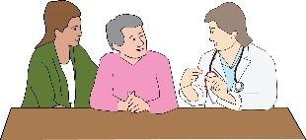
- If they are visiting their child
- If they are dealing with very bad mental
distress.
Mental distress: this means feeling really worried or upset.

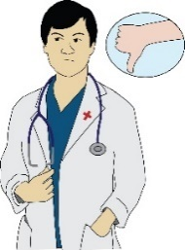
The effects of the lockdown on mental health shows that there is not enough support for disabled women.

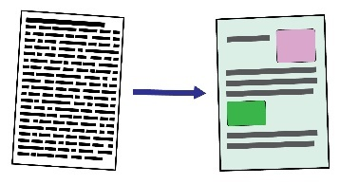
Being able to read information in accessible formats is very important during this pandemic.

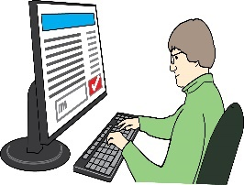
A survey found that only 37% of disabled people had access to home broadband. 23% of disabled people have no access to the internet at all. This stops disabled women from accessing emergency services and volunteer networks.

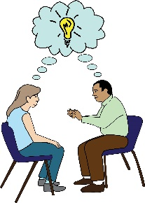
The organisation WISH told us some things that women said about the effects of lockdown on their mental health.
WISH: this is a user-led organisation that works with women in hospitals, prisons and the community. They aim to give women’s mental health a voice.

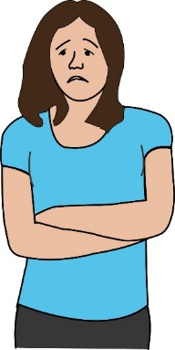
People have had issues like:
- Feeling locked up.

- Being scared to go shopping.

- Having flashbacks from the past.
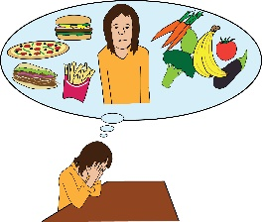
- Hearing voices.

- Not eating well.

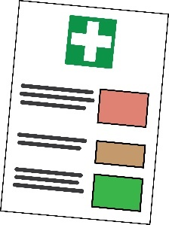
What actions need to happen?
- Make sure everyone can access the critical care guidance being used by the NHS. We must be able to see how they decide who to treat and how to give out Do Not Resuscitate orders.
Critical Care Guidance: this is a document which tells doctors and nurses how to treat people who are very ill with Covid-19.

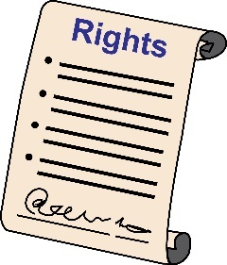
This will mean disabled people can be confident that their right to life will be looked after if they become very ill.
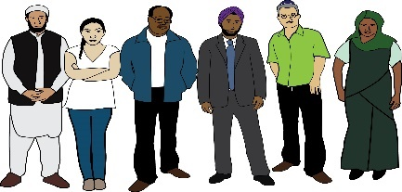
- Make sure support is given to Black, Asian and Minority Ethnic communities so that they can access medical care and services.

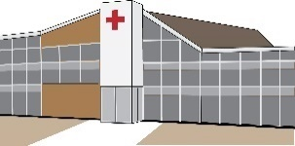
- Make sure there is enough Personal Protective Equipment for care home staff. Test patients before sending them home from hospital.
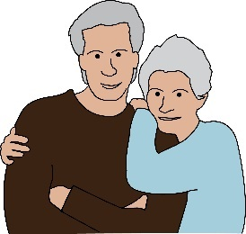
Make sure people living in care homes have fair access to treatment. Make sure that Do Not Resuscitate Orders are not used for everyone living in care homes. This is also called blanket Do Not Resuscitate Orders.
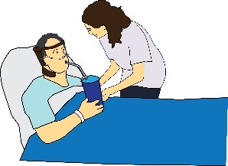
- Make sure that personal assistants or family carers can go with disabled people every time they are in hospital to support them.

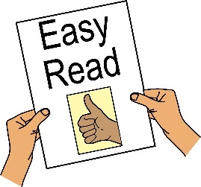
- Make sure Disabled people can read information in accessible formats. This means formats such as Easy read, Large print, British Sign Language and different languages.
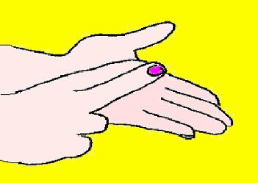
Make sure all important public announcements on TV are translated into British Sign Language. Make sure people can access the service and volunteer programmes, to get support during the pandemic.

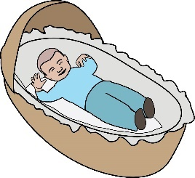
Voices of Disabled Mothers
Disabled women with children and babies have faced a lot of problems because of COVID-19.

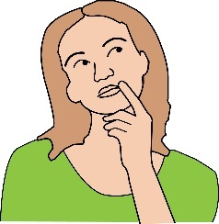
Fiona Anderson works for Enabled2Parent, an organisation for Disabled parents. She told us that Social Services do not understand that supporting disabled parents is very important. She said:

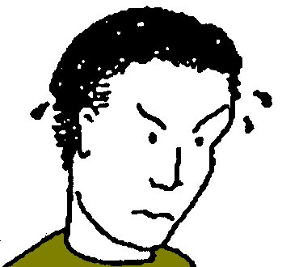
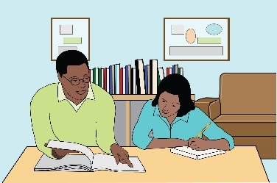
- Lots of disabled parents get to rest when their children are at school or nursery. Not being able to rest makes their conditions worse. This makes it hard for them to run activities or teach their children at home.

- When personal assistants don’t turn up, it puts a lot of pressure on the family

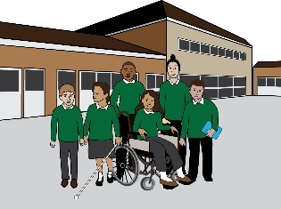
- Disabled parents need to be able to send their children to school, in the same way that key workers can.
Key workers: this means anybody who works in a job that is very important for keeping the country running. For example, nurses, doctors, cleaners, police officers.

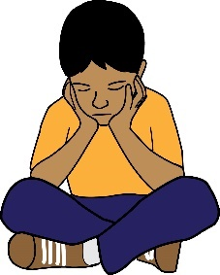
Gemma Nash from an organisation for women in Manchester said that lots of families are struggling with disabled children who can be violent. Mothers are struggling without support workers or services to deal with violent behaviour.
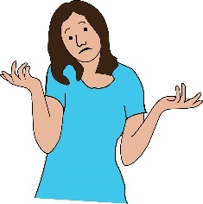
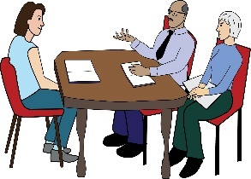
‘B’ is an advocate for disabled people. She is supporting two mothers with learning difficulties. Their children are in care but they have not been able to get in touch with them because the care centres are closed.
The women are not being given enough information or support around their cases.
Advocates: this means people who support a person to understand their rights and support them to speak up and be heard.

What actions need to happen?
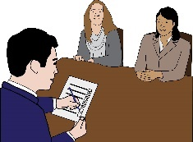
- We need to make sure that disabled parents are at the top of the list for social care support. We need local councils to do an assessment.
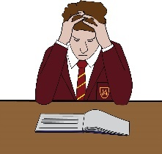
They need to look at disabled parents who need more support because of schools closing and other effects of lockdown.
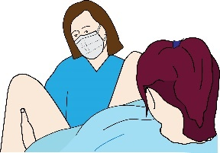
- We need to make sure that disabled parents get safe care after they give birth to children.

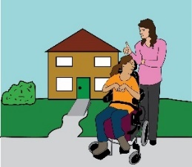
Access to support, care and independent living

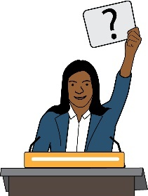
This is a very important question that lots of disabled people are asking:
I hire personal assistants using direct payments. If a Personal Assistant or the whole team need to isolate, how would my care needs be met? If I catch COVID-19, can my Personal assistant still support me?
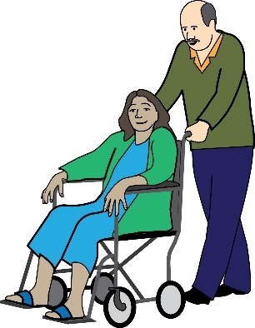
Around 70 thousand disabled people use personal assistants. Personal Assistants need to know all about a person’s care needs. Disabled people might be left without care services if their carers or personal assistants get ill or have to self-isolate.
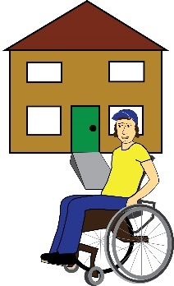
Lots of personal assistants have not been able to access Personal Protective Equipment. People who live in care homes are now being tested for the virus. However, people who live in their own homes and use care services can’t access these tests yet.

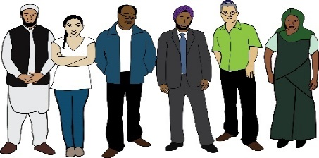
People in Black Asian and Minority Ethnic communities might also face more barriers. This is because they may rely more on community and family support, especially with disabled family members.

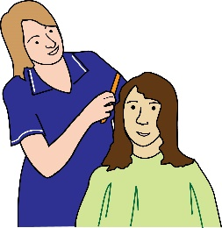
What actions need to happen?
- All Disabled people who have personal assistants or carers working in their homes must have access to Personal Protective Equipment.
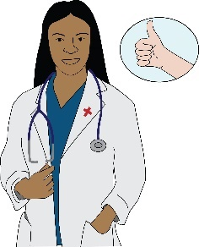
- All carers and personal assistants for Disabled people must be able to get COVID-19 tests. This will put disabled people at less risk of catching the virus.
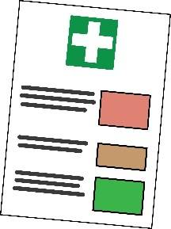
- Everyone should be given clear information about how to stop the spread of COVID-19 when they are using care and Personal Assistant services.

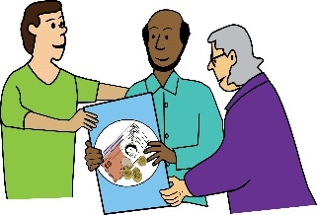
It doesn’t matter if the care is funded by direct payments or given by volunteers such as family members. It doesn’t matter if people are from Black, Asian and Minority Ethnic communities. Everyone should have access to this information.

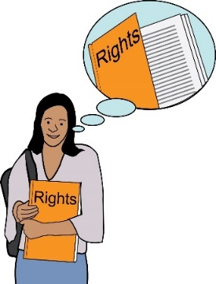
- COVID-19 and the Rights of Disabled Women

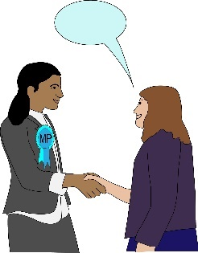
The Coronavirus Act is very worrying because it goes against the rights of disabled people, especially disabled women.

At least 10 disabled MPs have signed a letter asking the prime minister to make sure that the government gives better support to disabled people during COVID-19.

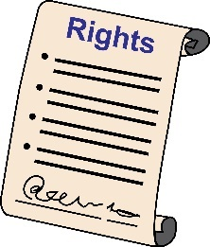
Disabled people’s rights are at risk. For example:
- The right to healthcare
- The right to social care and support
- The right to information.

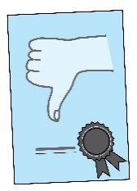
Another worrying effect of the pandemic is that there is now less safeguarding against abuse in mental health settings.

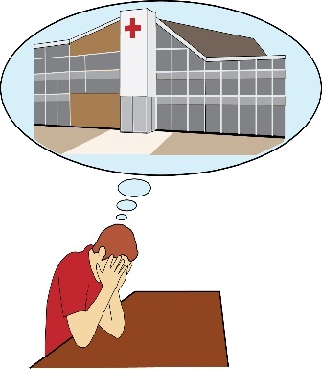
For example:

- Psychiatric detention can last longer. This means people can be forced to stay in hospital longer because of their mental health.
Psychiatric Detention: this means being forced to stay in hospital for mental health treatment.

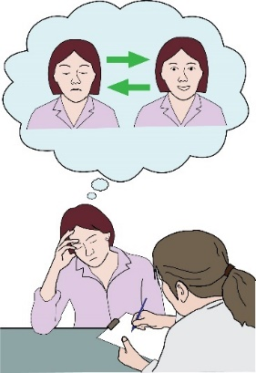
- Only one doctor needs to say yes to keeping a person in hospital because of their mental health. Before the Coronavirus Act, two doctors were needed.

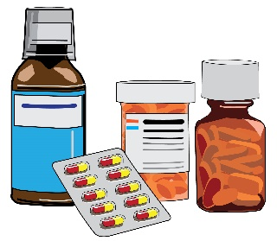
- Only one doctor needs to say yes before forcing someone to take medicine for their mental health. Before the Coronavirus Act, two doctors were needed.
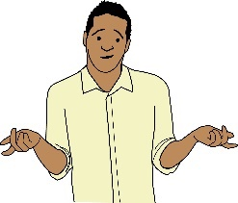
These measures will affect members of the Black, Asian and Minority Ethnic community more, because they are already treated unfairly in mental health settings.
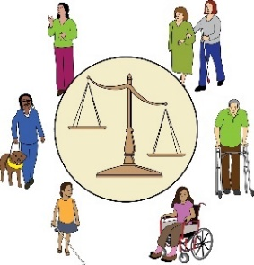
Akiko Hart, from NSUN said that the government needs to make sure that the Coronavirus Act doesn’t affect Disabled peoples’ rights badly in the long-term.
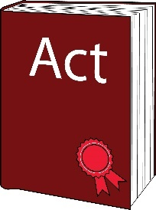
The Coronavirus Act also means that local authorities don’t have to meet their duties under Care Act for the next two years. This means disabled adults are at risk of being left in their homes with no care.
Duty: this is something that must be done by law.

It will mean disabled children get less support with their education. This will affect women more because they are more likely to be carers for these children.
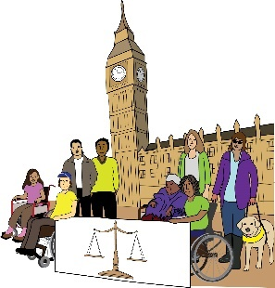
Shantha Rau Barriga, is the director of Disability Rights at Human Rights Watch, an organisation that pushes for human rights.
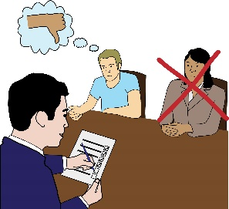
She said that the pandemic should not mean that thousands of disabled people and old people get less support. Government policies shouldn’t put them at more risk.

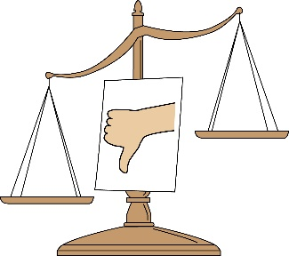
Kirsten H. says that disabled people have been treated unfairly. No reasonable adjustments have been made for disabled people because it’s an emergency situation. This makes us feel lonely and left out.
Reasonable adjustments: this means making changes to get rid of barriers faced by Deaf and Disabled people.

What actions need to happen?
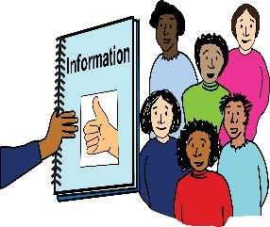
- We need any councils who are doing Care Act easements to share a document showing how they will still meet their duty of care to Disabled people. The document should talk about how they made the decision to do easements and when they will review that decision.
Care Act Easements: this is a change in law that means that local authorities have less responsibilities for meeting people’s care needs. It was brought in to help the care system deal with the new challenges brought by COVID-19.

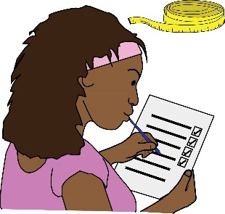
- The government should review the changes in their duties at least every three months. They should review how these changes affect disabled people who get care.
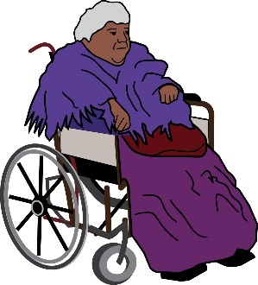
They should also look at how these changes affect people who have more than one protected characteristic, such as Disabled Black Asian and Minority Ethnic women.

Disabled Women and Domestic Violence or Abuse
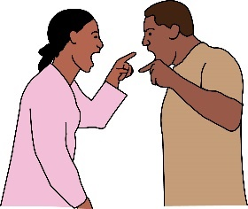
Disabled women are three or four times more likely to face domestic abuse than non-disabled women. They are more likely to face lots of different kinds of abuse in their lives.
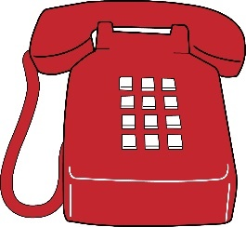
Lots more people have been phoning domestic violence helplines and support services during the coronavirus crisis.

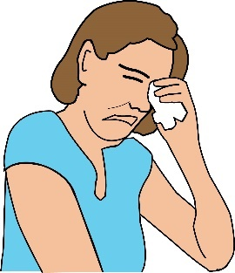
Abuse can happen very easily in lockdown. Isolation means that abuse can happen without anybody realising. This is because people are getting in touch less with friends, neighbours, family, work mates and other services.
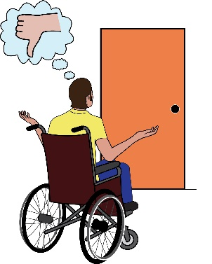
It also means that lots of people will find it much harder to escape from dangerous situations or find services that can support them with this.

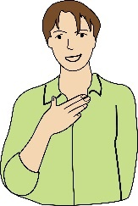
This will affect people who have already struggled to access support and rights, such as:

- Disabled women
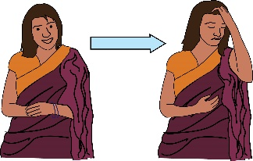
- Black Asian and Minority Ethnic women

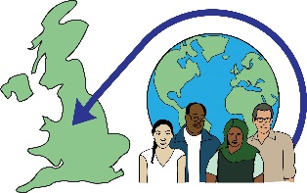
- Migrant women, this means women who have moved to the UK from another country for better living conditions.
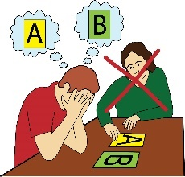
- People who don’t have access to support from local authorities

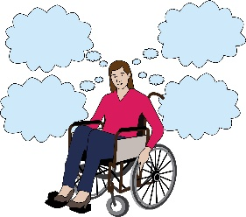
- Women with ‘complex needs’, this means women who have lots of different health and social needs. Often, they are forgotten about when it comes to health and social care.
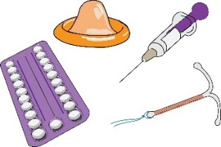

- Sex workers
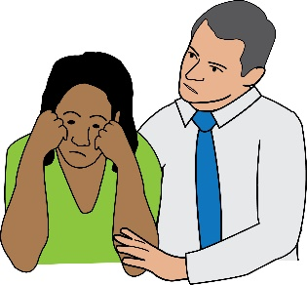
If women are not treated as important, they will be more likely to think they are not important. This will mean that their abusers can control them more easily.

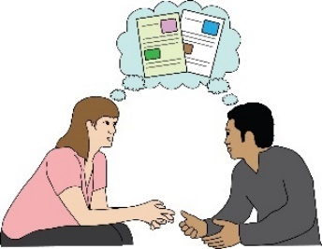
StaySafe East supports Deaf and Disabled survivors of domestic and sexual violence in London. They have been looking at making changes to the Domestic Abuse Bill. They have been listening to the extra problems caused by COVID-19.
Domestic Abuse Bill: this is a government document which was written in 2019. It talks about domestic abuse, how to stop it and how to support victims.

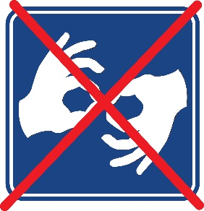
Deaf women are having problems talking and getting in touch with people. This is because of social distancing and having to talk on the phone. British sign language isn’t being used enough to give information. Advocates working from home are finding it hard to do their work well.

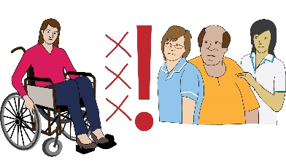
Women with learning difficulties don’t have access to their advocates Disabled women’s needs are not being met in safeguarding meetings. If their advocates can’t be with them, they are at risk of facing even more abuse.

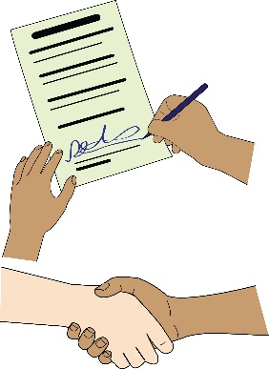
Disabled women are finding it hard to access advice about divorce. With social distancing rules, it’s unclear what will happen with things like moving house and how this will affect disabled people’s health.

What actions need to happen?
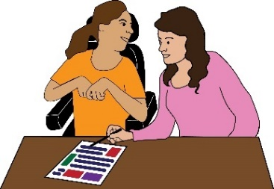
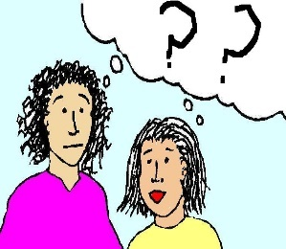
- Organisations that deal with violence against women and girls must be told about the needs of disabled women who are in danger of Domestic Abuse.
They must know about the needs of disabled women. This is not just about reasonable adjustments.
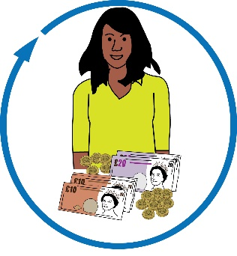

- We must ask Local Authorities to be more understanding about care packages for disabled women who are stuck in social isolation and in danger from Domestic abuse.
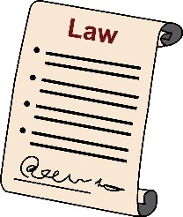

- We need to support the changes that Staysafe East have made to the Domestic Abuse Bill.

Disabled Women in Prisons and Detention
Detention: this means being forced to stay in hospital for mental health treatment.

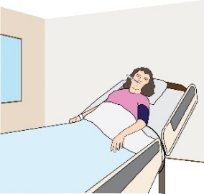
1% of people in prison could die if coronavirus spreads. This would lead to 800 deaths. Lots of prisoners already have other serious health conditions, meaning they could get very ill if they catch COVID-19.

Compared to the number of disabled people in the UK, there are lots of disabled people in prison. In 2012, Around half of women prisoners were disabled and around one third of prisoners who were men.

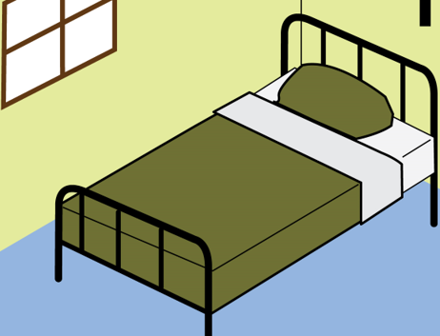
Around 2% of people in the UK has a learning disability. 7% of people who are part of the criminal justice system have a learning disability. Women prisoners are a bit more likely than men prisoners to have a learning disability.
Criminal Justice System: this is the system that deals with people who have committed a crime in the UK. It is made up of different services to do with the law.

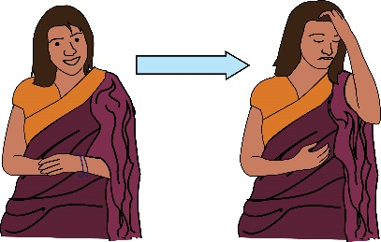
Lots of women prisoners have mental health problems. Women in prison are more likely to harm or try to kill themselves than women in the community. Women with mental health problems are likely to be affected badly by COVID-19.

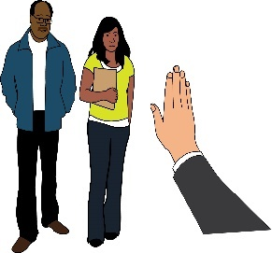
What actions need to happen?
- We need to look at how police treat disabled people, people from Black Asian and Minority Ethnic backgrounds, and other groups. We need to make sure they are meeting their needs under the Health Protection Coronavirus Regulations 2020.
Health Protection Coronavirus Regulations 2020: this is a law which means people can be kept in isolation to stop coronavirus spreading.

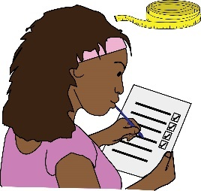
- A review needs to happen to look at how COVID-19 has affected disabled prisoners, especially women.

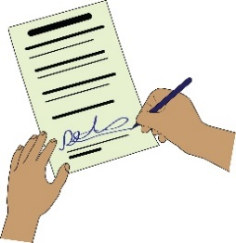
- Disabled Women and Jobs
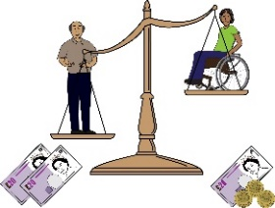
Over 100 politicians signed a letter to the Prime Minister. The letter asks the government to make sure disabled people are part of the plans to deal with coronavirus. The letter says:

- The Government can’t let the disability employment gap get worse.
Disability employment gap: this means when non-disabled people can access jobs much more easily or get paid more than disabled people.

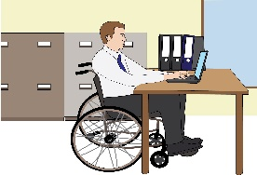
- Disabled people must not be treated badly at work because of the pandemic.
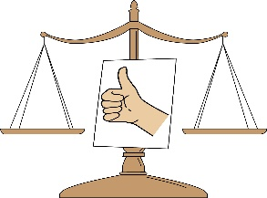
- The Government must do an assessment and make a plan to treat disabled people equally in the workplace.

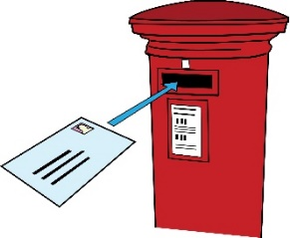
Disabled people have suffered the most from the pandemic and the lockdown. People who are shielding have been told not to leave the house. However, Access to Work still says forms must be signed and posted.
Shielding: this means when the people who are at a high risk of getting very ill from the virus stay inside at all times.
Access to work: this is a government programme that aims to support disabled people in work.

t

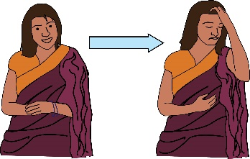
Conclusion
It is clear when we listen to disabled women’s stories that social isolation is leading to mental distress.
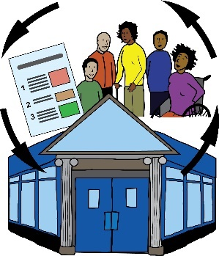
Deaf and Disabled People’s Organisations and groups of disabled people have been working together to support each other. However, not everyone can access online support groups and information, especially if they can’t access the internet.

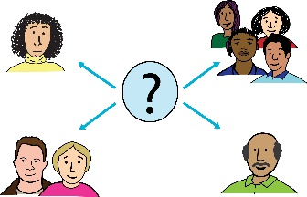
We must start to build networks of disabled people which everyone can take part it. These networks will give peer support and information to local communities and online.
Peer support: this means when people use their own experiences to help each other.

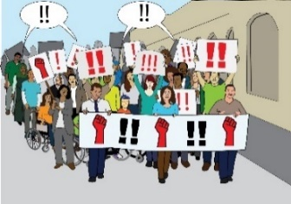
Lots of disabled people, especially women, are campaigning and pushing for disabled people’s rights during this pandemic. They are not being paid for this work.

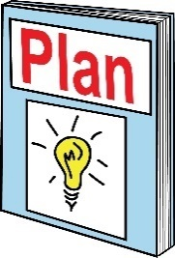
There should be more planning and funding for emergencies in the future.

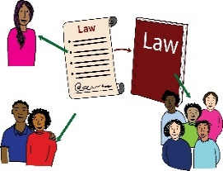
A speech at the UN about COVID-19 said that Disabled people should have the right to take part in making decisions that affect their lives. Disabled people come from lots of different backgrounds and have lived experience.
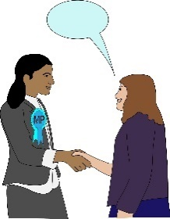
We are asking the government to work with disabled people’s organisations when they are making any policies that affect disabled people. This means disabled women’s organisations too.
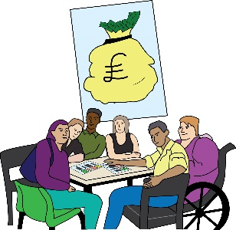
After COVID-19, disabled people’s organisations must be funded and built so that they can work with councils and MPs to get ready for emergencies in the future.

Final suggestions
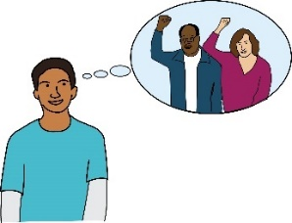
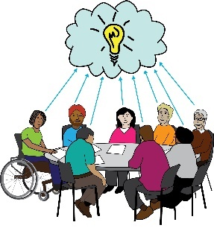
Here are some final thoughts about how we should push for the rights of Disabled Women during COVID-19:

Governments should work in co-production with disabled people and our organisations when they make policies about COVID-19.
Co-production: Co-production (working together) means that Disabled people and decision makers are working together in an active way. They do this to plan, design and review policy and services that affect our lives, to get rid of the barriers we face.

This should happen during lockdown conditions and as we leave lockdown.
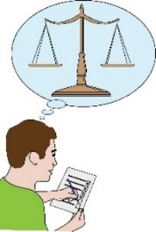
The government should do Equality Impact Assessments on all its COVID-19 policies.
Equality Impact Assessments: this is a way of making sure that policies don’t lead to discrimination against anybody.

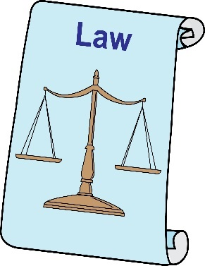
This means policies such as the:
- Coronavirus Act 2020

- Changes to the Care Act 2014

- Health Protection Coronavirus Regulations 2020

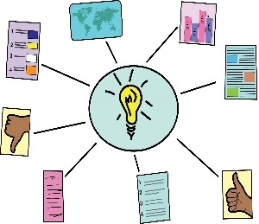
Magda Szarota says that society must not to go back to the way it used to be. She said:
As a disability and human rights activist and researcher I have been looking at public information about how to deal with COVID-19.
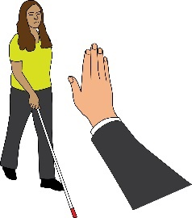
No documents look at disabled women and their situations. This discrimination against disabled women is not new, it has been happening for a long time and it causes people to die.
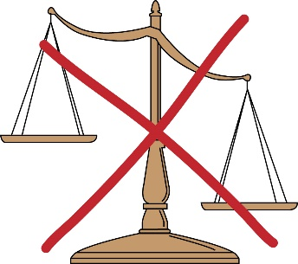
That’s why we can’t go back to the way things used to be. Because in normal life disabled women’s human rights are not looked after. Don’t bring back this version of the world.

Fleur Perry said COVID-19 has affected people really badly and I’m scared about it. However, there have been a few good effects.
She said:
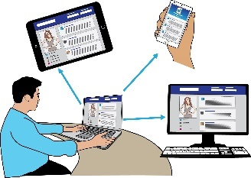
Lots of things now happen online. Travel is very tiring, so video calls and webinars mean I can take part in more events. There's less pollution, and less social pressure to have the energy to be somewhere and do something.
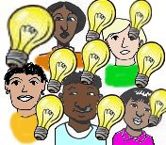
We have all found different routines and different ways to solve problems. We have to support each other more and learn new skills.
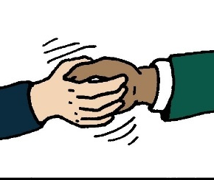
My health has gotten better since the start of lockdown and I know this is true for other people. We need these new support networks and access to online events to stay.
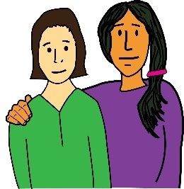
We have to carry on controlling and understanding our own and other people’s needs. If we can do that, the world after COVID-19 will be better than the one we remember. Let's do it!

