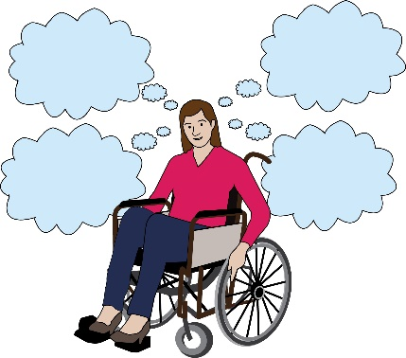
Examples
Below are some examples from Disabled women of the issues that they have faced during the Covid-19 pandemic:
Covid-19 or Coronavirus pandemic: this is the virus that has spread all over the world in 2020. It has changed the way that people live and work. It has affected Disabled people in particular because often, they are in danger of getting very ill if they catch the virus.
Pandemic: this is when a virus spreads all over the world.

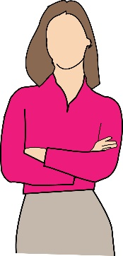
- Access to food
Here are some real-life examples:

Example 1
One person told us about the problems that disabled single mums and people with disabled children face when they go shopping.

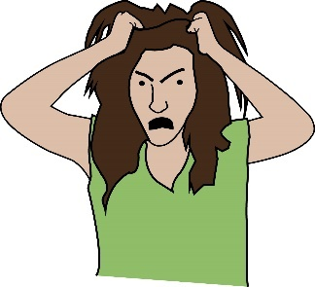
She said that:
- Shopping is very stressful if you don’t have help.

- You have to get there very early if you don’t want to queue.
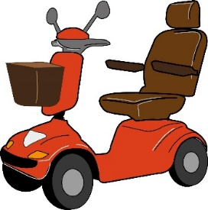
- It’s hard to push a trolley when you have a mobility scooter and a buggy

- People push in the queue.

Example 2
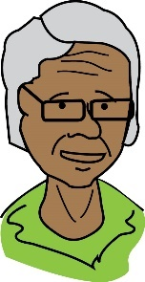
Dr. Sarabajaya Kumar is shielding. She said that:
Shielding: this means when the people who are at a high risk of getting very ill from the virus stay inside at all times.

- Shopping online was not possible for the first 4 weeks of lockdown because the government told everyone to shop online.
Lockdown: in this document, this means the rules that have been put in place to stop the spread of Coronavirus. People have been told to stay inside unless they need to go to shops or work. Schools, restaurants and gyms have also been closed.

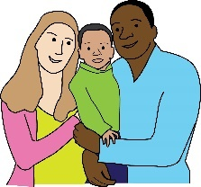
- Not being able to access food and cleaning items badly affected her and her family.
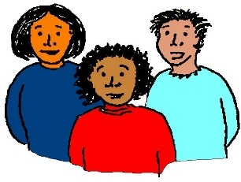
- Some neighbours helped them but she didn’t want to ask them for too much.

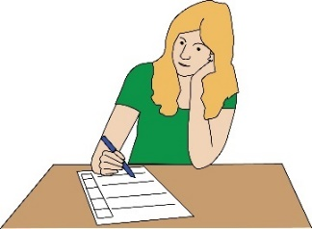
- She wrote to supermarkets but they just gave her standard replies.

- It’s still very hard to find delivery slots for online shopping, even though she’s on the list of people who are shielding.

- The local authorities told her to find volunteers through Facebook to do shopping for her. She had one really bad experience. It made her feel worried about safeguarding.
Safeguarding: this means putting rules into place to make sure that people who could be at risk, can live safely.

- Access to Health and Medical Services
Here are some real-life examples:
Example 1
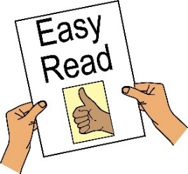
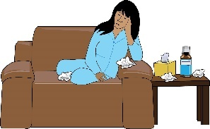
Michelle said her partner was put in hospital because he had Coronavirus. She wasn’t tested when he came home. She’s really tired because she has to cook and clean and do everything in the house.
She has dyslexia and there is no information about the virus is in a format that is easy to read. There’s no one to talk to about it.

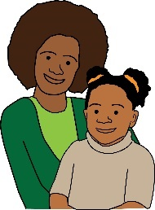
Example 2
Begam is a disabled mother with four children. She is self-isolating with her family. Her flat is really small and some of her children don’t even have a bed to sleep on.
Self-isolating: this means staying inside and keeping away from all other people all the time, to stop the spread of Coronavirus. Lots of Disabled people have to do this to stay safe during the pandemic.
.

Example 3
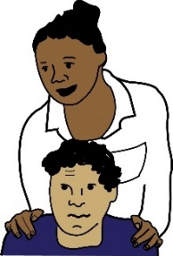
‘A’ is a disabled woman and a carer for her disabled son. She is worried about being on the list of people shielding because she is worried about getting a Do Not Resuscitate Order in hospital. Because of the virus, some hospitals are giving out Do Not Resuscitate Orders without asking the patients or their families if this is ok.
Do Not Resuscitate Orders: this means an agreement that people sign to say that if their heart stops the doctor does not need to try to bring them back to life.

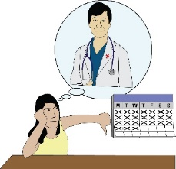
She has nightmares and panic attacks. Her hospital appointments have all been delayed so her impairment is getting worse. Disabled people will die if their needs are not met.
Impairment: in the document, this is used to talk about a Disabled person’s medical condition, diagnosis or difference. This could be physical or mental.
Panic attack: this means when a person feels really worried all of a sudden. This feeling can last for a few seconds or hours. The person might sweat, shake or find it hard to breath.

Example 4
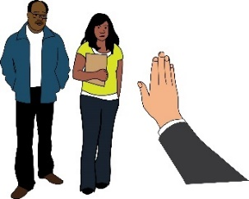
‘S’ is a disabled woman from the Black, Asian and Minority Ethnic community. She said that people don’t take much notice of Disabled women carers from Black, Asian and Minority Ethnic communities. This is especially true if their conditions are hidden. Discrimination is very hurtful, but nobody seems to care.
Black Asian and Minority Ethnic communities or BAME: this means people living in the UK who are not from white communities.
Discrimination: in this document, this means when people are treated unfairly because of their disability, race, sex or gender.

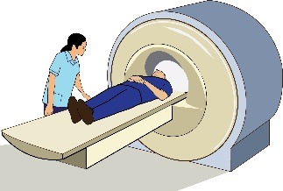
She is worried about catching COVID-19 in hospital. Her appointment for cancer was cancelled. A report said that almost 18,000 more people with cancer in England could die after the Coronavirus pandemic, because of appointments being moved back or cancelled.

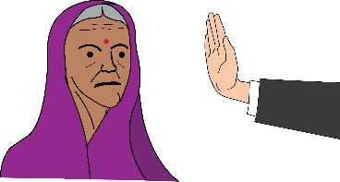
Example 5
N, a disabled woman who is Pakistani, told us she is struggling to get medical care for her parents.
Example 6
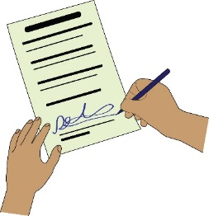
Kate said she was scared to register as shielding, because she might not get treatment if she gets very ill. She doesn’t feel safe in the UK. ‘A’ was also very worried about Do Not Resuscitate orders.

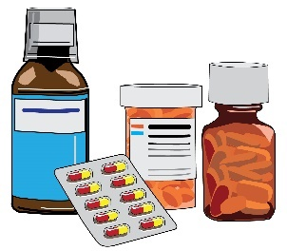
Example 7
Sue has a muscle condition. She is worried she might not be able to access the filters that she uses to help her breath. Instead, they might be given to COVID-19 patients.

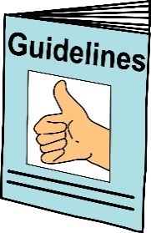
Example 8
Fleur Perry says that NHS England’s guidance about visitors puts her at risk of serious harm and discriminates against her. It goes against her human rights and her right to life too.
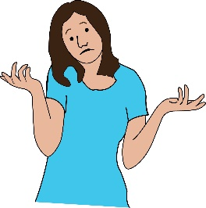
Perry is worried that NHS staff can’t meet her needs. They don’t know how to use her equipment or move her safely. NHS Staff shouldn’t be put in a position where they have to do this.

- Voices of Disabled Mothers
Here are some real-life examples:
Example 1
‘C’, a new disabled mother, tells us how cuts to services have affected her and her baby. She said:

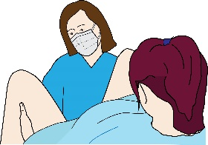
- The birth was very stressful because of lockdown and the hospital service was rushed

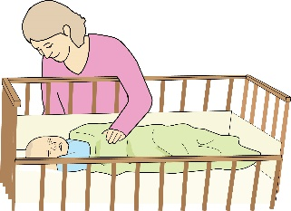
- She is scared her baby will get sick because he won’t get proper help

- Her family still haven’t been able to meet the baby
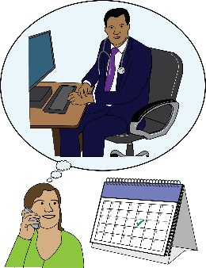
- She’s not had a check-up and she’s scared her baby’s vaccinations will be cancelled

- Her baby isn’t registered as being born

Example 2
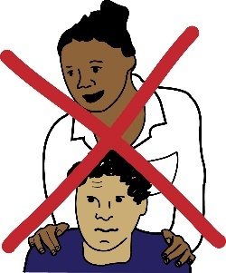
‘L’ is a disabled mother. She said it’s been really hard to find care for her disabled son. His carers can’t fly into the UK because of lockdown. They are scared to catch the virus off a new carer. She’s scared she won’t be able to care for him on her own.

Example 3
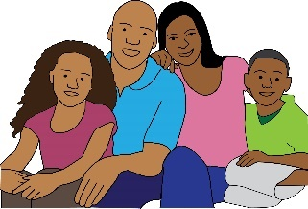
‘A’ is a disabled woman and a carer for her disabled son. She said she has lots of responsibilities in the house. She has been very physically and emotionally stressed because of COVID-19.

- Access to support, care and independent living
Independent living: this means Disabled people living in the community with the same choices, control and freedom as anybody else.

Here are some real-life examples:

Example 1
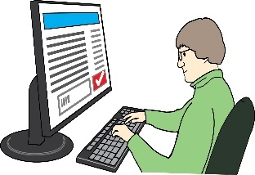
Fiona Anderson told us that she is having trouble finding enough Personal Assistant support during the pandemic. She’s also having to buy Personal Protective Equipment off websites like amazon. There’s no guidance about what to buy.
Personal Protective Equipment or PPE: in this document, this means clothing you can wear to stop the spread of Coronavirus. For example, you could wear a facemask and gloves when you go to the shops.

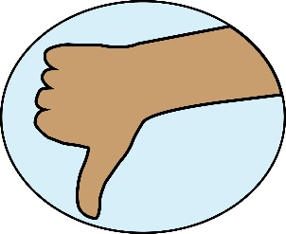
Personal Assistants don’t always feel safe with the Personal Protective Equipment they are given.

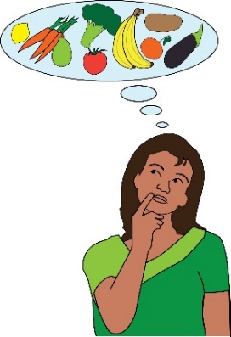
Example 2
‘A’ can’t find enough Personal Assistants to support her and her disabled son during the pandemic. This has affected her access to food badly. She has no support to open, cook or use food. She can’t access ready meals easily.
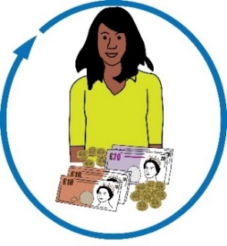
Example 3
Kate told us she is worried that self-isolating with her mum could affect her access to direct payments. She doesn’t trust services and the government.
Direct payments: this is money from the government to pay for care and support needs.

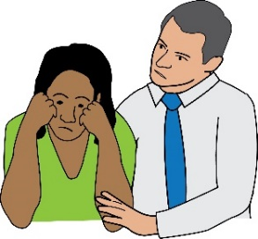
She is scared that social services might stop paying her personal assistant. She didn’t register as vulnerable for weeks in case the government found out where she is living.
Register as vulnerable: this means when a person tells the government that they have a medical condition. This condition means they are at risk of getting very ill if they catch Covid-19. This is so the person can access support to government services.

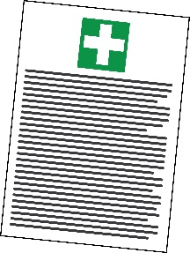
She felt very uncomfortable giving her personal details and information about medical conditions to strangers. She had to do this to get her prescriptions picked up.
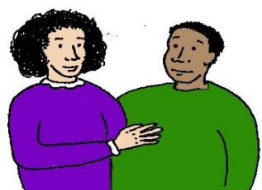
She realised that she is only really safe because she is in a healthy relationship with her partner.

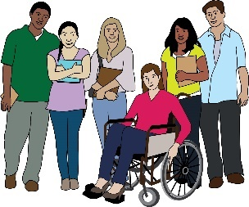
Example 4
‘E’ has Chronic Fatigue Syndrome and usually gets support from friends, family and loved ones with things like shopping and cleaning.
Chronic fatigue syndrome: this is a long-term condition with lots of symptoms. The main symptom is feeling really tired all the time.

However, she hasn’t been able to get this support during lockdown. This has had a really bad effect on her physical and mental health. This has also affected her university studies.

- Covid-19 and the Rights of Disabled Women

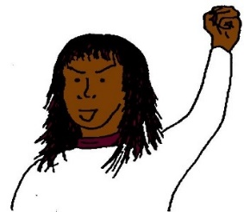
Here are some real-life examples:

Example 1
Dr. Sarabajaya Kumar was a candidate for the Women’s Equality Party last year. She wants to push for equality for everyone. But she is shielding without a carer.
Candidate: this means someone that puts themselves forward for a job.

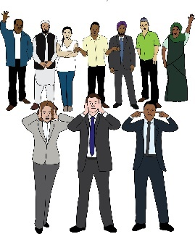
She is trying to teach university lectures from home. She is feeling more and more worried that disabled people’s rights are getting worse under COVID-19.

Research shows that women from Black Asian and Minority Ethnic backgrounds, are often not listened to when they have symptoms.

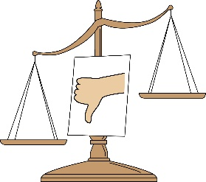
Health care is not equal for everybody. She is a disabled woman of colour. Nobody notices that she is treated a lot less fairly than non-disabled white people.
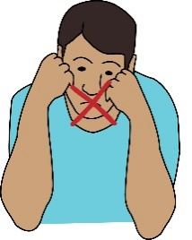
There have been lots of rules put in place to make sure families and the NHS are safe. As a disabled woman, Dr. Sarabajaya Kumar has lost a lot of control over her life.

Example 2
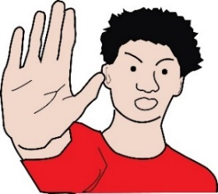
Eleanor is worried about hate crime against East Asians in the UK, because of COVID-19 lockdown. She’s already faced hate crime because of her disability now she’s worried about facing hate crime because of her race.
Hate crime: this means when somebody commits a crime against a person because of a reason that makes them seem different such as their sex, gender, disability or race.

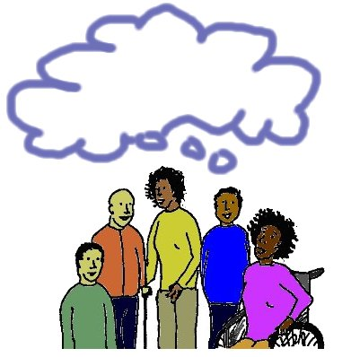
Example 3
E. talked about the discrimination faced by people with impairments that can’t be seen. When people talk in public about COVID-19, they don’t talk about how lockdown might affect disabled people.
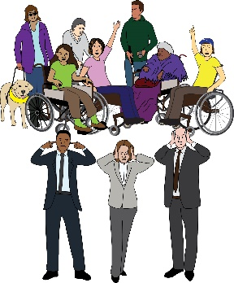
People with conditions like chronic fatigue syndrome are being ignored and nobody is talking about the stresses and problems they are facing in lockdown. Disabled people are expected to not speak up about feeling lonely and left out.

- Disabled Women and Domestic Violence or Abuse
Domestic violence: this means when abuse happens between people in a relationship. It can be any type of bullying, controlling or violent behaviour.

Here are some real-life examples:

Example 1
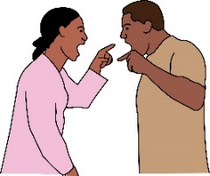
- A safeguarding meeting was held about a disabled woman facing domestic abuse. When she got there, she found out that the person who had been abusing her had been invited to the meeting too. He was asked whether he was abusing her and he said no.
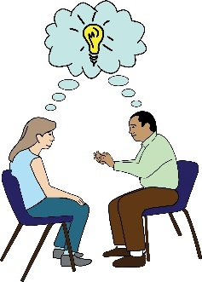
- Then, the social worker asked the disabled woman questions about the abuse. Her advocate tried to stop this. The social worker said the disabled woman should find somewhere safe to stay, away from the person abusing her.
Advocate: this means a person who supports disabled people to understand their rights. They support them to speak up and be heard.

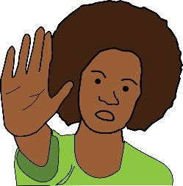
- The advocate managed to stop the meeting so that she could support the disabled woman to be safe. If the advocate hadn’t been there, the disabled woman would have gone back to her home and faced even more abuse.

Example 2

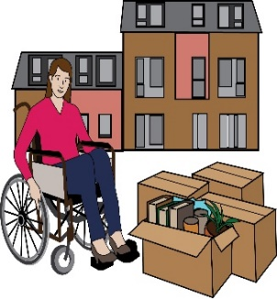
- Tracy has just been through a really nasty divorce. Her and her ex-husband are selling the house. Her husband is angry that nobody can view the house for 12 weeks, because Tracy is shielding. If the social distancing carries on after this, he wants to take her to court.
Social distancing: this means keeping your distance from other people to stop the spread of Coronavirus.

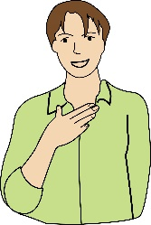

- Tracy is at risk because she has a condition that affects her lungs.
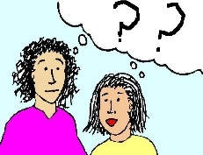
- She is trying to find out if her husband can force her to go to court or to move house if social distancing carries on.

- Disabled Women in Prisons and Detention

There are no examples for this section.

- Disabled Women and Jobs

Here are some real-life examples:

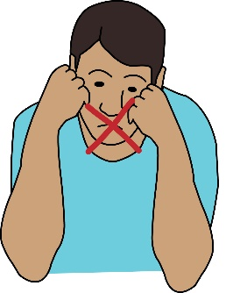
Emma Vogelmann can’t support her charity under the new lockdown rules. She is an important figure in the disabled community but she feels like she has been silenced. She can’t write blogs to support her community and she can’t share her fundraising appeal in case it is seen as work.

Some other Disabled women talked about how Covid-19 has affected them in their workplaces:

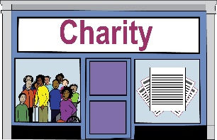
One woman talked about being on furlough from her job with a charity that supports disabled people. She was really upset about not working.
Furlough: this means when the government pays workers some of their wages if they are not able to work because of the Coronavirus pandemic.

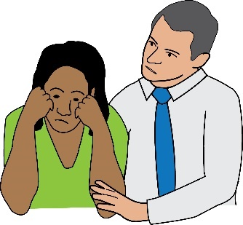
Some women are finding it really hard to work from home. One woman talked about feeling like she was failing as a wife. She can’t go for a walk to get space without falling and getting injured. A lot of space is not safe for her anymore.
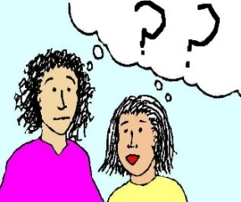
Nobody thinks about disabled women having more than one role. Being told to stay inside for 12 weeks isn’t easy. Disabled women are being made to feel like no-one even notices them.

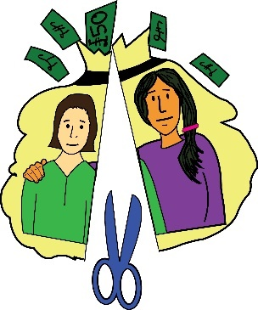
One self-employed Disabled woman talked about not being able to get a job. She’s not sure if Access to Work will punish her for this. She still has a support worker and can’t furlough him because he is self-employed. She doesn’t want to lose a good worker.
Access to work: this is a government programme that aims to support disabled people in work.

t

