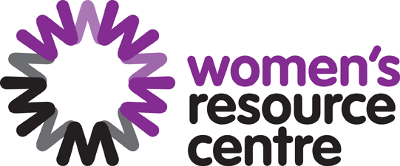

We are asking for help from disabled women

WRC contact: Simma Rai shadowreport@wrc.org.uk

Our aim
The Government has to tell the United Nations about women’s rights in the UK.

We are collecting experiences from women across England to give to the United Nations. They will use these when they question the UK Government.

We want to be sure that disabled women are included. This report will reinforced what DDPOs wrote to the UNCPRD committee in last year’s examination in Geneva. But we will focus more on disabled women and girls’ issues.

Please tell us:
- What the problems are, in your own words – we are interested in your personal experiences
- Links to any evidence (research reports if you have them)
- what the government has/has not done since the last time it reported in 2013, and
- your recommendations for what needs to be done.
NB we are reporting on the period from 2013 to date.

We can only give a very short report to the United Nations - only 6,600 words!
We are interested in any information you can give us. Some of the areas that the UN will look at include:

- Trafficking and Prostitution
- Healthcare – how the NHS supports accessibility of healthcare for disabled women
- Political and Public Life – whether disabled women are properly represented
- Economic and Social Benefits - social security payments, universal credit, PIP etc
- Rural Women – the special needs of women outside towns and cities including public transport, slow wifi speeds and access to disability services
- Nationality - special needs of disabled migrant women
- Equality Before the Law – are disabled women equal?
- Education – access to schools, colleges and university for disabled women and girls
- Marriage and Family Life – disabled women’s rights to a family life
- Employment – access to good quality work, and support to work (Access to Work)
- Violence Against Women and Girls - particular problems for disabled women, for example, domestic violence, or such violence against disabled women

Your evidence will be published unless you tell us otherwise.
Let us know if you want:
☐ EITHER your evidence to be completely confidential, OR
☐ to be shared with the Equality and Human Rights Commission only.

Timescale
The deadline for evidence and information is 28 February 2018. Send your evidence to: cedaw@wrc.org.uk

There is more information here
General information – https://thewomensresourcecentre.org.uk/our-work/cedaw/
The Government’s own report is here - http://tbinternet.ohchr.org/_layouts/treatybodyexternal/Download.aspx?symbolno=CEDAW%2fC%2fGBR%2f8&Lang=en

The last shadow report from women’s groups is here: http://tbinternet.ohchr.org/Treaties/CEDAW/Shared%20Documents/GBR/INT_CEDAW_NGO_GBR_13333_E.pdf

If you have any questions please contact us.

Your experience

Any Links to Evidence? Yes/No

Has the Government taken action?

Your recommendations

