Sisters of Frida’s Accessibility Guide to Meetings and Events – a Toolkit
Contents
The Social Model of Disability 2
Publicity for the Meeting or Event 3
Choosing a Venue 4
The Meeting/Event Room 5
Seating 6
Other considerations 6
Chairing/facilitating 8
Presenting 9
Catering/ food and drink 10
Conclusion 10
Links 10

Sisters of Frida CIC is a collective of disabled women, bringing disabled women together, mobilising and sharing through lived experiences.

This guide has been produced as a practical tool to help groups to support and ensure that disabled women will be included and participate when planning meetings and events. There are other accessibility toolkits but we have included specific mentions to disabled women’s needs.

The guide is based upon the Social Model of Disability - that focuses on barriers or difficulties as created by society and not on the individual impairments.

The guide covers:

- Access considerations when publicising meetings
- Access considerations when choosing a venue
- Access considerations during meetings.

The very minimum that most organisations consider is wheelchair access at the venue where a meeting or event is being held. There should also be an accessible toilet.

At the very least, BSL British sign language interpreters should be offered /or palantypists (voice to text). Not every deaf or hearing impaired person understand /use BSL (121 captions provide live captioning services and live electronic notetaking remotely)

The Social Model of Disability

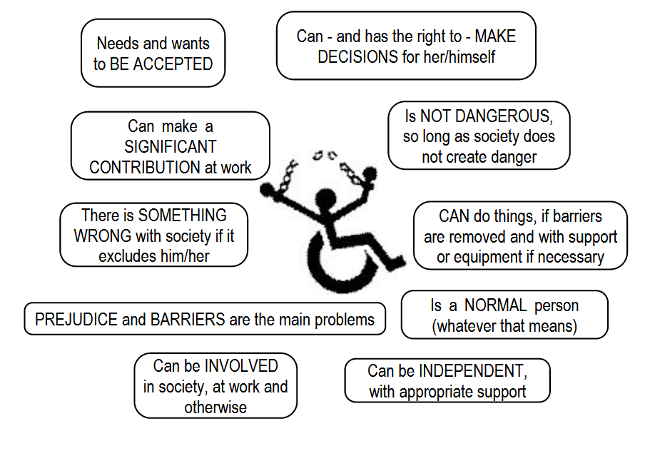
Fig.1 The social model of disability ( image from the TUC)

The Social Model of Disability is a civil rights model of disability.

The Social Model was developed by disabled people. It takes the view that society creates barriers that 'disable' people from participating fully and on an equal basis with others and that these barriers must be removed. By creating barriers in buildings and structures or by not producing information in different formats such as Braille or Easy Read, people with impairments/health conditions are ‘disabled’. This way of thinking takes the focus away from what is ‘wrong’ with a disabled person (their impairment or condition) and puts the emphasis on what we should all do, in alliance, to identify and remove barriers.

Definition from ALLFIE http://www.allfie.org.uk/pages/useful%20info/models.html

It is not the responsibility of Disabled and Deaf individuals to “make do” to a system or environment if it is not accessible or inclusive.

Publicity for the Meeting or Event

- Inform people what the meeting is about e.g. networking meeting, action/event planning, Annual General Meeting, or training session.
- Do not use jargon, explain acronyms, use plain English.
  - All leaflets, posters etc should include access details e.g.:
  - Transport – nearest step-free underground/overground station, bus information,
  - Nearest accessible parking
  - Whether the meeting venue is step free, has a lift and accessible toilets
  - Whether there will be sign language interpreters at the meeting
  - Check for the day itself, if there will be roadworks or changes in public transport/diversions.

- Give people as much notice as possible. Get publicity out early. People may need to arrange BSL English interpreters, support or transport, book childcare, plan routes etc.
- Make sure that publicity material includes an email address, telephone, text numbers that people can use to get details about access.
  - Allow for alternative formats in case it is requested.
  - Use appropriate terminology and positive and inclusive
images of Deaf and Disabled People have been used on information and publicity?
  - Minimise use of PDFs and provide texts readable by text readers.

Choosing a Venue

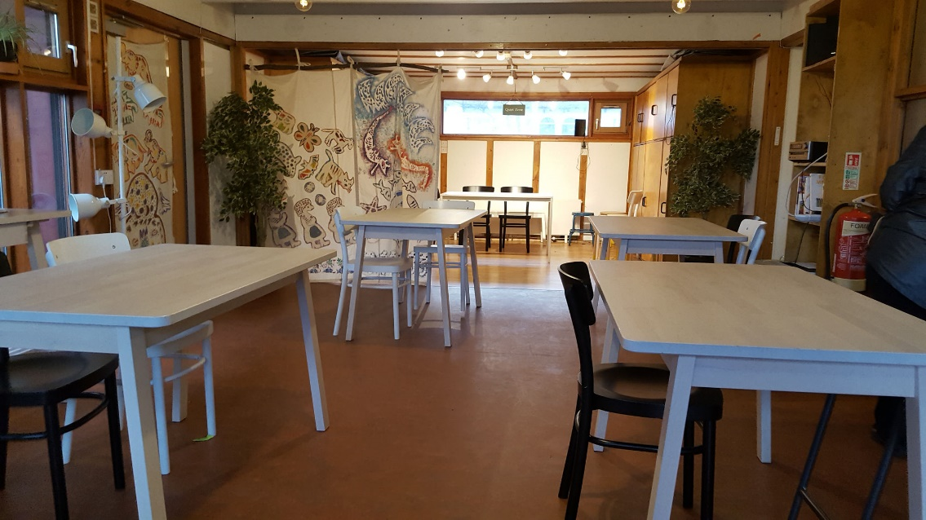
Fig.2 Make enough room for movement around spaces

Find out:
- Any food shops/ cafes/ restaurants in the area/venue where people can get drinks or food before the meeting if they require it?
- Is the venue in a safe area?
- Is there good street lighting in the area?
- Are there people around at night if it is isolated?
- Are there phones in the venue/ or lobby /reception area that people without mobiles can use to call taxis?
- Are corridors and reception areas obstacle free? If there are any obstacles these should be clearly highlighted.
- Is there enough room for movement around tables, chairs and the
spaces used?
- Is there a gender neutral toilet?
- Is there a space for a guide dog to go to toilet outside?
- Is there a child-friendly space next to the meeting space?
- Is there street parking? Are there single or double yellow lines? Are there any parking spaces for blue badges? Accessible parking bays?
- If parking is only available in a car park, what is the height restriction of the entrance?
- Are there hearing loops?
- If there is no ‘Changing Places’ toilets (http://www.changing-places.org/the_campaign/what_are_changing_places_toilets_.aspx) find out where the nearest would be (http://www.changing-places.org/find_a_toilet.aspx). This might make a difference as to whether a disabled person can come.

The Meeting/Event Room

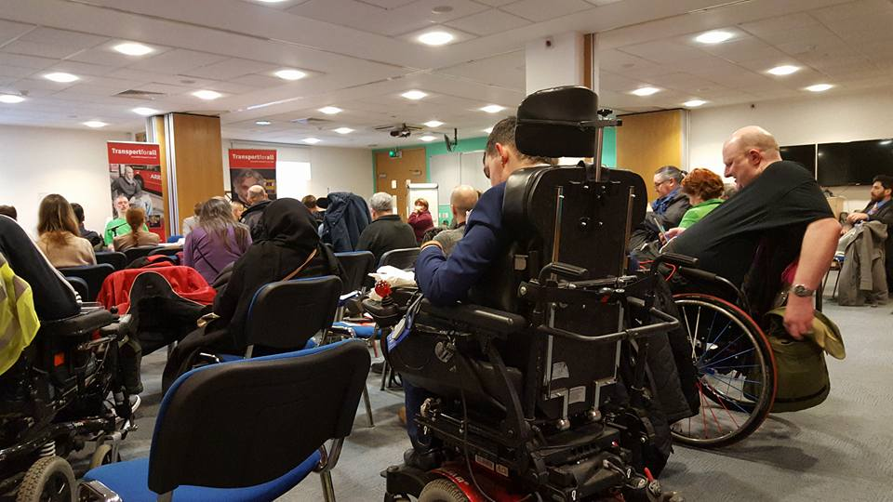
Fig.3 Good lighting and flexible seating

- Is there an accessible toilet on the same floor as the meeting room?
- Has all clutter, including materials used by cleaners, been moved out of the accessible toilet?
- If a key is needed for the accessible toilet, do the meeting organisers have one / know where this is kept?
- Is there adequate lighting in the meeting room to enable people with visual impairments to move around easily and see the speakers?
- If a stage is being used is it accessible by ramp?
- Do lifts have tactile buttons at a height accessible for wheelchair
users and/or short people ?
- Is the lift large enough for at least one wheelchair user and one other
person?
- Does the lift tell passengers which floor it has stopped on?
- Are there heavy doors between the lift and the meeting room – if yes, can the doors be propped open?
- Are stairs well lit, with high-visibility markings & bannisters both sides?
- Can the heating in the room be altered?
- Is there a safe/quiet space (other than the reception or toilet) that people can use if required?
- Is there a screen for palantypist/skype if required?

Seating

- Have seats been reserved for BSL English interpreters/ palantypists?
- Is the room furniture flexible for rearrangement?
- If there is limited seating, can some of it be reserved for anyone who finds standing for long periods of time difficult?
- Have some seats with armrests, and some bigger chairs and some with back support.

Other considerations

- Have BSL English Interpreters / palantypists been booked? This may be needed, and there is a significant cost associated with sign language interpretation. Make sure this is factored into the costs at the planning stage.

- BSL English (sign language) interpreters or personal assistants (PAs) of a Disabled Person enable access. They should not be viewed simply or necessarily as an additional member of the group. Engage directly with the Disabled Person, not the support worker/ personal assistant or the interpreter. You may need 2-3 or more weeks’ notice to book support. BSL interpreters can be very busy. It is also good to ask them if they mind being photographed or video if you plan to video the event.

- Electronic notetaking and Palantype are two speech-to-text access systems. Some people who have low hearing or a hearing loss prefer to have electronic notetaking. This means that a person sits next to the Deaf person typing all that is being said. Palantypists have a large screen where the speech-to-text typist will type everything that is being said and this will be on a visual display for everyone to read. Do not assume what people might need, best to check with individuals.

- Find out whether the venue has an induction loop system. If it has, check that it works and has been tested. If the loop system is not present a portable one can be hired or its absence clearly noted

- If papers are being discussed, circulated beforehand in people’s preferred formats, e.g. by email, if requested.

- Have comfort breaks been built into the agenda of the meeting for people who need them?

- Have the speakers/participants been briefed about how to work with any Interpreters or those attending who are using Braille, etc?

- Check the acoustics. Background noise also may make it difficult for some people to join in the meeting?

- Ask participants not to wear perfumes or scents for people who have neuro diverse to smells.

- You might need to designate a quiet room for people who might feel overwhelmed and need a quiet space.

- For people who could not make it for some reason, consider livestreaming or videoing the event. Have a twitter hashtag for participants to network and comment as well as live tweet the event. Not all events can be exposed to social media. Consent should be sort from the attendees.

- Are you offering a crèche or child minding facilities?

- It might be helpful to have a stool for people of short stature in the loo to facilitate transfers.

- Consider ‘buddies’ for people with sight impairments – to give them descriptions of the room, the size, or the people, to guide them around to have a better experience of the event.

Chairing/facilitating

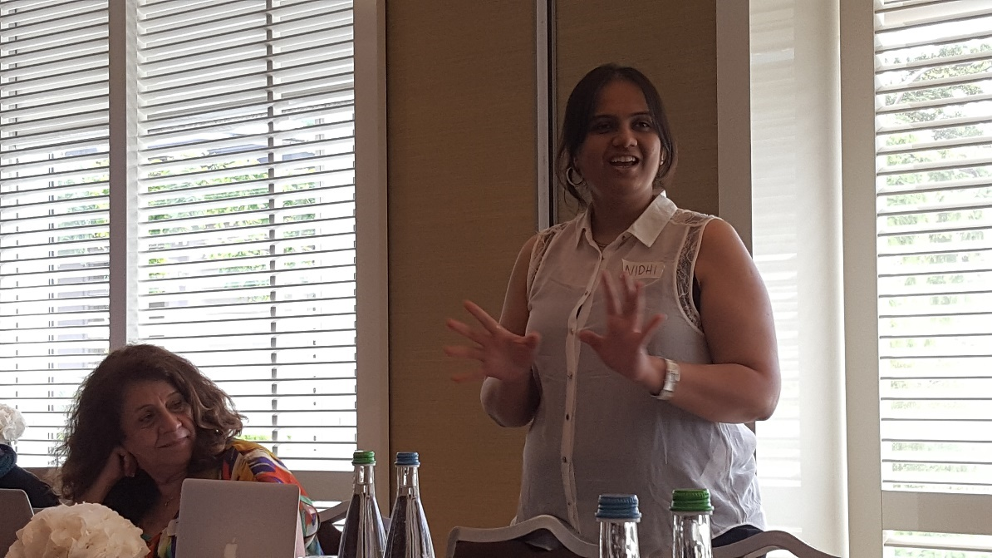
Fig 4 Be careful of having speakers against brightly lit windows

- Do not assume pronouns of delegates - e.g. refer to the person in the orange top, rather than the lady with the brown jumper.

- Keeping to time is an accessibility requirement for many reasons. People may have planned toilet or rest/ prayer breaks (working with PAs) around particular speakers, need to take medication, or need to leave at a certain time for any number of reasons. Allow flexibility, inform the group that they may leave if necessary.

- Although time keeping is important, being strict sometimes also has accessibility problems! People may become flustered or upset if stopped before they have finished.

- If this is a specialist group, then be sensitive about the identities of the people present. Ask people not to mention that they have attended the meeting outside of the immediate group.

- If there are many delegates/participants, use a microphone for the questions asked, or else ask the Chair to repeat the question.

- Remind people not to have flash photography.

- At the event, do not have speakers against brightly lit windows

Presenting

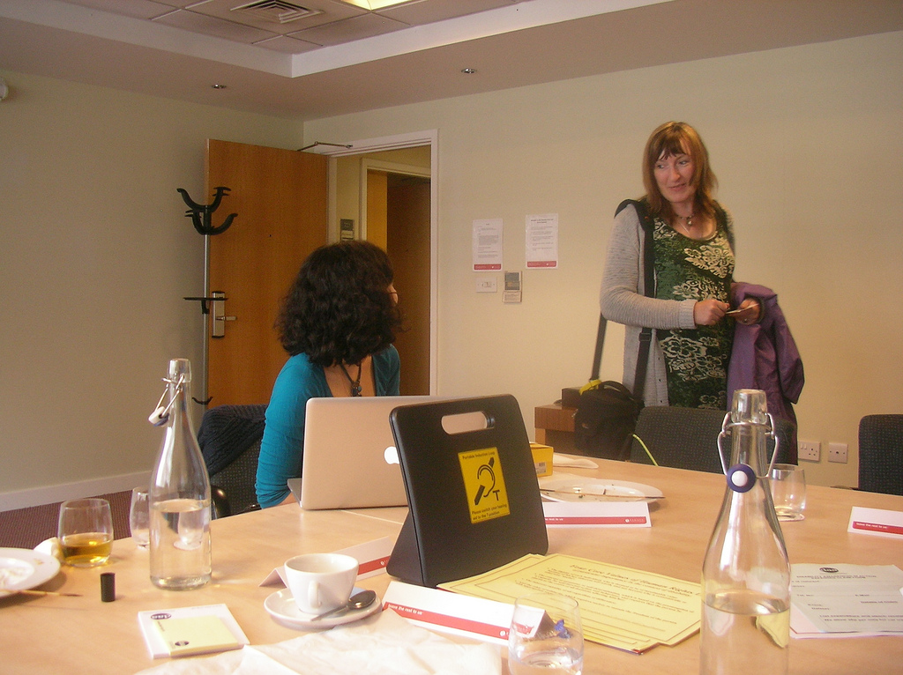
Fig.5 Have a portable hearing loop if there is no hearing loop

- Ask speakers using flip-charts, PowerPoint, to read out the information on them for the benefit of people who do not access print. Ideally PowerPoint presentations should be circulated, in advance

- Are tables, notice boards, flip charts, whiteboards, other furniture
and equipment also accessible to wheelchair users?

- Provide writing material for people who might like to write notes.

- Get everyone to introduce themselves, and ask them to let you know if they have any other access needs which are not being met. Ensure icebreakers are inclusive so that nobody gets left out.

- Have comfort breaks every 60 - 90 minutes.

- Be clear as to what decisions are being made – repeat them before moving on to the next agenda item.

- Inform the presenter the format of the day in advance. Ask them if they mind answering questions.

Catering/ food and drink

- Lunch breaks need to be long enough for everyone to eat, drink and go to a toilet. Some people use this time to network and catch up with friends.

- Ask for dietary requirements in the booking form beforehand, and order some vegetarian/dairy/gluten-free/ carb free /kosher / halal options in case people sign-up late or forget to get in touch in advance.

- Drinks serving could include glasses with a handle and straws

Conclusion

Holding any inclusive event can be expensive. But make provisions for access when you apply for funding (include it into your budget to be considered).
You can sometimes get better deals with some venues and depending on the event, you might be able to get sign language interpreter volunteers. (but don’t count on it)

Links

Equality Act 2010 and ‘reasonable adjustments’

http://www.legislation.gov.uk/ukpga/2010/15/section/20

https://www.citizensadvice.org.uk/law-and-courts/discrimination/what-are-the-different-types-of-discrimination/duty-to-make-reasonable-adjustments-for-disabled-people/

ISAN Access Toolkit: making outdoor arts accessible for all (2009) offers guidance to help organisers make Outdoor Arts more accessible for Deaf and disabled audiences and artists and it will help you to understand your obligations under the Disability Discrimination Act. (pre Equality Act 2010)

http://www.isanuk.org/wp-content/uploads/2014/04/ISAN-Access-Toolkit-2010.pdf

Independent BSL interpreters
http://www.interpretersconnect.co.uk/

Floating PAs (for London only)
https://www.ilanet.co.uk/

Live Captions
https://www.121captions.com/

Acknowledgements

Many thanks to Kirsten Hearn who provided us with her guidelines from her work
http://www.kirstenhearn.com/

And to Jen Slater (Sheffield Hallam University) from accessibility guidelines from her own experiences organising accessible events.
https://jenslater.wordpress.com/accessible-events-organising-and-research/

This toolkit was compiled by Eleanor Lisney, a co-founder of Sisters of Frida and a certified Access Advisor.
http://ethoelisney.uk/

With thanks also to Maria Zedda (Sisters of Frida cofounder), of Wideaware, for casting her eyes over the toolkit and suggesting some missing points.

Funded by the RSA (Royal Society for the encouragement of Arts, Manufactures and Commerce) Catalyst grant as part of the Disability/Sexuality project
https://www.thersa.org/

